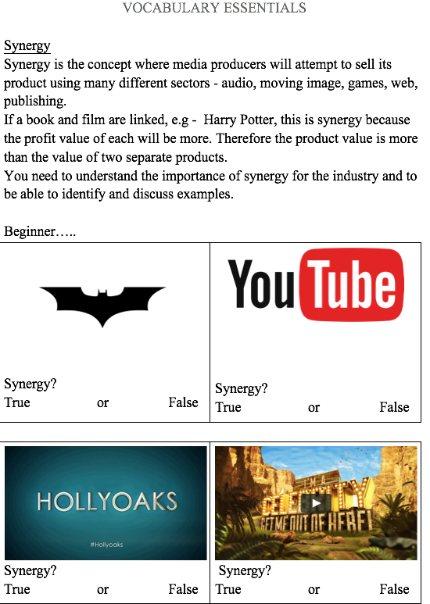

connotation in Music Videos

Connotation is EVERYWHERE in the media…….including music videos.
Connotation is the EXTRA LAYER of meaning that we associate with objects, colours, etc. See the example of a ROSE below, it's NOT JUST a flower is it?
To get you thinking about this, here are some tasks to deepen your learning about it.

TASK ONE

Choose a GENRE of music: e.g. Trap, Rock

Drill

Choose 3 different artists that are examples of this GENRE
1.
2.
3.

For each artist, choose 2 examples of appropriate, professionally-produced music videos
Artist | Ex 1 | Ex 2

If you can, Add screengrabs below from these videos to illustrate the important things that happen in each video.

What OBVIOUS CONNOTATIONS appear in these shots? Add text to EXPLAIN these CONNOTATIONS

If not, just describe what you see in each video
What OBVIOUS CONNOTATIONS appear? Try to EXPLAIN these CONNOTATIONS

GENERIC CONVENTIONS
Each style of music has it’s own CONVENTIONS for it’s music videos. Through your research in the previous section, you should now be able to see some of the things that are common to all these videos.
For example, some videos might have:-

● well-choreographed dance routines
● animation
● tells a story,
● uses quick and fast-paced editing
● lots of close ups
● lots of the human body revealed
● artist looks directly into camera often
● lip sync
● playing instruments
● repeated shots

TASK TWO
Compare the videos you have watched and spot the SIMILARITIES and DIFFERENCES
The SIMILARITIES will be the CONVENTIONS for this style

Write a paragraph below to sum up the CONVENTIONS for your chosen style of music

TUESDAY
REGULATION - BBFC

pass = I can remember what MEDIA REGULATION means
merit = I can apply the right MEDIA REGULATIONS to the right products
distinction = I can evaluate why products are REGULATED

Use bbfc.co.uk to answer the following questions……..

1. What does BBFC stand for?

2. What do they REGULATE?

3. What are the definitions of these BBFC ratings (look on the right hand side of the webpage)?
●
●
●
●
●
●

4. Much like PEGI Ratings, the BBFC has a list of key features which they use to classify a film. What are these features? Click on the age ratings to bring up this list…….
Or visit https://bbfc.co.uk/about-classification/u
1. Discrimination
2. D_________ B________
3. D
4. L
5.
6.
7.
8.

5. Describe at least one of the key differences that you would see on the screen between a film rated 12, and a film rated 12A?

Use a film of your own choosing….

Title:-

YT Link to trailer, etc. -

Brief plot summary:-

BBFC Rating:-

Reason(s) for this rating (IN YOUR OPINION, not the BBFC’s opinion)

TUESDAY
PACK

NAME:
DATE:

pass = I can remember what MEDIA REGULATION means
merit = I can apply the right MEDIA REGULATIONS to the right products
distinction = I can evaluate why products are REGULATED
The PEGI age labels
PEGI 3
The content of games with a PEGI 3 rating is considered suitable for all age groups. The game should not contain any sounds or pictures that are likely to frighten young children. A very mild form of violence (in a comical context or a childlike setting) is acceptable. No bad language should be heard.
PEGI 7
Game content with scenes or sounds that can possibly be frightening to younger children should fall in this category. Very mild forms of violence (implied, non-detailed, or non-realistic violence) are acceptable for a game with a PEGI 7 rating.
PEGI 12
Video games that show violence of a slightly more graphic nature towards fantasy characters or non-realistic violence towards human-like characters would fall in this age category. Sexual innuendo or sexual posturing can be present, while any bad language in this category must be mild. Gambling as it is normally carried out in real life in casinos or gambling halls can also be present (e.g. card games that in real life would be played for money).

PEGI 16
This rating is applied once the depiction of violence (or sexual activity) reaches a stage that looks the same as would be expected in real life. The use of bad language in games with a PEGI 16 rating can be more extreme, while games of chance, and the use of tobacco, alcohol or illegal drugs can also be present.

PEGI 18
The adult classification is applied when the level of violence reaches a stage where it becomes a depiction of gross violence, apparently motiveless killing, or violence towards defenceless characters. The glamorisation of the use of illegal drugs and explicit sexual activity should also fall into this age category.

The PEGI content descriptors
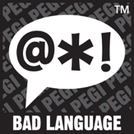
The game contains depictions of violence. In games rated PEGI 7 this can only be non-realistic or non-detailed violence. Games rated PEGI 12 can include violence in a fantasy environment or non-realistic violence towards human-like characters, whereas games rated PEGI 16 or 18 have increasingly more realistic-looking violence.
The game contains bad language. This descriptor can be found on games with a PEGI 12 (mild swearing), PEGI 16 (e.g. sexual expletives or blasphemy) or PEGI 18 rating (e.g. sexual expletives or blasphemy).

This descriptor may appear on games with a PEGI 7 if it contains pictures or sounds that may be frightening or scary to young children, or on PEGI 12 games with horrific sounds or horror effects (but without any violent content).

The game contains elements that encourage or teach gambling. These simulations of gambling refer to games of chance that are normally carried out in casinos or gambling halls. Games with this sort of content are PEGI 12, PEGI 16 or PEGI 18
The game refers to or depicts the use of illegal drugs, alcohol or tobacco. Games with this content descriptor are always PEGI 16 or PEGI 18.
The game contains depictions of ethnic, religious, nationalistic or other stereotypes likely to encourage hatred. This content is always restricted to a PEGI 18 rating (and likely to infringe national criminal laws).
What do you think the PEGI Ratings are of the following games? (some are still to be rated)

Merit/Dist - What EVIDENCE justifies your rating? (remember all of those symbols)

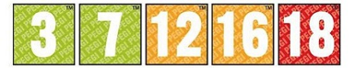

Merit/Dist - What EVIDENCE justifies your rating?

What do you think the PEGI Ratings are of the following games? (some are still to be rated)
Merit/Dist - What EVIDENCE justifies your rating?

Merit/Dist - What EVIDENCE justifies your rating?

Merit/Dist - What EVIDENCE justifies your rating?

