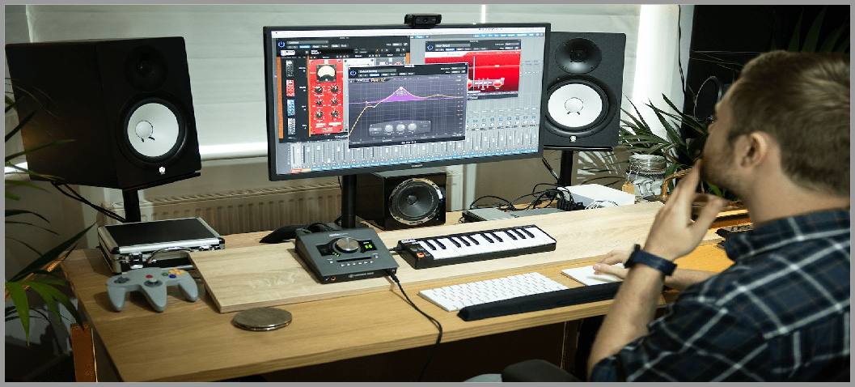

Music Technology Home Learning Pack

The best way for you to complete any work for Music Technology whilst school is closed is via Google Classroom.

To log-in search gmail in google, using your @stonesouplearns.com, then open Google Classroom,
and click on NCFE MUSIC TECHNOLOGY.

Work will be sent to your email account, with an accompanying video that will support and explain the work.

I will also be uploading tutorials on how to create music on soundtrap.com.

Alternatively this pack contains all the google classroom work you will be expected to complete.

Year 11 should aim to complete all the work in this pack. Year 10 should focus on EQ, and Balancing Sound Sources. Year 9 will need to focus on soundtrap projects.

IF YOU HAVE ANY QUESTIONS PLEASE EMAIL ME AT JOSHUA.GLOVER@STONESOUPLEARNS.COM

Balancing Sounds

Today
- Open your mixed track;
- Complete the slide;
- Answer questions about your track.

Complete the sentences.
I can use to control the volume of each individual track.

I can use to control which ear I hear my track in.

As a , I can change how my track sounds by mixing and panning my track.

Your Balanced Track

What did you change?

What makes your track unique?

- Volume;
- Faders;
- Panning;
- Which instruments?
- How does your track sound compared to the original?
- Listen to the original and compare it on youtube.

Write, record, or email me your answer for 3 extra points.

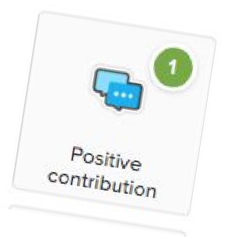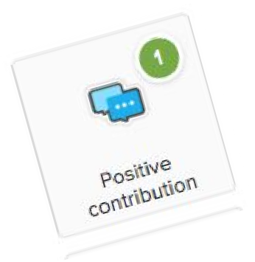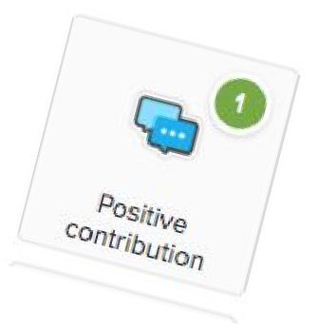Why is balance important in a track?

EQ

Cut, Boost, Enhance

Today
- Cut,
- Boost,
- Repair,
- Enhance.

What does EQ do?
I can use EQ to , and parts of my track.

I can how my track sounds by cutting and boosting certain frequencies.

EQ can be used to badly recorded audio.

Before and After

Before EQ
After EQ

- Sounded like…..
- Muffled?
- Flat???
- Sounded better because...
- Clearer?

Write, record, or email me your answer to this question to earn 3 extra positives.

Do you think EQ is essential?

EQ

Cut, Boost, Enhance

- Cut,
- Boost,
- Repair,
- Enhance.

Today

What does EQ do?
I can use EQ to , and parts of my track.

I can how my track sounds by cutting and boosting certain frequencies.

EQ can be used to badly recorded audio.

Before and After

Before EQ
After EQ

- Sounded like…..
- Muffled?
- Flat???
- Sounded better because...
- Clearer?

Write, record, or email me your answer to this question to earn 3 extra positives.

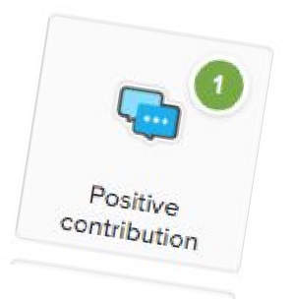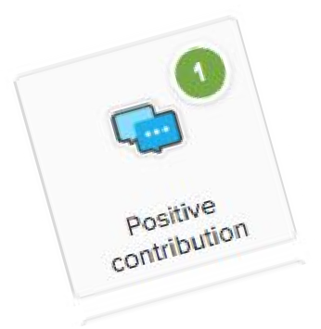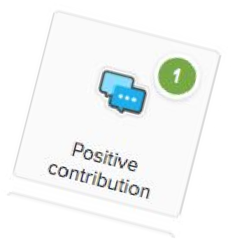Do you think EQ is essential?

Reverb & Delay

Creating Space

- Reverb,
- Delay,
- Repeat,
- Space.

Keywords

What does reverb and EQ do?
I can use reverb to add to audio. Delay can be creatively used to audio.
and are both effects that enhance the quality of audio.

Before and After

Effect of Reverb Effect of Delay
- What effect did reverb have on your track?
- How did it make it better?
- What effect did delay have on your track?
- How did it make it better?

Is there a difference
Write, record, or email your answer to earn 3 extra points.

between reverb and delay?

Understanding MIDI

Adding Virtual Instruments

- Pencil,
- Velocity,
- Input,
- Virtual

Keywords

What does MIDI do?

I can use the tool to add in notes to instruments.

I can control the volume of each note of my track by using the tool.

I can notes onto instruments to make music.

How did tools help you create music?

Pencil Tool Velocity Tool
- What does the pencil tool do?
- Could you edit the size of notes?
- How did repeating notes improve the quality of your drums?
- What does the velocity tool do?
- How did it help you control volume?
- What impact did this have on your music?

Write, record, or email me your answer for 3 extra points.

Is it cheaper to use virtual instruments?

EDITING AUDIO/MIDI

Your name here!!!

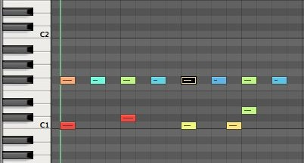
Match Tools to Audio or MIDI
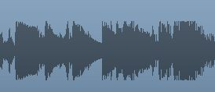
AUDIO MIDI

Fill in the Blanks

I can edit audio using the , and tools.

We can edit MIDI by using the , and tools.

When cutting audio using the tool stops the audio from clipping/popping.

How does audio editing improve your track?
How does MIDI editing improve your track?

1.

2.

3.
1.

2.

3.

LEVELS
(1) EMERGING: I understand the difference between editing Audio, and MIDI in Logic, and some of the tools I have used.
(2) DEVELOPING: I can apply a different set of tools to edit Audio, and MIDI to improve my track.

(3) MASTERY: I am creatively using both Audio and MIDI editing features to enhance the quality of my track.

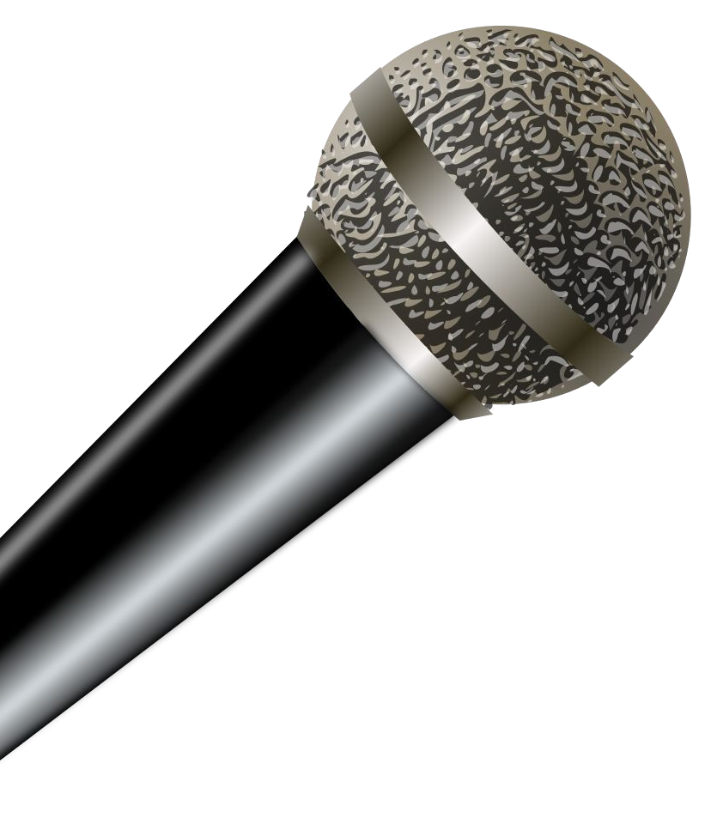
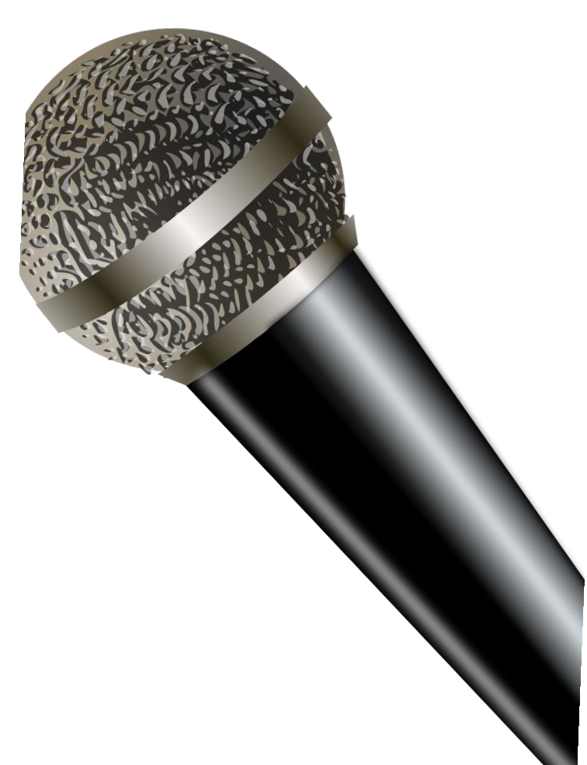
Your Compilation

Creating Transitions

- Transition
- Compilation
- Fade Tool
- Scissor Tool

Keywords

Creating Transitions

- What does it do?
- How did it improve your music?
- How did the scissor tool help you create transitions?
- What does it do?
- How did it improve your music?
- How did the fade tool help you create transitions?

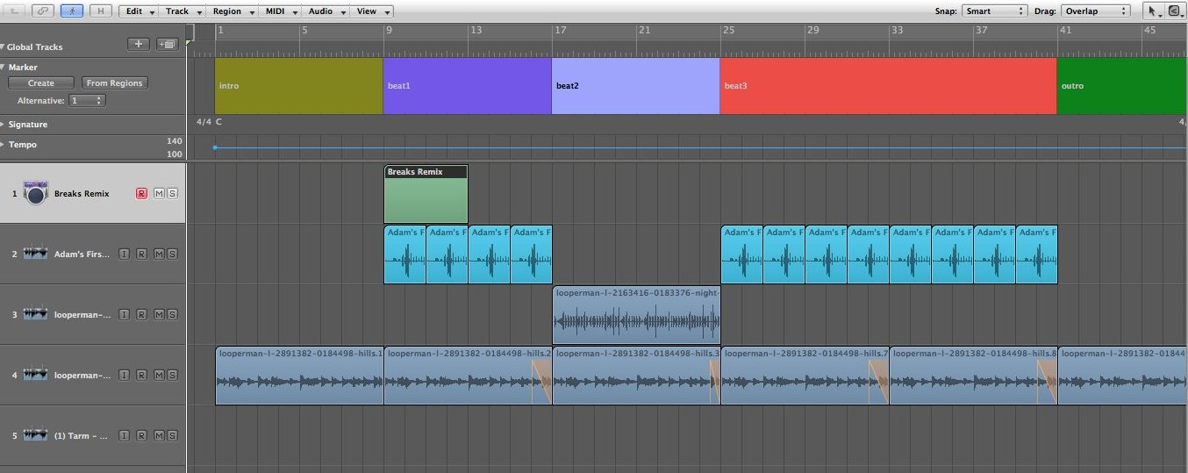

Audio
Virtual Instrument
Marker s

ANNOTATED SCREENSHOT

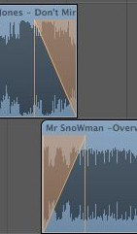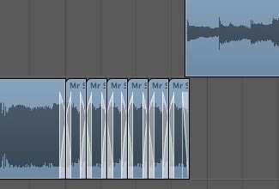Identify the Transitions
Fade Out
Cut and Repeat
Speed Up/Slow Down

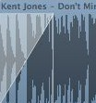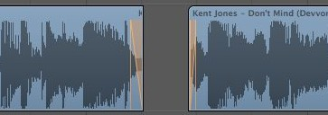

Fade In
Cut and Mute

Does creating transitions improve a compilation?

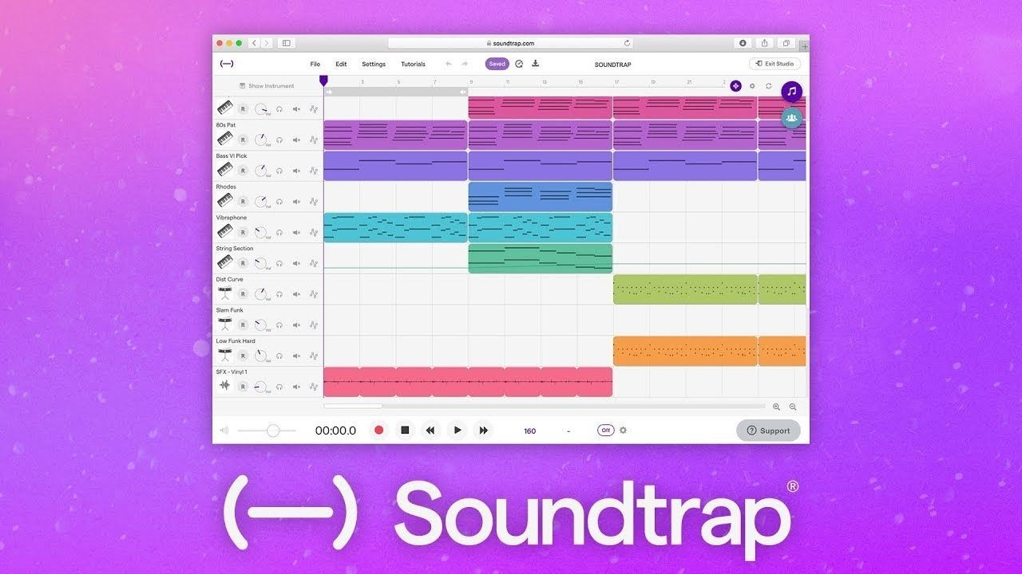

Making Music at Home

Search for ‘soundtrap’ in your browser, or on any app store and log in using your @stonesouplearns.com account.

Then search, or click on ‘soundtrap tutorials’ for an introduction to the software.

Below are some details explaining what you are looking at:

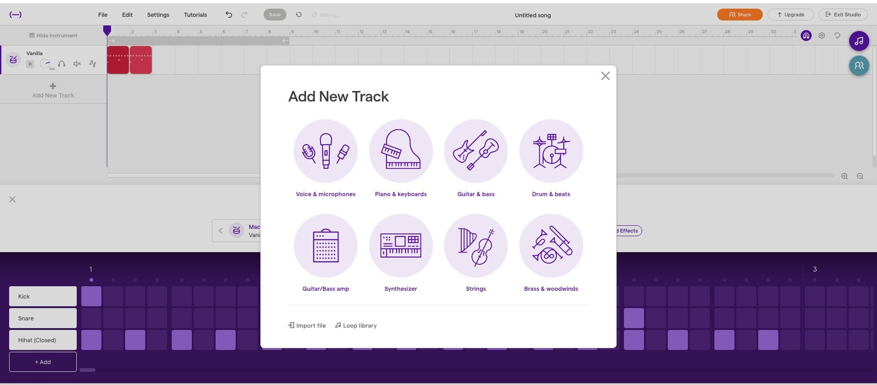

Add Drums

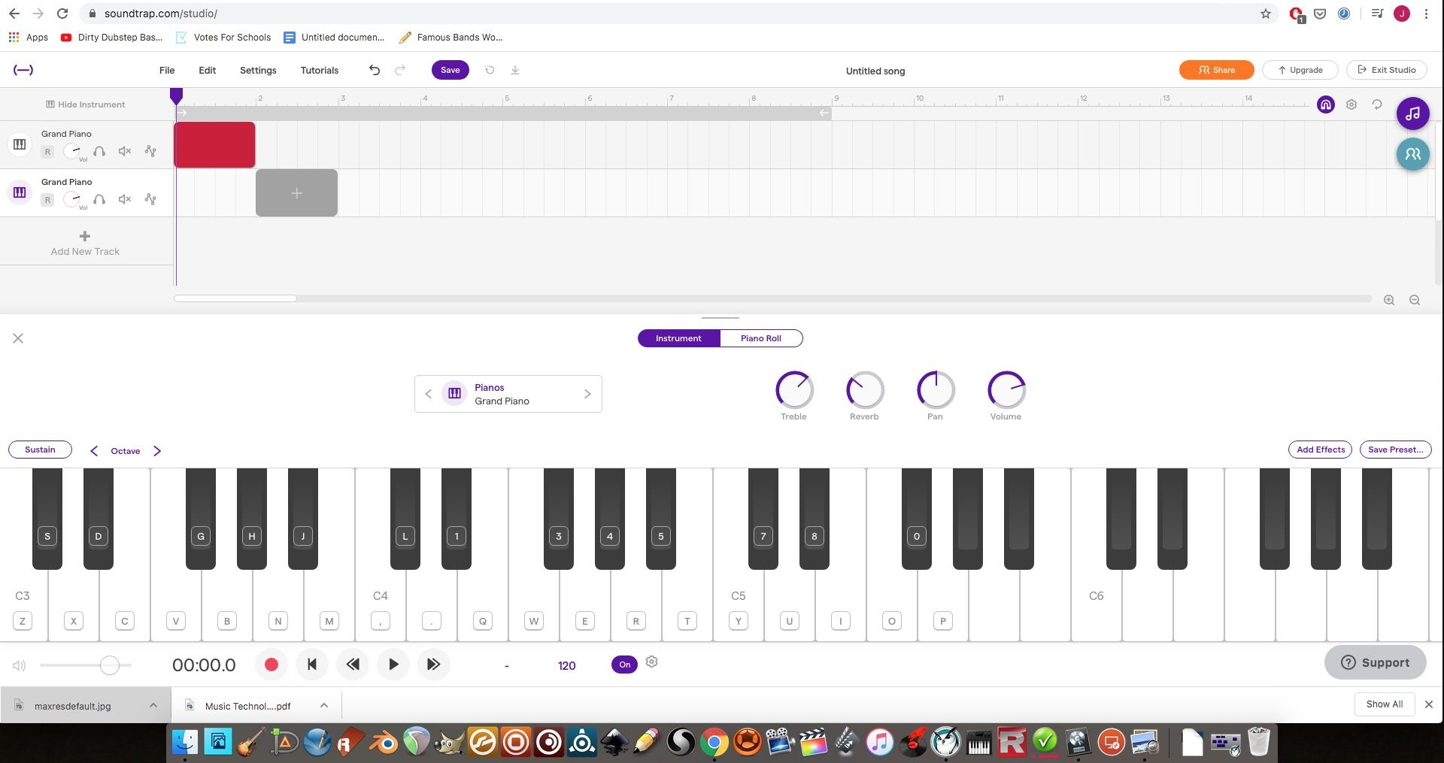
Add New Track

Play Using Keyboard

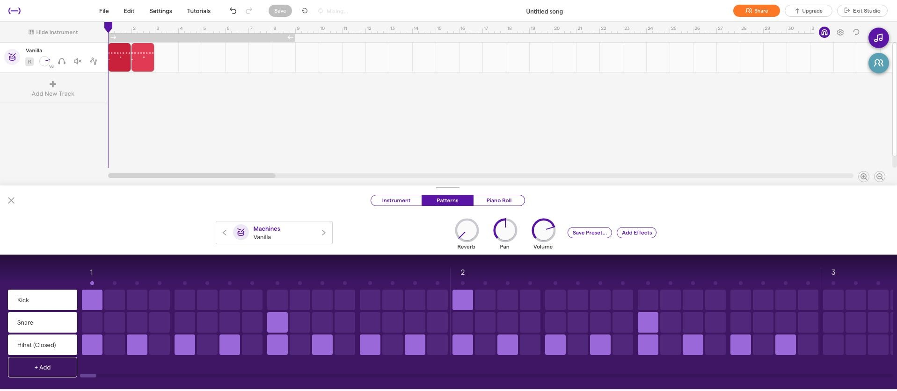

Turn On/Off Loop

Copy Drum Pattern

Click on Loop Library

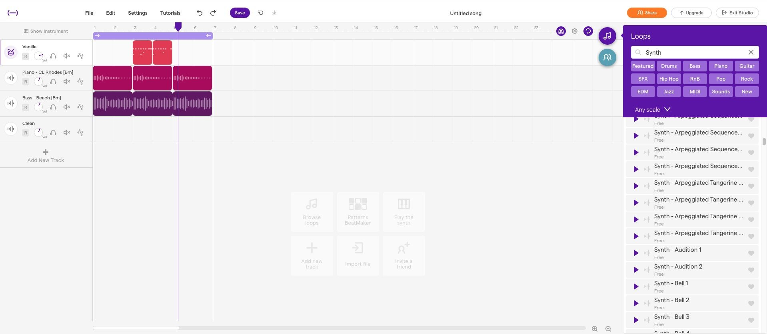

Search for Loops.

Click, drag and hold ones you like into your project.

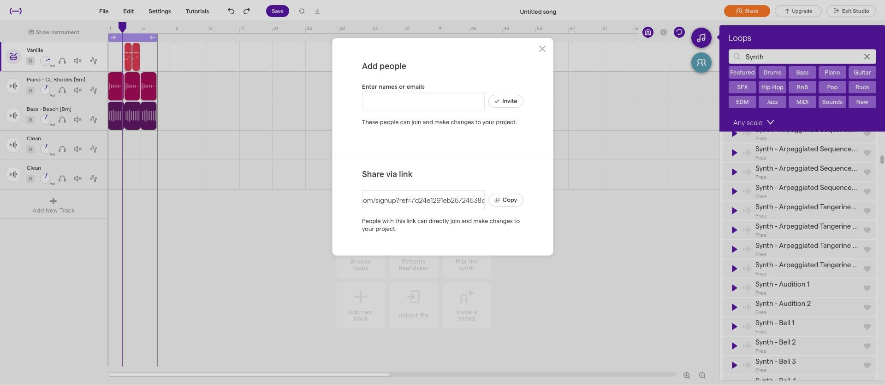

Click SHARE

Send to joshua.glover@stonesouplearns.com when you have a project you’re enjoy.

