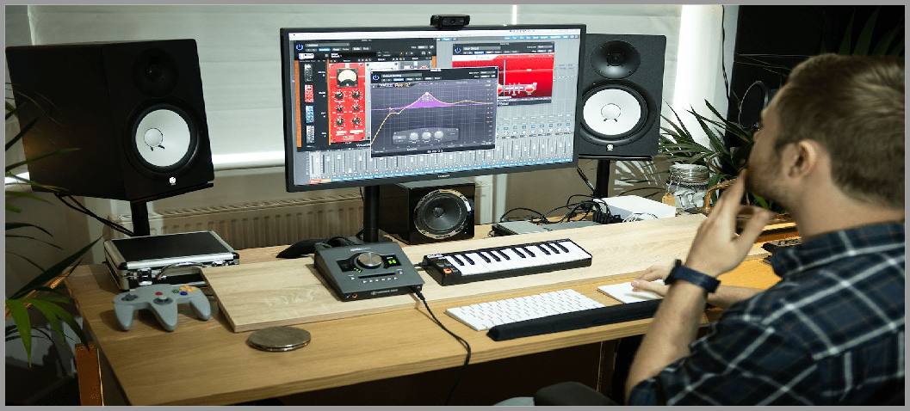

Music Technology Home Learning Pack

The best way for you to complete any work for Music Technology whilst school is closed is via Google Classroom.

To log-in search gmail in google, using your @stonesouplearns.com, then open Google Classroom,
and click on NCFE MUSIC TECHNOLOGY.

Work will be sent to your email account, with an accompanying video that will support and explain the work.

I will also be uploading tutorials on how to create music on soundtrap.com.

Alternatively this pack contains all the google classroom work you will be expected to complete.

Year 11 should aim to complete all the work in this pack. Year 10 should focus on EQ, and Balancing Sound Sources. Year 9 will need to focus on soundtrap projects.

IF YOU HAVE ANY QUESTIONS PLEASE EMAIL ME AT JOSHUA.GLOVER@STONESOUPLEARNS.COM

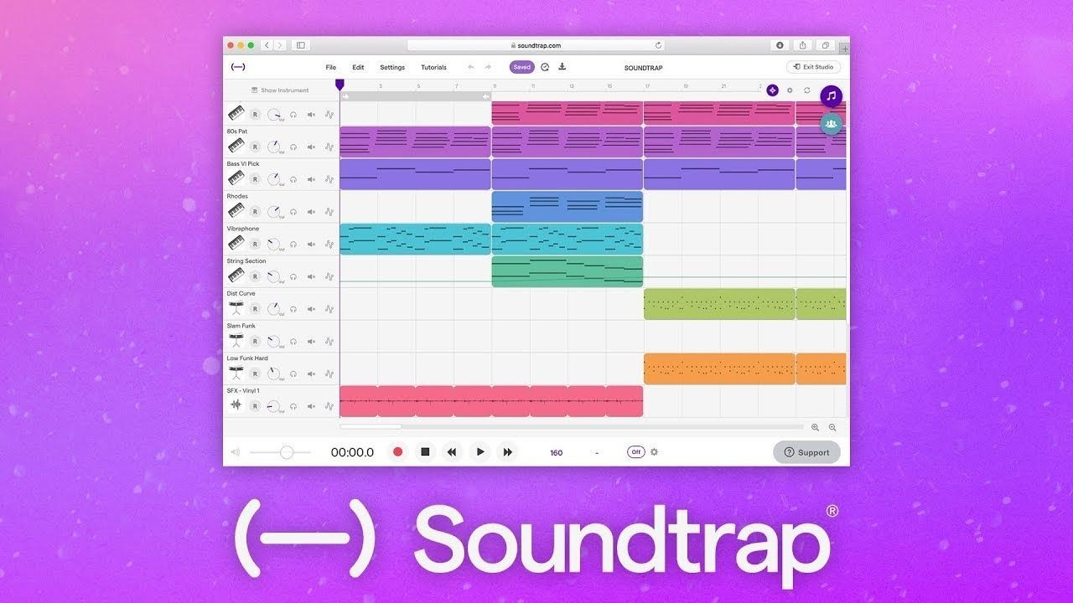

Making Music at Home

Search for ‘soundtrap’ in your browser, or on any app store and log in using your @stonesouplearns.com account.

Then search, or click on ‘soundtrap tutorials’ for an introduction to the software.

Below are some details explaining what you are looking at:

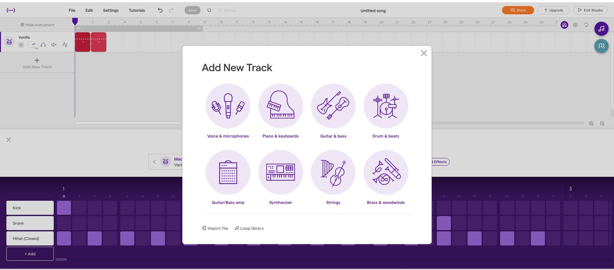

Add Drums

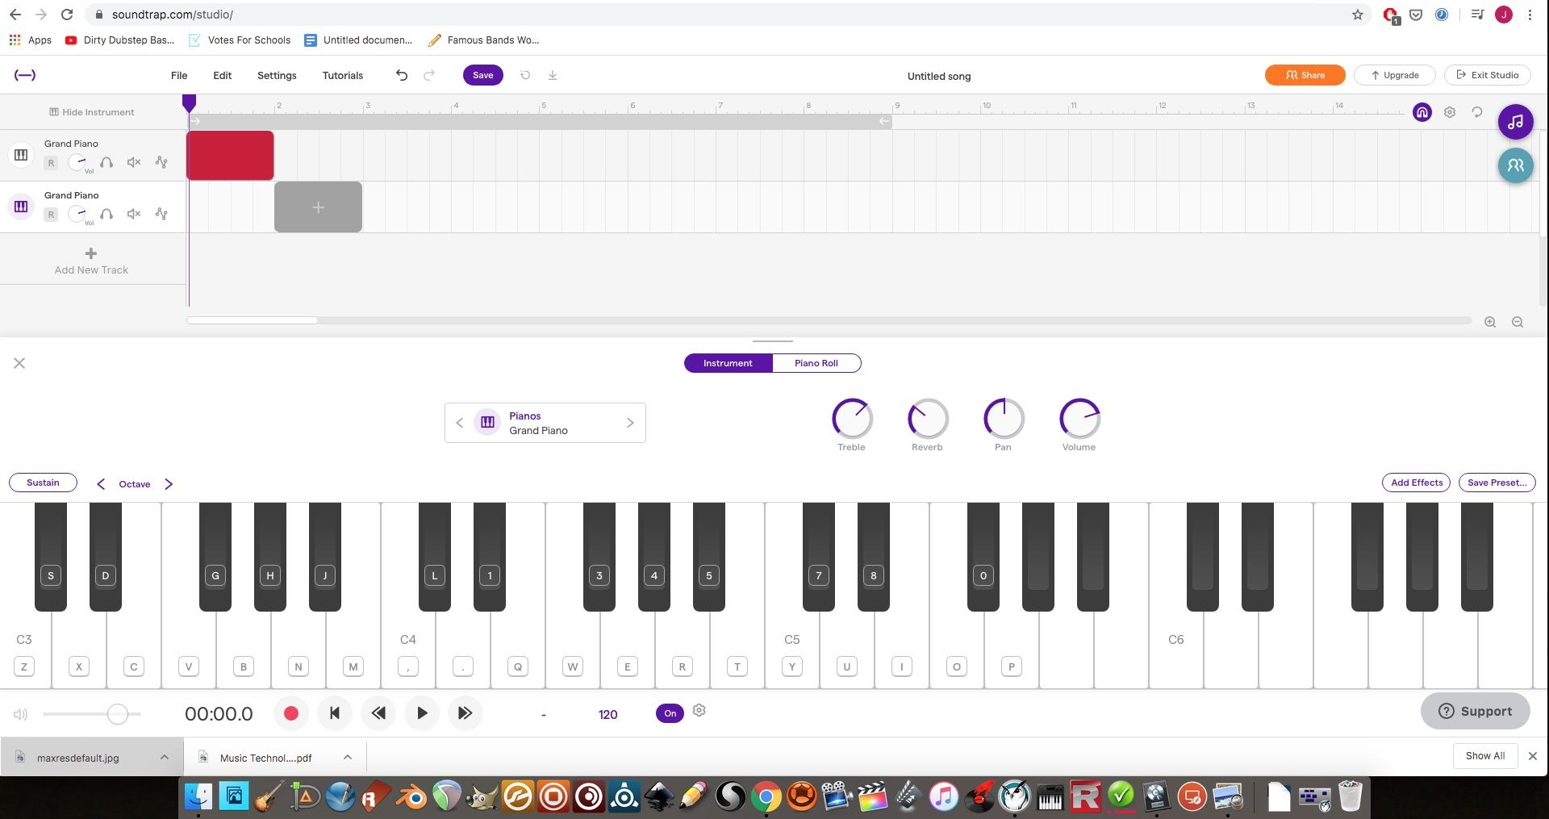
Add New Track

Play Using Keyboard

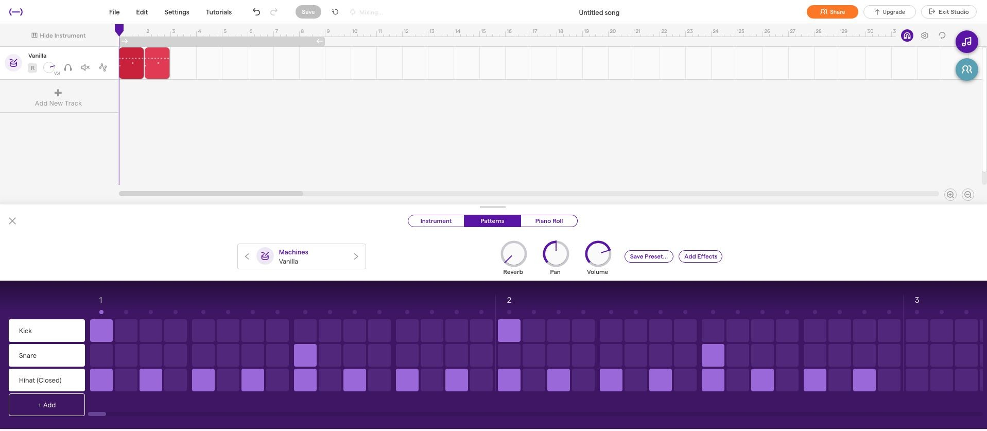

Turn On/Off Loop

Copy Drum Pattern

Click on Loop Library

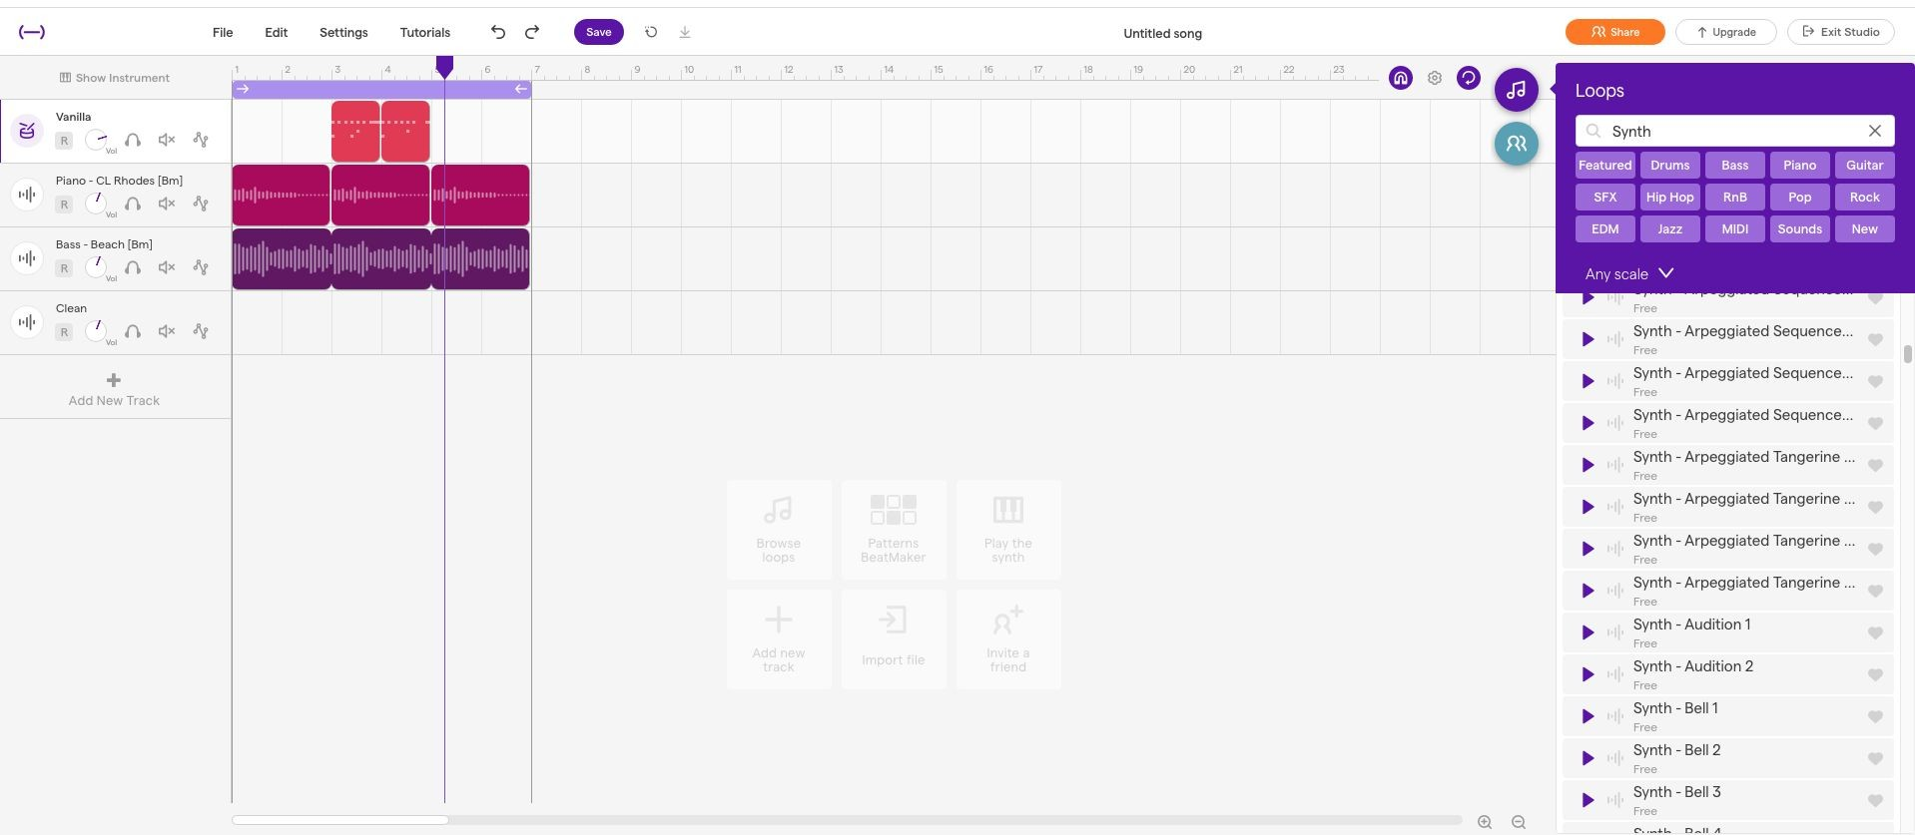

Search for Loops.

Click, drag and hold ones you like into your project.

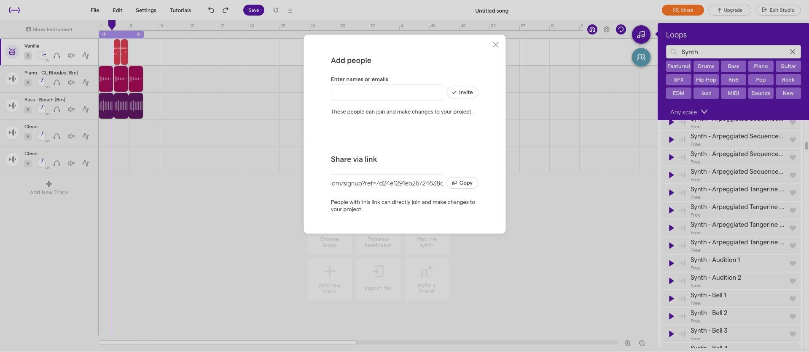

Click SHARE

Send to joshua.glover@stonesouplearns.com when you have a project you’re enjoy.

B est of the Decade: Top Selling Songs

Find,research, listen, and rate the top selling songs of the decades below. Rate it out of ten, and write the first three words that come to your mind when you listen to it.

1920s

Artist:

Song:

Rate it (out of ten):

Three words:

1 930s

Artist:

Song:

Rate it (out of ten):

Three words:

1 940s

Artist:

Song:

Rate it (out of ten):

Three words:

1950s

Artist:

Song:

Rate it (out of ten):

Three words:
1960s

Artist:

Song:

Rate it (out of ten): Three words:

1 970s

Artist:

Song:

Rate it (out of ten): Three words:
1980s

Artist:

Song:

Rate it (out of ten): Three words:
1990s

Artist:

Song:

Rate it (out of ten): Three words:

2 000s

Artist:

Song:

Rate it (out of ten): Three words:
2 010s

Artist:

Song:

Rate it (out of ten): Three words:

B est of the Decade: Top Selling Songs

Find,research, listen, and rate the top selling songs of the decades below. Rate it out of ten, and write the first three words that come to your mind when you listen to it.

1920s

Artist:

Song:

Rate it (out of ten):

Three words:

1 930s

Artist:

Song:

Rate it (out of ten):

Three words:

1 940s

Artist:

Song:

Rate it (out of ten):

Three words:

1950s

Artist:

Song:

Rate it (out of ten):

Three words:
1960s

Artist:

Song:

Rate it (out of ten): Three words:

1 970s

Artist:

Song:

Rate it (out of ten): Three words:
1980s

Artist:

Song:

Rate it (out of ten): Three words:
1990s

Artist:

Song:

Rate it (out of ten): Three words:

2 000s

Artist:

Song:

Rate it (out of ten): Three words:
2 010s

Artist:

Song:

Rate it (out of ten): Three words:
2020s

Artist:

Song:

Rate it (out of ten): Three words:

