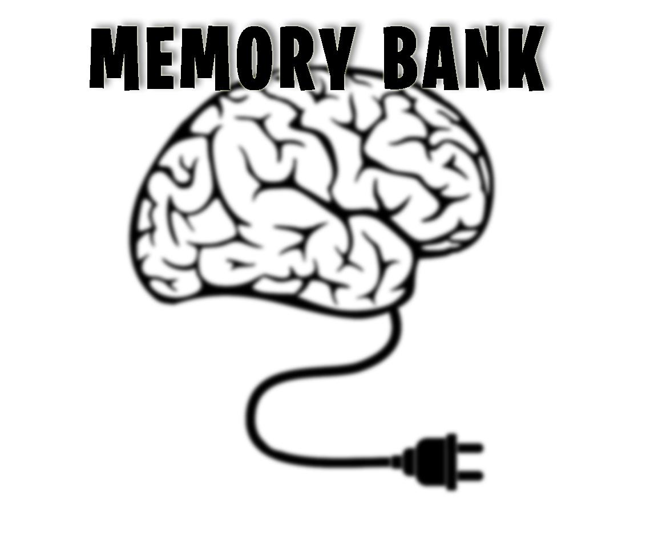To help you prepare for exam resit, test your memory on these key terms.

Q1. There are 4 Media Sectors and they are: TV, Publishing, Games and Website
TRUE FALSE

Q2. There are 5 Media Sectors and they are: Moving Image, Publishing, Games, Website and Audio
TRUE FALSE

Q3. You will be expected to know about both Digital and Analogue media Types
TRUE FALSE

Q4. BBC News Website is an example of an Analogue media type.
TRUE FALSE

Q5. BBC iPlayer is a media Device.
TRUE FALSE

CONNOTATION
This is the billboard poster for upcoming Sky TV drama, Temple.
Use your knowledge of CONNOTATION to explain what this show is about. What are the clues and how do they generate meaning?

↓↓↓↓↓↓
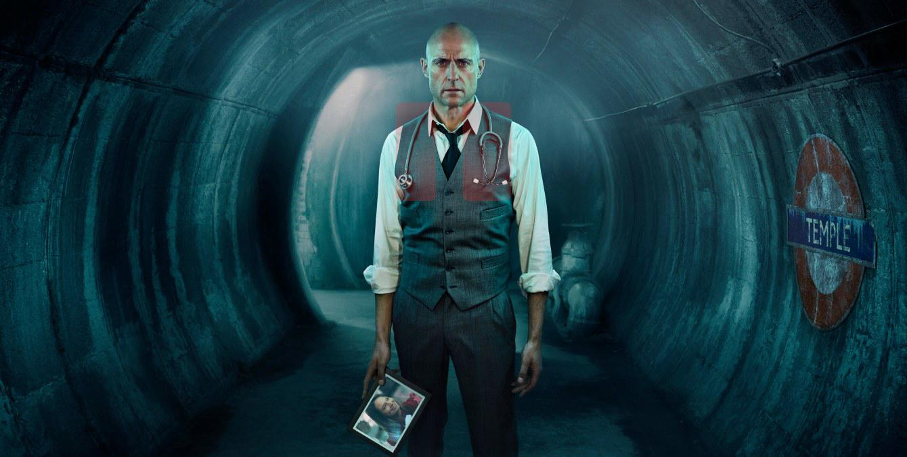

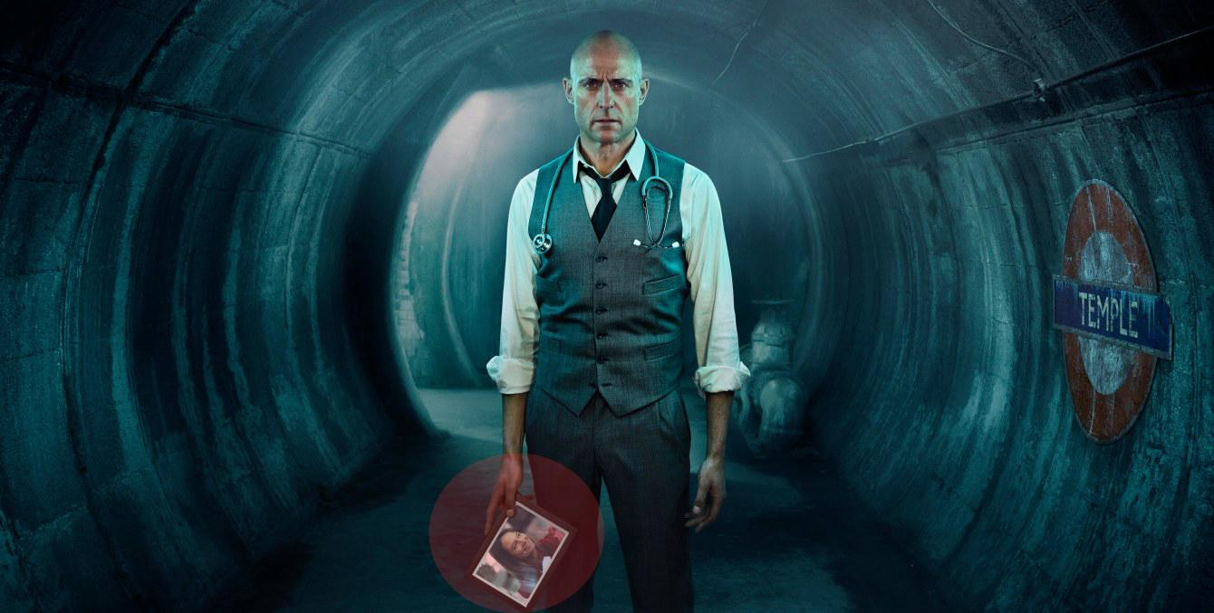

If you think Clive is wrong, put your corrections in the box!

- Media has 6 sectors.

2. These 6 sectors are AUDIO, WEB, FILM, TV, GAMES, PUBLISHING.

3. Batman is an example of publishing media.

4. Every media product can only belong in ONE sector.

5. Fortnite is an example of games media.

To help you prepare for exam resit, test your memory on these key terms.

Q1. There are 5 Media Sectors and they are: Moving Image, Publishing, Games, Website and Audio
TRUE FALSE

Q3. BBFC set the rules for age ratings on films
TRUE FALSE

Q3. The 5 stages of Production are
Pre-Production / Production / Post-Production /Distribution / Exhibition
TRUE FALSE

Q4. BBC iPlayer is a media Device.
TRUE FALSE

Q5. Age and Gender are DEMOGRPAHICs.
TRUE FALSE

Q6. Analogue media products still exist in the 21st Century.
TRUE FALSE

Q7. ASA stands for the Advertising Services Association.
TRUE FALSE

Q8. iTunes is a media platform.
TRUE FALSE

Q9. Youtube offers users an “interactive” experience.
TRUE FALSE

Q10. Watching a streaming service is an example of group consumption.
TRUE FALSE

If you think Clive is wrong, put your corrections in the box!

Your Example

1. (Statement)__________________________________________________________________________________________________

2. ______________________________________________________________________________________________________________

3. _______________________________________________________________________________________________________________

4. _________________________________________________________________________________________________________________

If you think Erica is wrong, put your corrections in the box!

NAME:

Date:

- 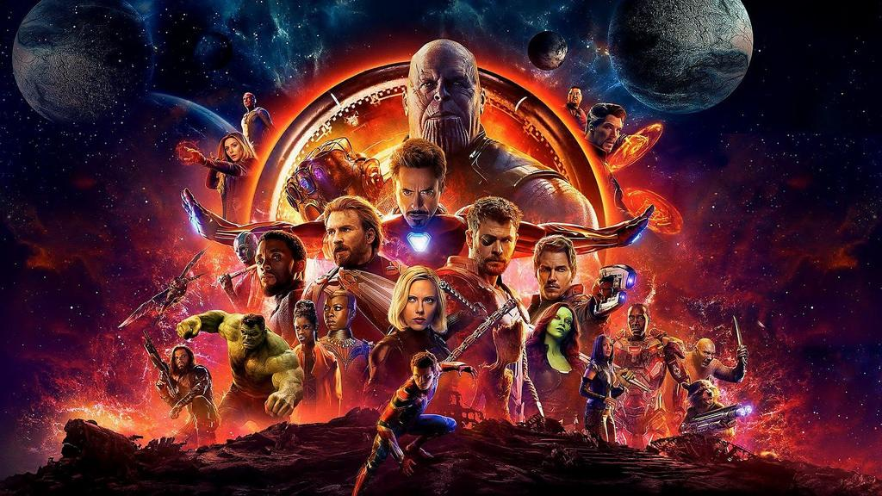
Avengers Infinity War belongs in Audio Sector.

2. Avengers Infinity War is a Digital product

3. Avengers Infinity War is NOT an example of synergy.

4. The platforms it is available on include Digital Download and DVD.

5. Avengers Infinity War’s Primary Audience is under 10s

6. Avengers Infinity War’s Secondary Audience is ABC1 men and women

7. Avengers Infinity War Pre-Production tasks were jobs such as music and special effects.

8. Avengers Infinity War can be viewed on devices such as a games console, a TV, a Computer, a DVD player, a mobile device and a tablet.

KEY MEDIA VOCABULARY REVISION, for exam resit.
Just scan these codes with your smart device and it will take you to the site.

https://tiny.cards/decks/7gRyPdqp/analogue-or-digital-media

https://tiny.cards/decks/7gxXzpNX/name-the-sector

https://tiny.cards/decks/7gxybNLo/sector-platform-or-device

https://tiny.cards/decks/7d7R7d3B/essential-vocabulary

https://tiny.cards/decks/7gPQi2QS/camera-shots-and-angles

Stage 2, more Advanced.
https://tiny.cards/decks/7gyeVAWj/media-regulation

https://tiny.cards/decks/7gRw8JTa/pegi-regulation-games
https://tiny.cards/decks/7gyGQNBF/audience

FLASH CARDS for revising key vocabulary

https://quizlet.com/229837107/october-17-creative-digital-media-production-unit-1-flash-cards/

https://quizlet.com/216191191/learn

https://quizlet.com/300579934/match

https://quizlet.com/268953156/feb-2018-vocab-booster-flash-cards/

