VOCABULARY ESSENTIALS

Synergy
Synergy is the concept where media producers will attempt to sell its product using many different sectors - audio, moving image, games, web, publishing.
If a book and film are linked, e.g - Harry Potter, this is synergy because the profit value of each will be more. Therefore the product value is more than the value of two separate products.
You need to understand the importance of synergy for the industry and to be able to identify and discuss examples.

Beginner…..
  Synergy?  True or False |   Synergy?  True or False

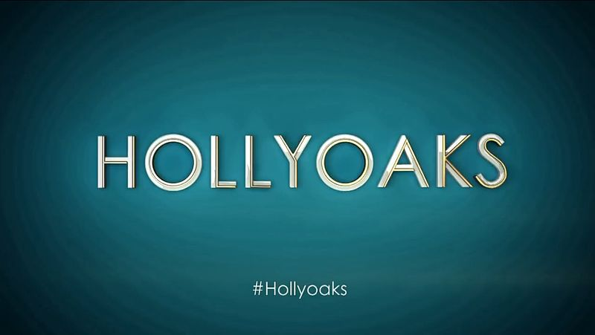  Synergy?  True or False |   Synergy?  True or False
Advanced

Benefits of synergy?

Drawbacks of synergy?

