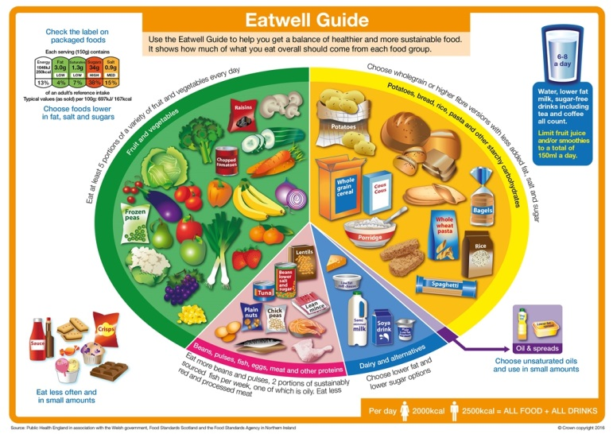

**The Eatwell Guide**

In the UK, the healthy eating model is known as the Eatwell Guide.

**The food groups**

**Fruit and vegetables**

**Potatoes, bread, rice, pasta and other starchy carbohydrates**

**Beans, pulses, fish, eggs, meat and other proteins**

**Dairy and alternatives**

**Oils and spreads**

**Key messages**

**Eat at least 5 portions of a variety of fruit and vegetables every day.**

**Base meals on potatoes, bread, rice, pasta or other starchy carbohydrates; choosing wholegrain versions where possible.**

**Eat some beans, pulses, fish, eggs, meat and other proteins (including 2 portions of fish every week, one of which should be oily).**

**Have some dairy or dairy alternatives (such as soya drinks); choosing lower fat and lower sugar options.**

**Choose unsaturated oils and spreads and eat in small amounts.**

**Drink 6-8 cups/glasses of fluid a day.**

**If consuming foods and drinks high in fat, salt or sugar have these less often and in small amounts.**

Fruit and vegetables should make up just over a third of the food we eat each day.

Aim to eat at least five portions of a variety of fruit and vegetables each day.

Choose from fresh, frozen, canned, dried or juiced.



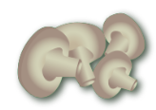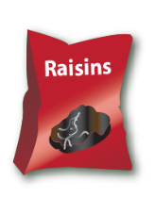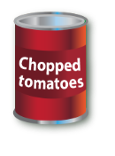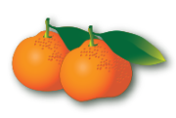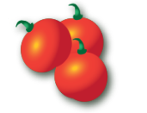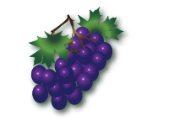

**Fruit and vegetables**

A portion is 80g or any of these:

* 1 apple, banana, pear, orange or other similar-size fruit;
* 3 heaped tablespoons of vegetables;
* a dessert bowl of salad;
* 30g of dried fruit   
  (counts as a maximum of one portion a day);
* 150ml glass of fruit juice or smoothie   
  (counts as a maximum of one portion a day).

**Potatoes, bread, rice, pasta and other starchy carbohydrates**

Starchy food should make up just over a third of the   
food we eat.

Choose higher-fibre, wholegrain varieties when you can by purchasing wholewheat pasta, brown rice, or simply leaving the skins on potatoes.



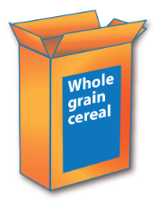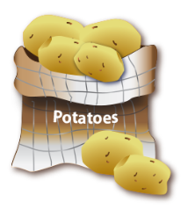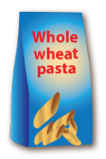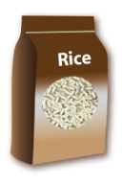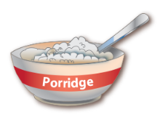

**Why choose wholegrain?**

Wholegrain food contains more fibre than white or refined starchy food, and often more of other nutrients. We also digest wholegrain food more slowly so it can help us feel full for longer.

Remember, you can also purchase high fibre white versions of bread and pasta which will help to increase your fibre intake.





**Potatoes, bread, rice, pasta and other starchy carbohydrates**

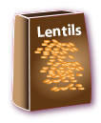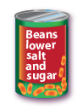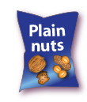

**Beans, pulses, fish, eggs, meat and other proteins**

These foods are sources of protein, vitamins and minerals, so it is important to eat some foods from this group.

Beans, peas and lentils (which are all types of pulses, sometimes called ‘legumes’) are good alternatives to meat because they’re naturally very low in fat, and they’re high in fibre, protein and vitamins and minerals. Other vegetable-based sources of protein include tofu, bean curd and mycoprotein.

Aim for at least two portions (2 x 140g) of fish a week, including a portion of oily fish. Most people should be eating more fish, but there are recommended limits for oily fish, crab and some types of white fish.*

**\*Please see** [**www.nhs.uk/Livewell/Goodfood/Pages/fish-shellfish.aspx**](http://www.nhs.uk/Livewell/Goodfood/Pages/fish-shellfish.aspx)  **Also** [**www.msc.org/**](http://www.msc.org/) **for more guidance on sustainably sourced fish.**



Some types of meat are high in fat, particularly saturated fat. So when you’re buying meat, remember that the type of cut or meat product you choose, and how you cook it, can make a big difference.

If you eat more than 90g of red or processed meat per day, try to cut down to no more than 70g per day. The term processed meat includes sausages, bacon, cured meats and reformed meat products.





**Beans, pulses, fish, eggs, meat and other proteins**

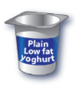

* Try to have some milk and dairy food (or dairy alternatives) such as cheese, yoghurt and fromage frais.
* These are good sources of protein and vitamins, and they’re also an important source of calcium, which helps to keep our bones strong.
* Some dairy food can be high in fat and saturated fat, but there are plenty of lower-fat options to choose from.



**Dairy and alternatives**

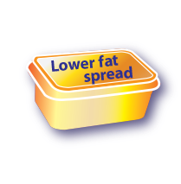

Although some fat in the diet is essential, generally we are eating too much saturated fat and need to reduce our consumption.

Unsaturated fats are healthier fats that are usually from plant sources and in liquid form as oil, for example vegetable oil, rapeseed oil and olive oil.

Swapping to unsaturated fats will help to reduce cholesterol in the blood, therefore it is important to get most of our fat from unsaturated oils.

Choosing lower fat spreads, as opposed to butter, is a good way to reduce your saturated fat intake.

Remember that all types of fat are high in energy and should be limited in the diet.

**Oils and spreads**

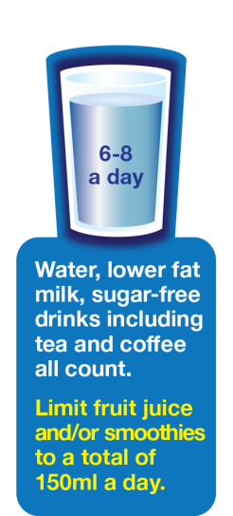

Aim to drink 6-8 glasses of fluid every day.

Water, lower fat milk and sugar-free drinks including tea and coffee all count.

Fruit juice and smoothies also count towards your fluid consumption, although they are a source of free sugars and so you should limit consumption to no more than a   
combined total of 150ml per day.

Sugary drinks are one of the main contributors to excess sugar consumption amongst children and adults in the UK.

Swap sugary soft drinks for diet, sugar-free or no added sugar varieties to reduce your sugar intake in a simple step.

**Hydration**

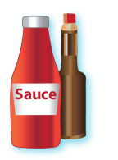

This includes products such as chocolate, cakes, biscuits, full-sugar soft drinks, butter and ice-cream.

These foods are not needed in the diet. If they are included, have infrequently and in small amounts.

If you consume these foods and drinks often, try to limit their consumption so you have them less often and in smaller amounts. Food and drinks high in fat and sugar contain lots of energy, particularly when you have large servings.

Check the label and avoid foods which are high in fat,   
salt and sugar!

**Foods high in fat, salt and sugars**



Eat the seasons



**What are seasonal foods?**

Seasonal food is the time of year when food is at its best, in terms of flavour or harvest.

Many foods are available all year, as they are imported from other countries.

When local seasonal food is available it tends to be fresher and cheaper - there has been less travel/storage from farm to fork.

WHY EAT THE SEASONS?

There are a number of good reasons to eat more local, seasonal food:

to reduce the energy (and associated CO2 emissions) needed to grow and transport the food we eat to avoid paying a premium for food that is scarcer or has travelled a long way

to support the local economy

to reconnect with nature's cycles and the passing of time

But most importantly,

seasonal food is fresher and so tends to be tastier and more nutritious

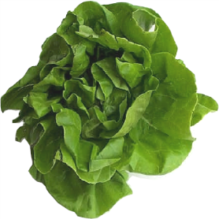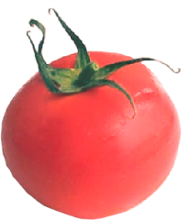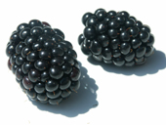

* Foods are usually harvested when they are at their peak and typically have the most flavour and nutrients, so the food tends to be tastier, healthier and better for the environment.
* Take a look at the seasons to see when different foods are at their best.
* Eat seasonal foods.

**Why seasonal food?**

   

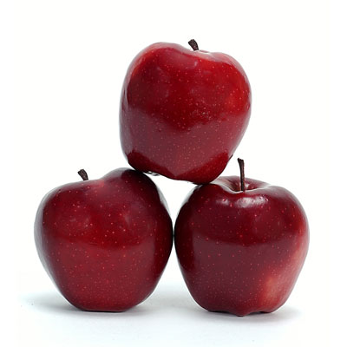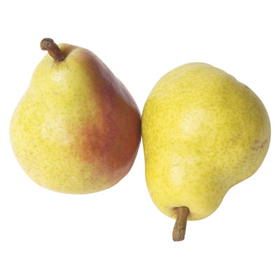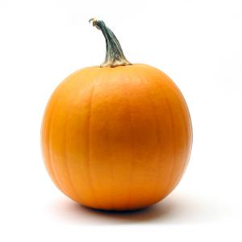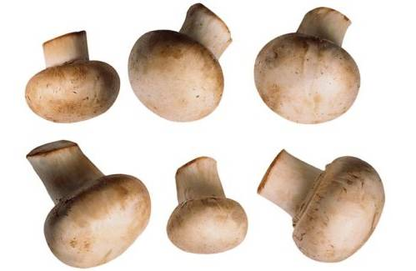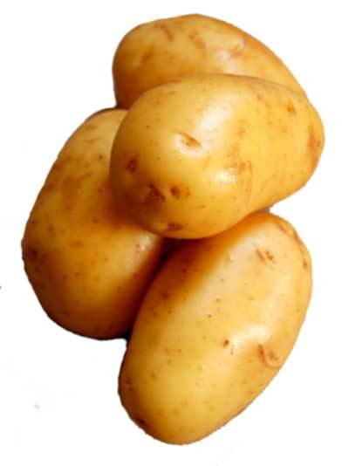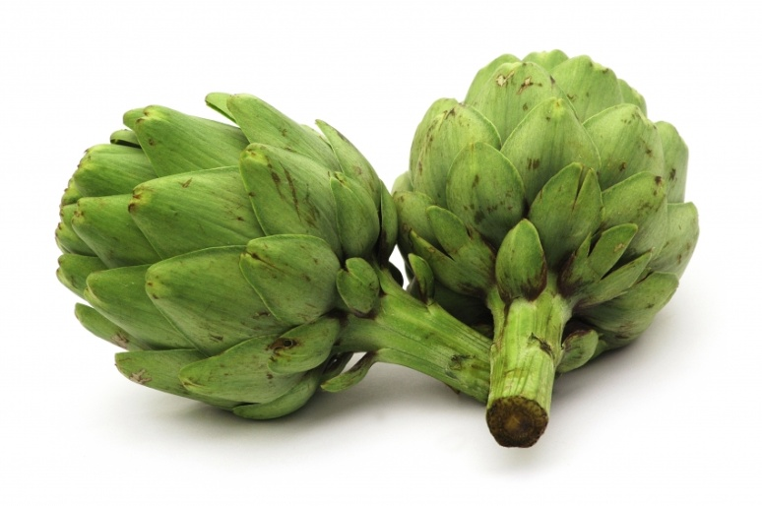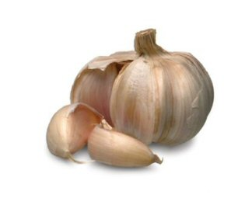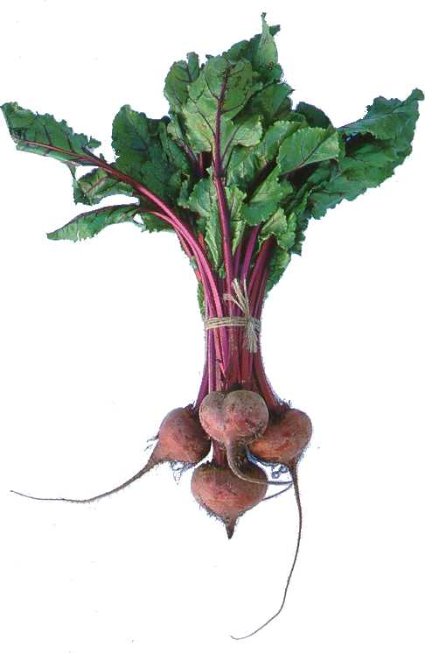

Autumn

Fruit and Vegetables

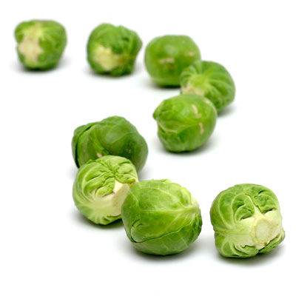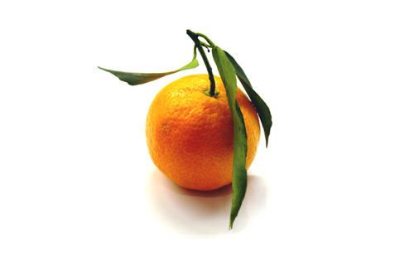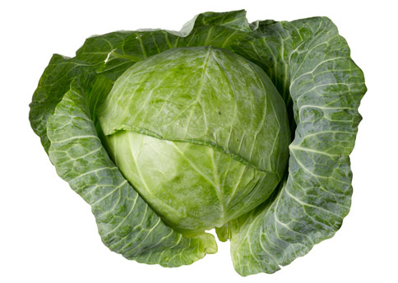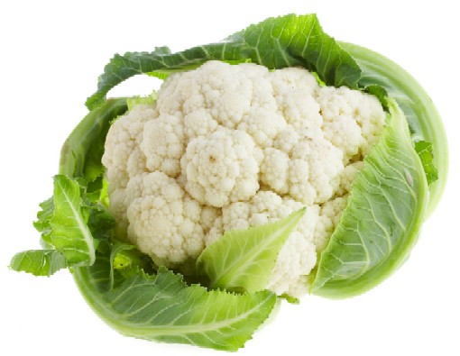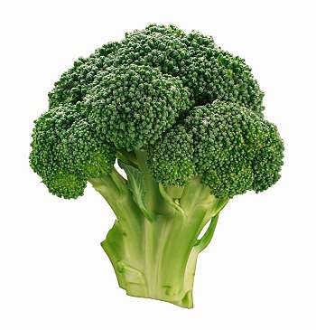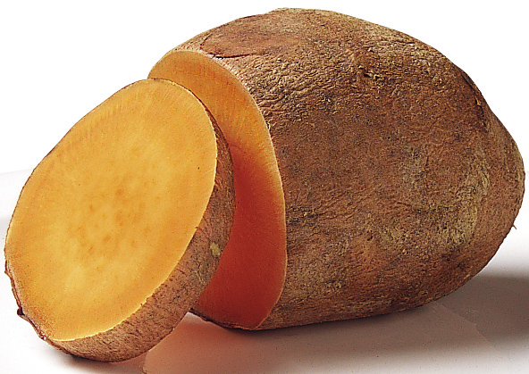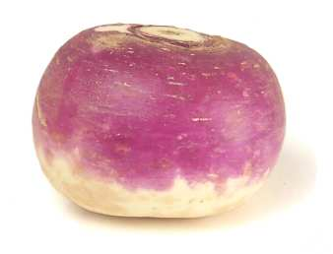

Winter

Fruit and Vegetables

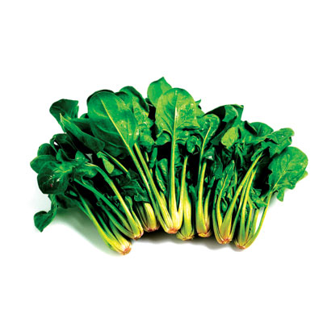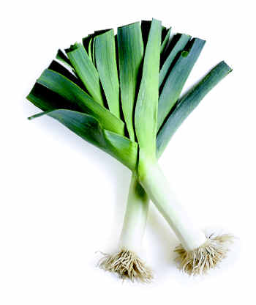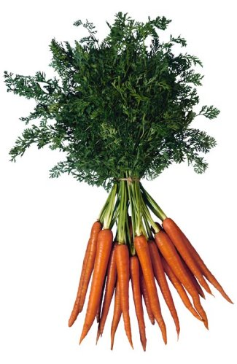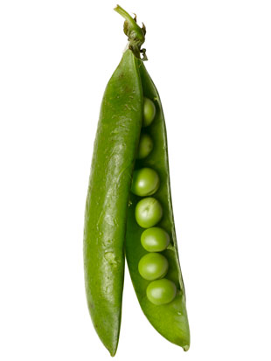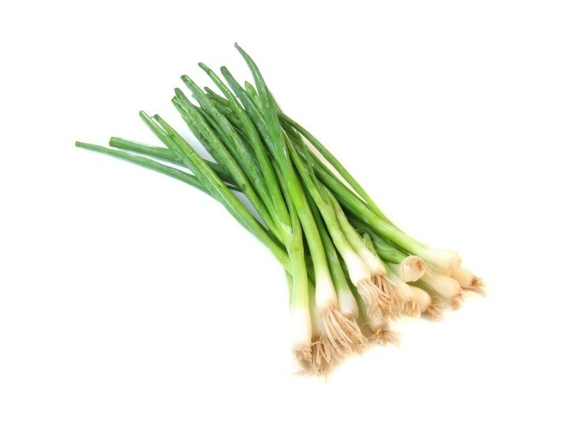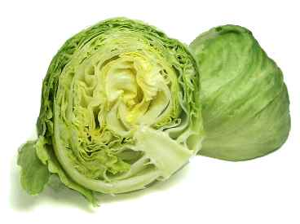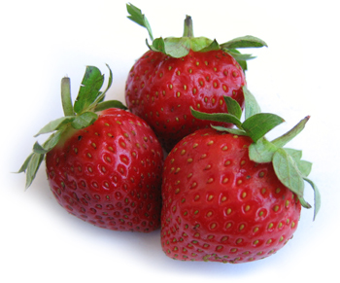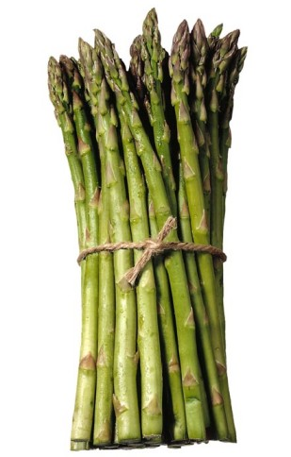

Spring

Fruit and Vegetables

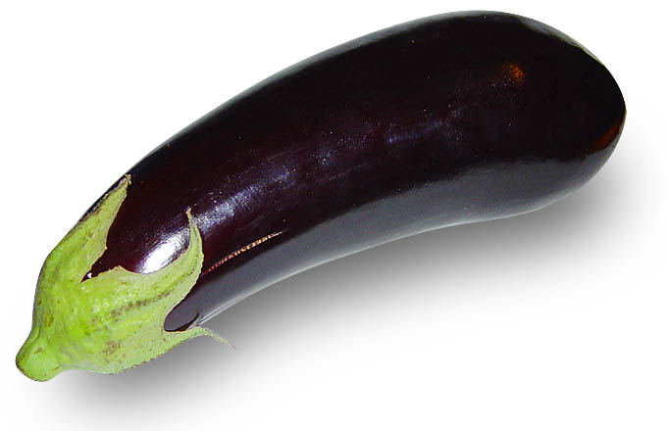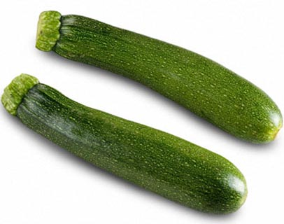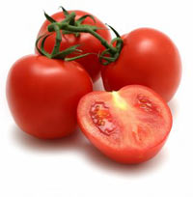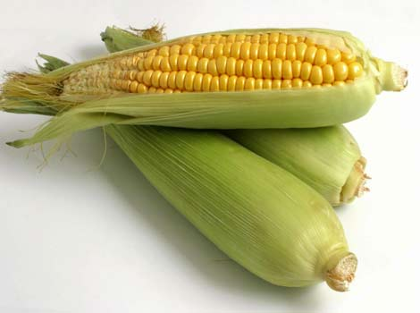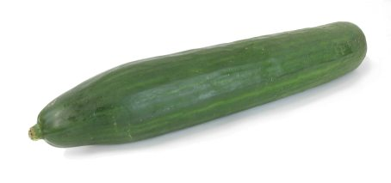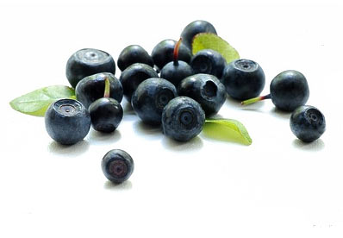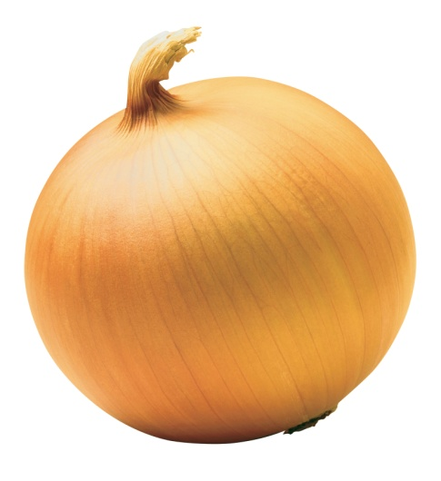

Summer

Fruit and Vegetables

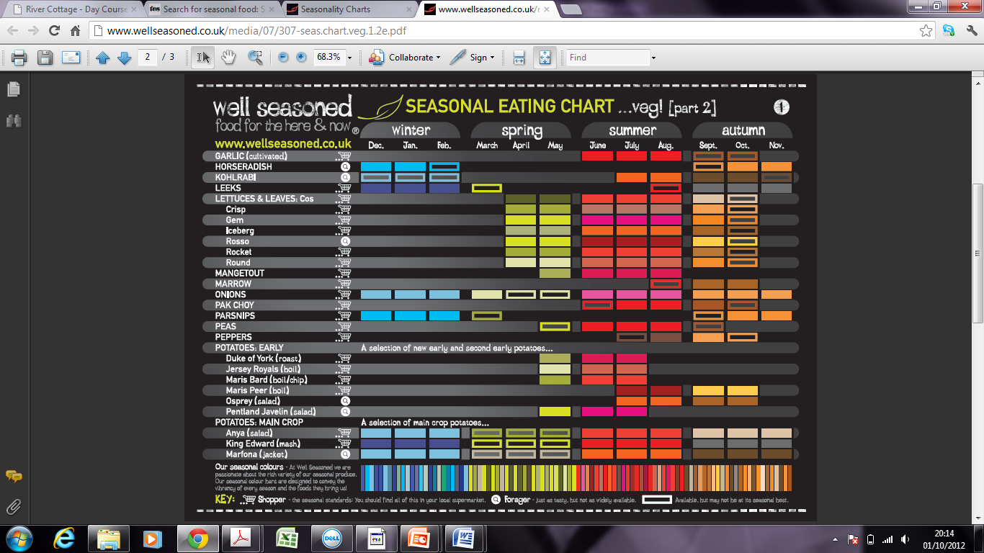



**Factors affecting food choice**



**Balanced diet**

Eating the right balance of a wide range of foods provides most people with the energy and nutrients that they need to stay healthy.

A balanced diet, together with regular physical activity, can help people to maintain a healthy weight and may reduce their chance of developing diet related illness, such as obesity.

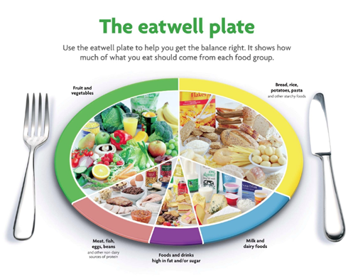

**The guide for a balanced diet**

All around the world people choose to eat different foods for many different reasons.

The eatwell plate provides guidance in the UK on how everyone can achieve a healthy varied diet.

**Factors influencing food choice**

Food choices for a balanced diet depend on many factors, such as:

• individual energy and nutrient needs;

• health concerns;

• cultural or religious practices;

• cost;

• food availability;

• food preferences;

• social considerations;

• environmental considerations;

• advertising and other point of sale information.

**Individual energy and nutrient needs**

The amount of energy, carbohydrate, fat, protein, vitamins and minerals needed differs between different age groups and between males and females.

For example, women of child-bearing age should consume extra amounts of folate and foods with added folic acid during early pregnancy to decrease the risk of fetal neural tube defects, e.g. spina bifida.

Energy needs also depend on activity levels. Athletes will have much higher energy requirements due to their high level of physical activity.

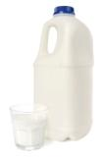

**Health concerns**

Diets which exclude many foods due to a person’s health concerns or for medical reasons need to be planned carefully.

For example, people who are lactose intolerant cannot eat some dairy products and so must make sure that they eat other foods which are good sources of calcium, e.g. soft edible bones in fish such as tinned salmon or sardines.

However, they can consume hard cheese, as it is low in lactose, and also yogurt in moderate amounts, because the bacteria in yogurt helps digest the lactose.

**Cultural or religious practices**

Ethical and religious practices, such as avoiding meat, may limit the range of foods people eat.

For example, a strict Vegan will not consume any meat products. They should choose non-meat food sources which are high in protein, iron and vitamin B12.



**Cost**

Cost of food is a particularly important factor for people with low incomes.

Food prepared food at home is often cheaper than eating out or buying take-aways.

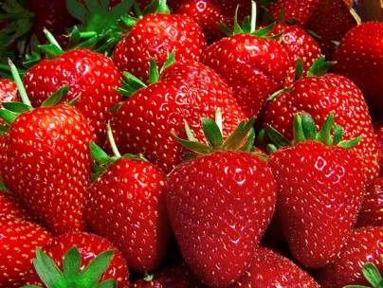

**Food availability**

Most foods are grown in a particular season of the year, e.g. strawberries are harvested in summer. These are called ‘seasonal foods’.

Buying foods when they are in season will often ensure the food price is lower.

Technology and the importation of food, however, has allowed food to be available all year round.

Frozen foods such as vegetables are a great alternative to fresh, if they are unavailable.



**Food preferences**

Not everyone likes the same food, but some foods are particularly popular or unpopular.

The taste, texture or appearance of foods can affect people in different ways.

People should choose a balanced diet with a wide range of foods they enjoy by choosing from the 4 main food groups of The eatwell plate.

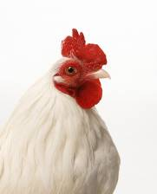

**Social concerns**

Human welfare and fair trading, where growers or producers in developing countries are paid a good minimum price to cover their costs, can be a high concern for some people.

Animal welfare can also be a concern for some people. This can affect the choice between caged or free-range hens, or ‘dolphin friendly’ tuna.

**Environmental concerns**

Scientific intervention in the food chain also causes concerns for some people. Genetically modified (GM) ingredients changing a plant, animal or micro-organism's genes or inserting one from another organism. These foods are labeled so people may decide to choose non-genetically modified food products.

People may also choose foods labelled as organic. The word 'organic' has come to have the meaning of foods grown without the use of inorganic fertilisers, or pesticides. Food sold as 'organic' must come from growers, processors and importers who are registered and approved by organic certification bodies, which are shown on the food label.

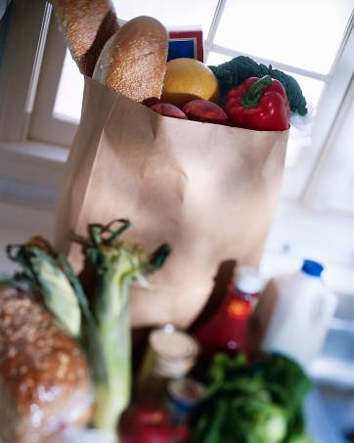

**Food advertising**

Advertisements encouraging people to choose certain foods often appear on the television, internet, radio, posters, magazines and newspapers.

Point of purchase information and product placement are strategies often used to provide information to consumers. This can assist people in making healthier choices.

**Sources of information**

There are many sources of information to assist people making food choices.

In the UK, the Department of Health and the Food Standards Agency help to increase understanding about what makes a healthy and varied diet.

The use of front of pack sign post labeling is another good source of information. This provides information in the high, medium or low amounts of fat, saturated fat, sugars and salt. The label also tells you how much of each nutrient is in a portion, to make healthier food choices easier.

**Other sources of information**

Supermarkets and food manufacturers, charities and

other groups also produce information on what we should be eating.

The most common source of information for many people, however, is the media, i.e. internet, newspapers, radio, magazines and television programmes.

It is important that advice is clear and consistent so that people are not confused about what good nutrition means.

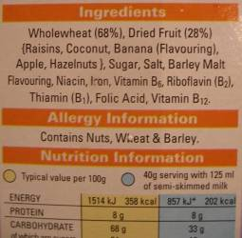

**Types of information**

Nutrition panel and ingredients lists can provide information on food. Information about the nutrient content of food from a food label can be helpful when planning a balanced diet.

Recipe and cookery ideas, and information about how to use less familiar ingredients, can make it easier to put healthy dietary advice into practice.

**For more information visit   
  
  
 www.nutrition.org.uk   
  
  
www.foodafactoflife.org.uk**