Reflection
*There are templates for questions 1, 2, 3, 4, 5 and 6 at the end of this exercise Question 1: Re#lect each shape in the mirror line given
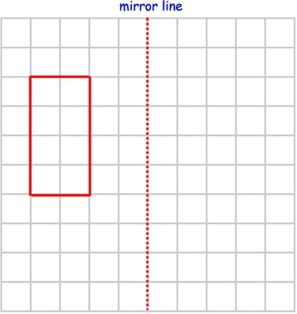
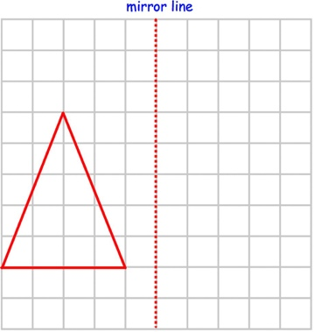
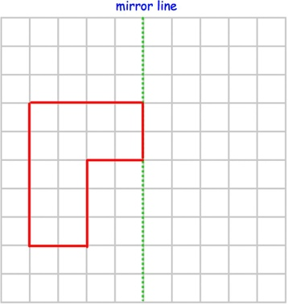
(a) (b) (c)
(d) (e) (f)
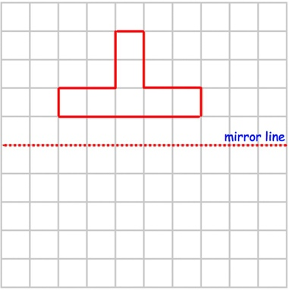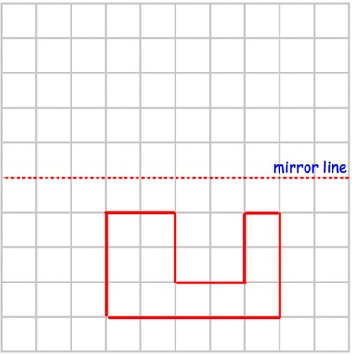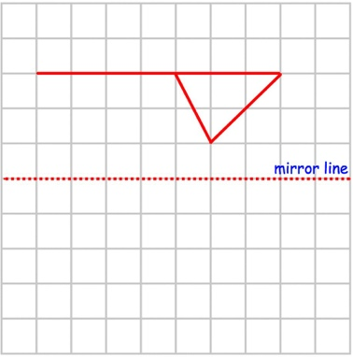

(g) (h) (i)
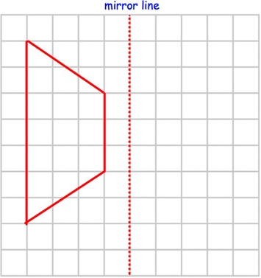
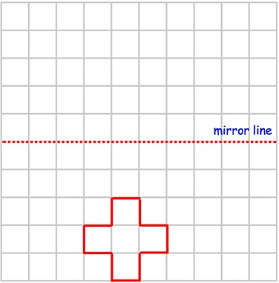
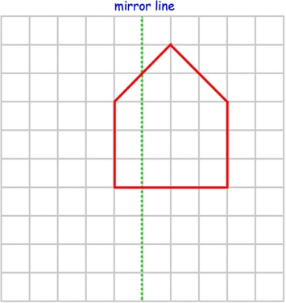

Question 2: Re#lect each shape in the mirror line given

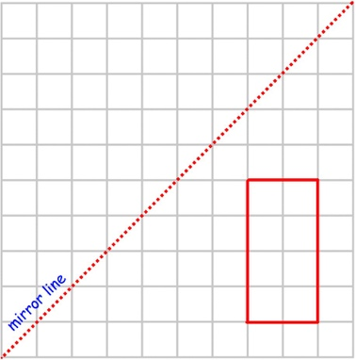
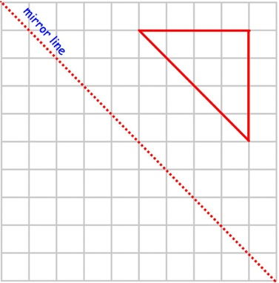
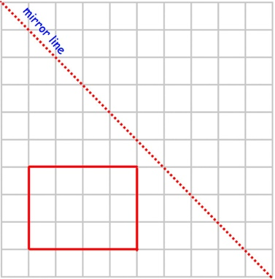
(a) (b) (c)
(d) (e) (f)
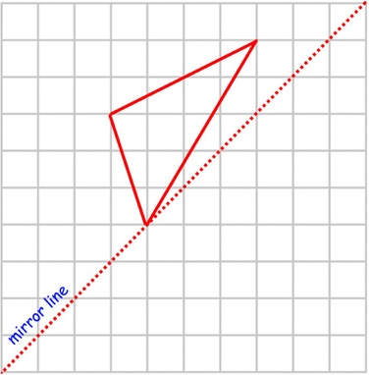
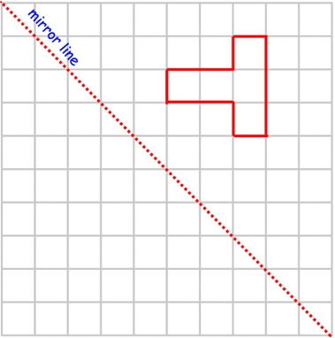
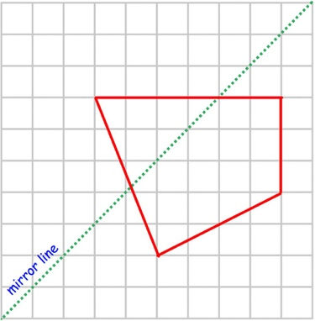
Question 3: Find the mirror line for each of the re#lections below.

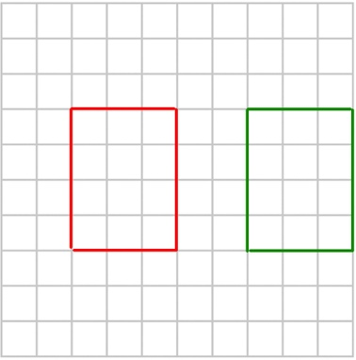
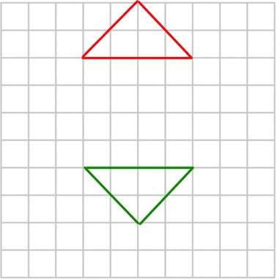
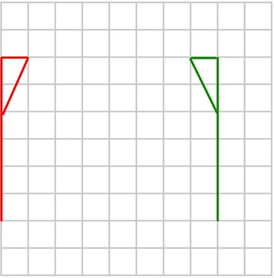
(a) (b) (c)

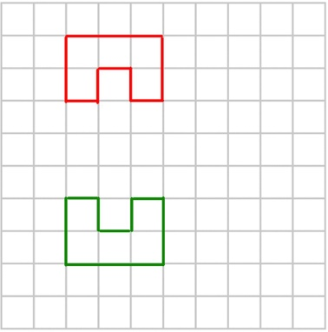
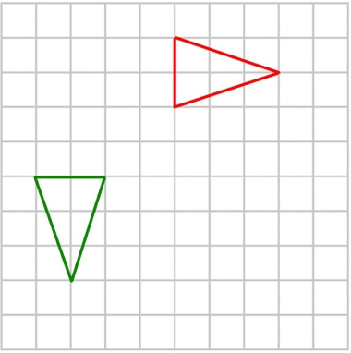
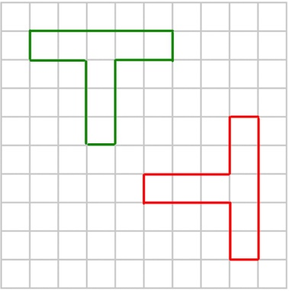
(d) (e) (f)

Question 4:
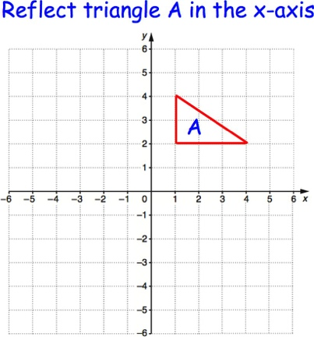
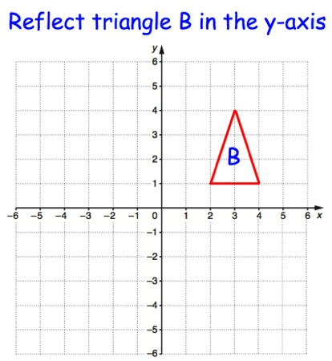
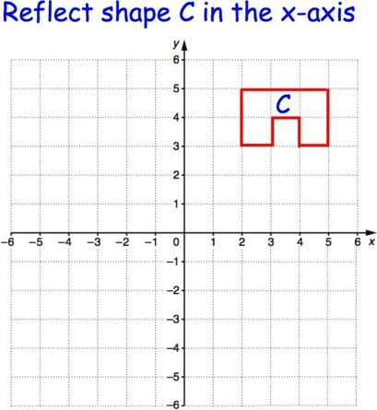
(a) (b) (c)

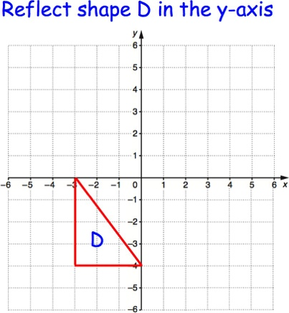
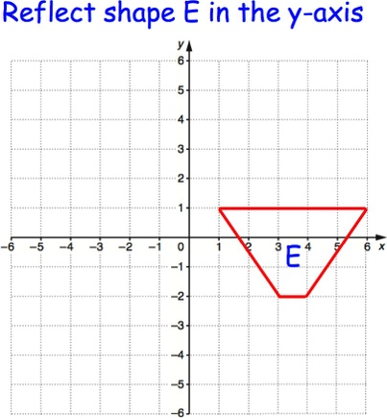
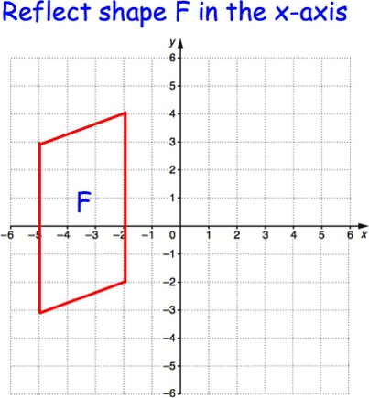
(d) (e) (f)

Question 5:
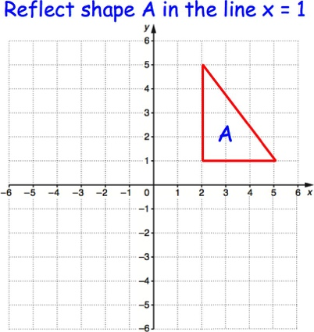
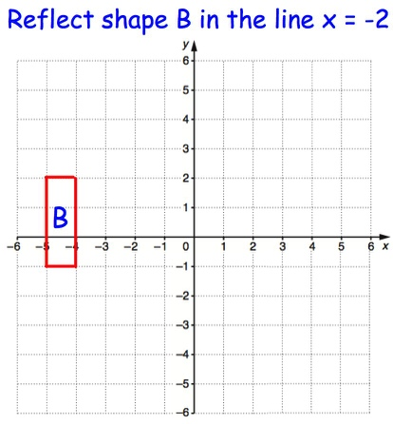
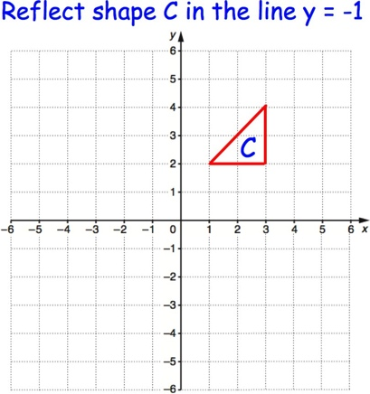
(a) (b) (c)

(d) (e) (f)
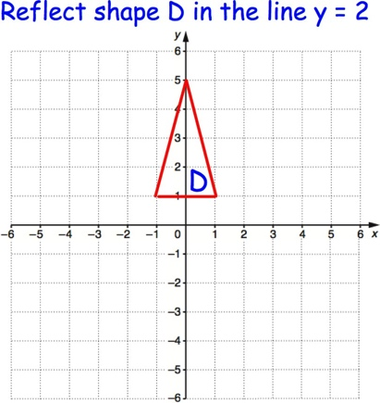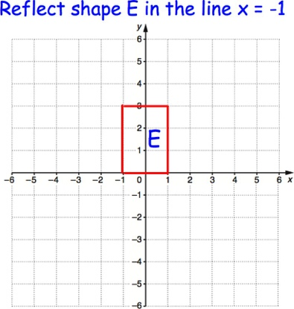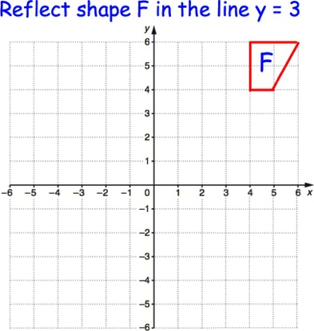

Question 6:

(a) (b) (c)
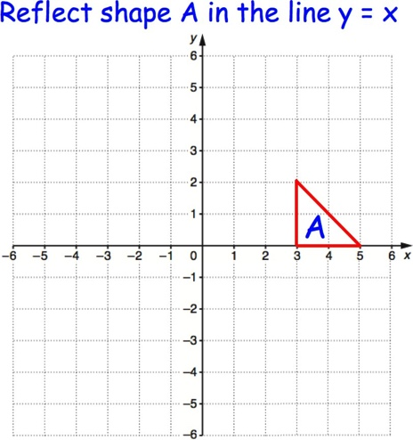
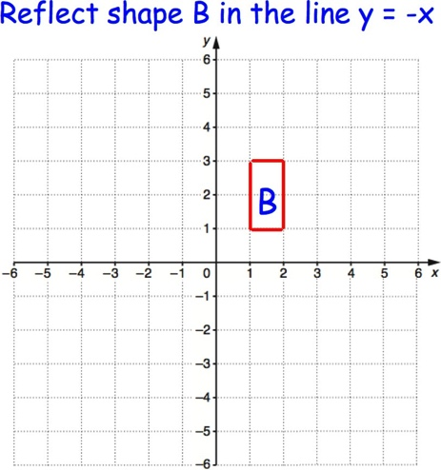
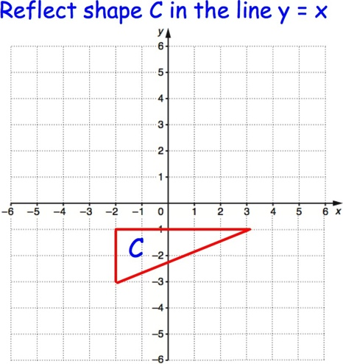

Question 7: Describe fully the single transformation that takes shape A to shape B.

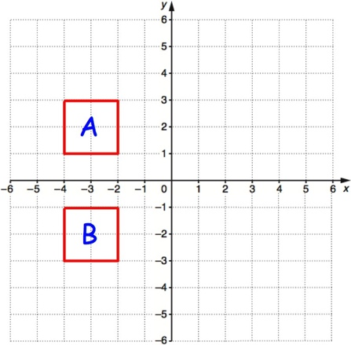
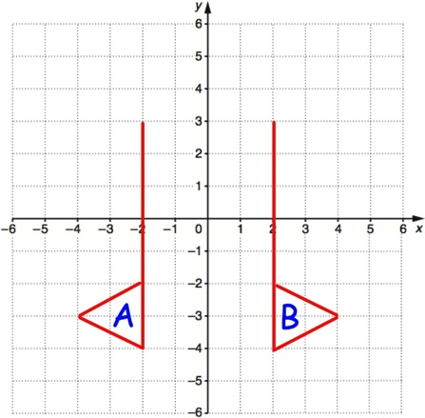
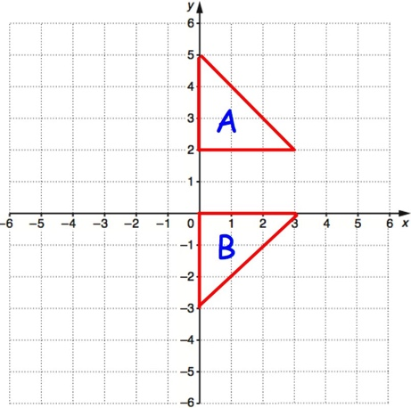
(a) (b) (c)

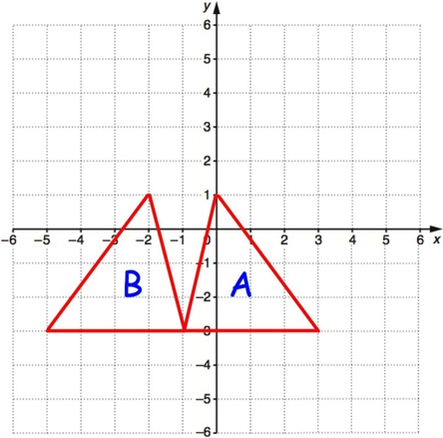
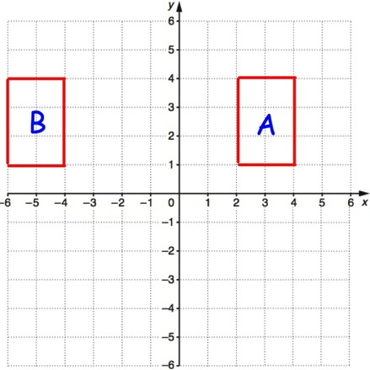
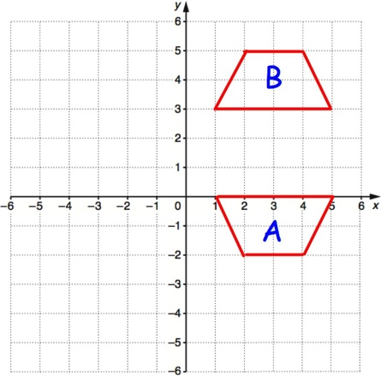
(d) (e) (f)

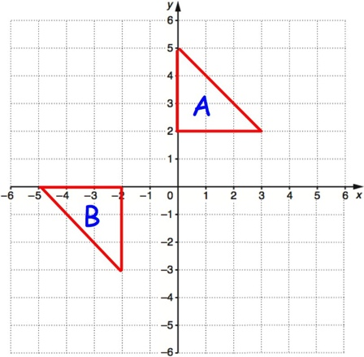
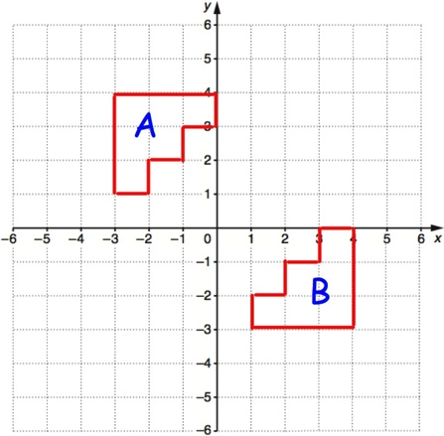
(g) (h)

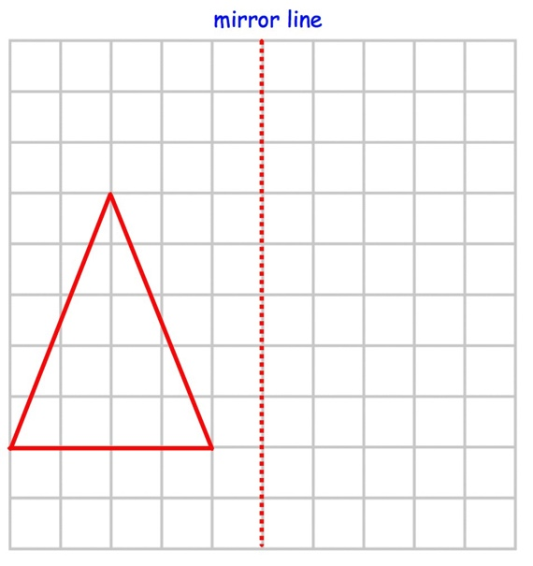
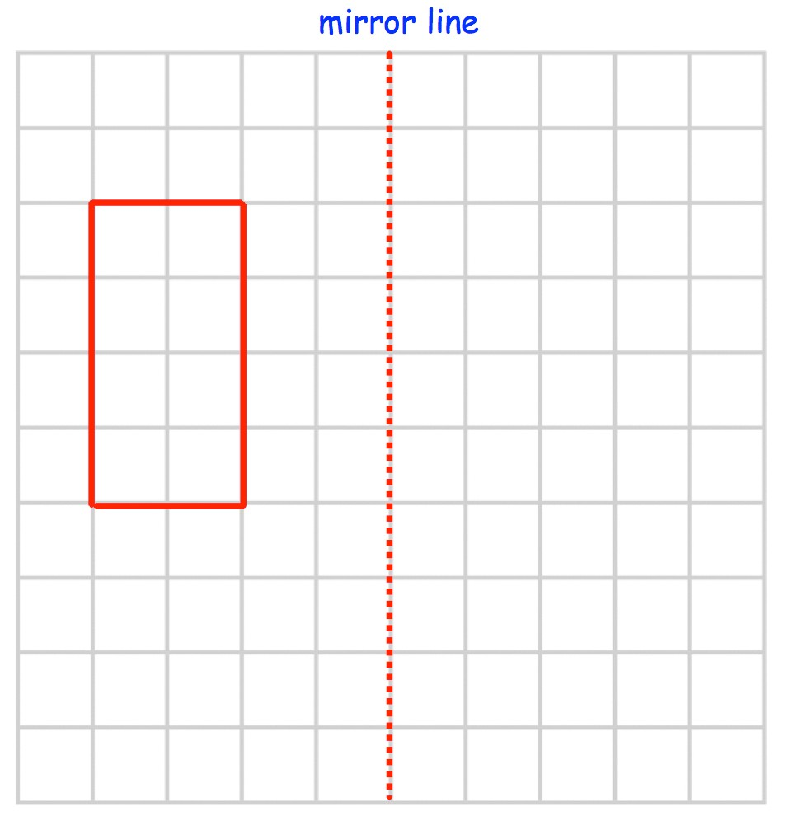Question 1(b)
Templates
Question 1(a)

Question 1(c) Question 1(d)
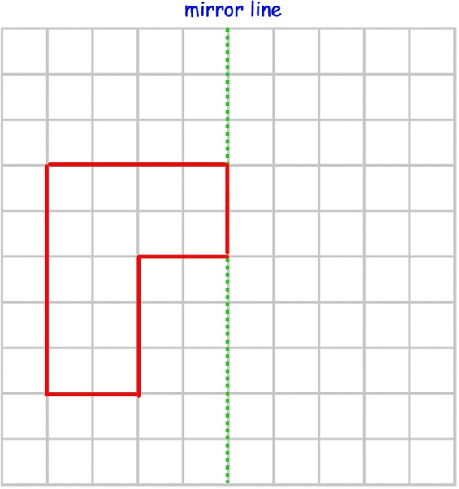
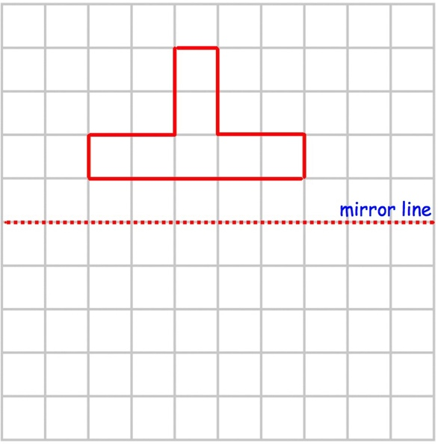
Question 1(e) Question 1(f)
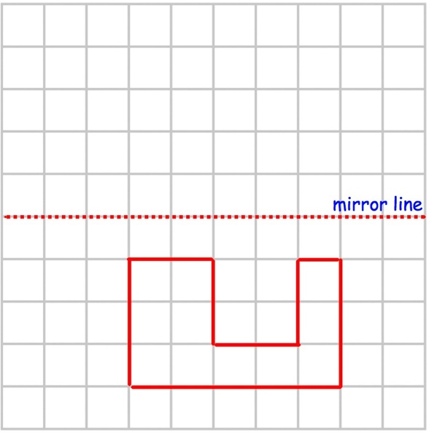
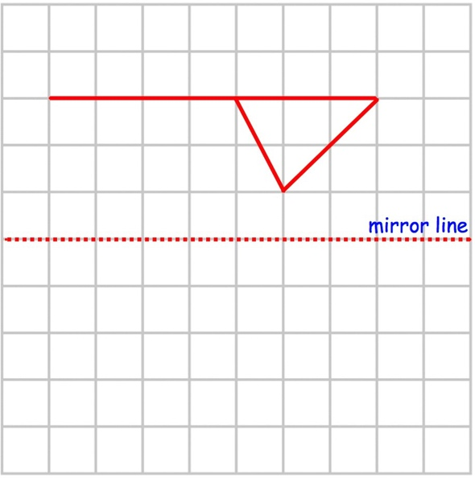

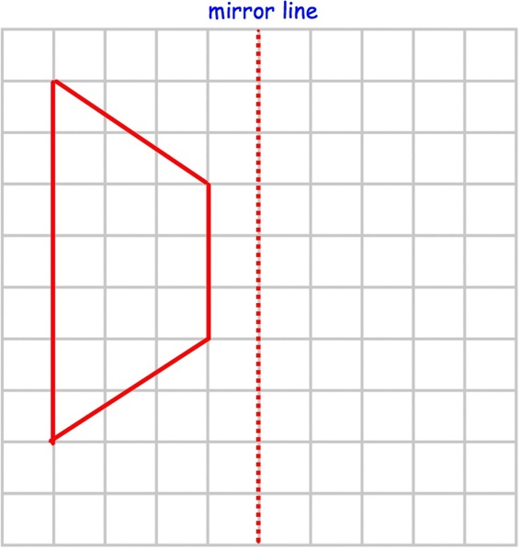
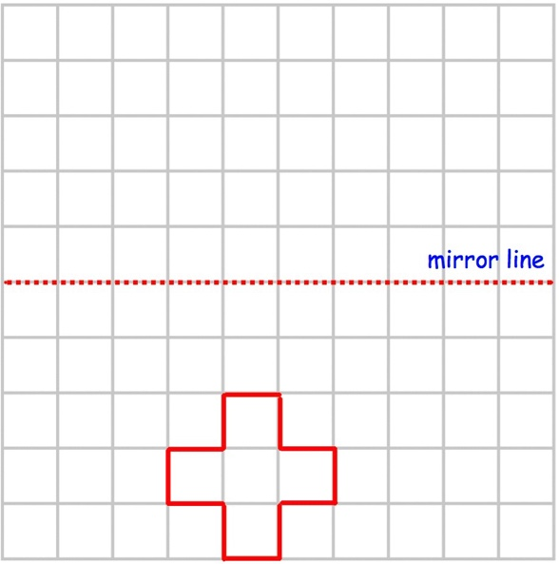
Question 1(g) Question 1(h)
Question 1(i) Question 2(a)
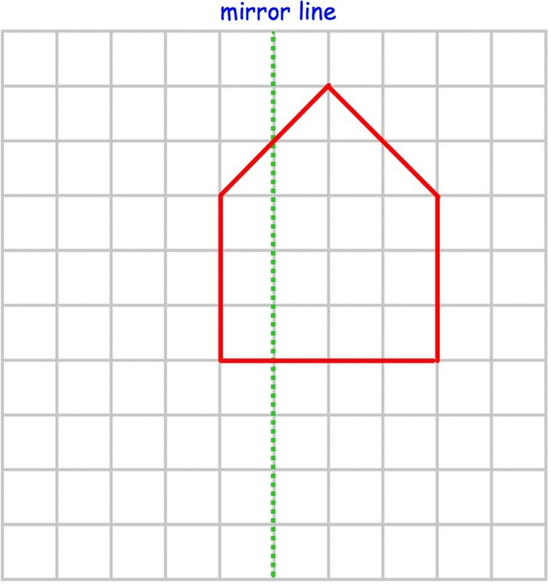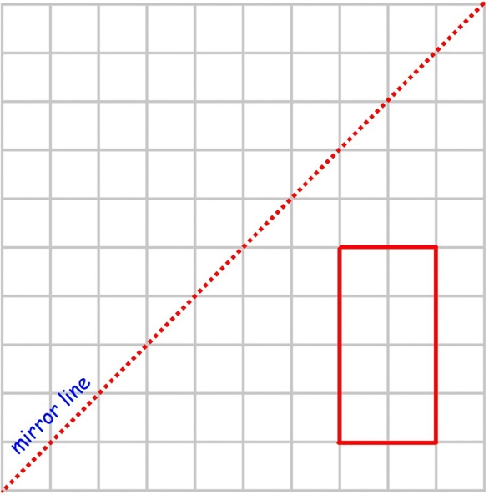
Question 2(b) Question 2(c)
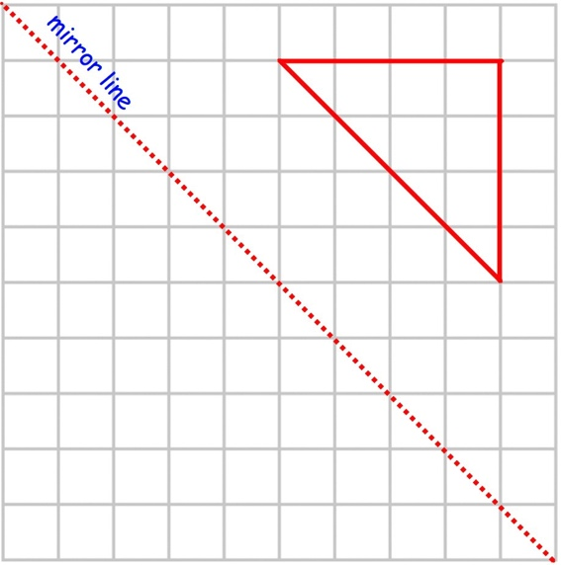
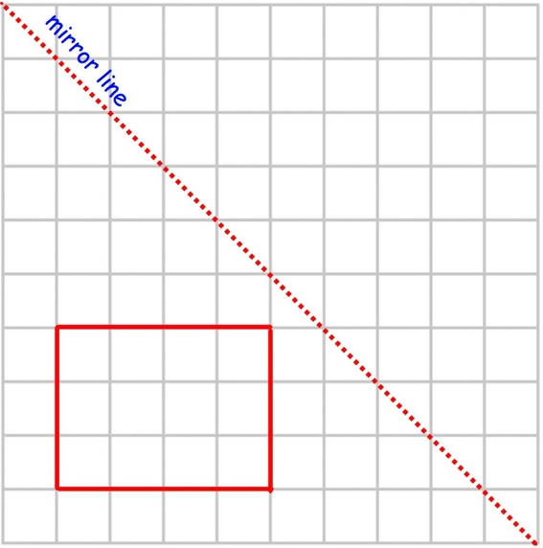

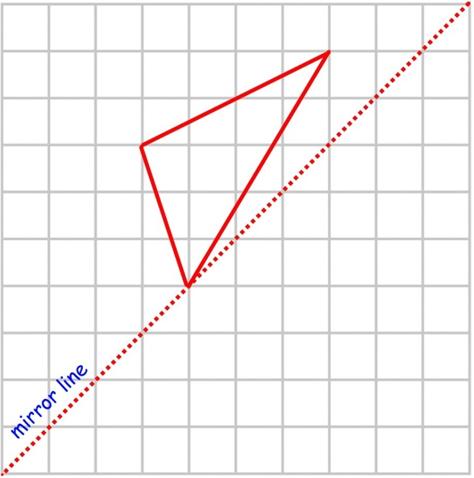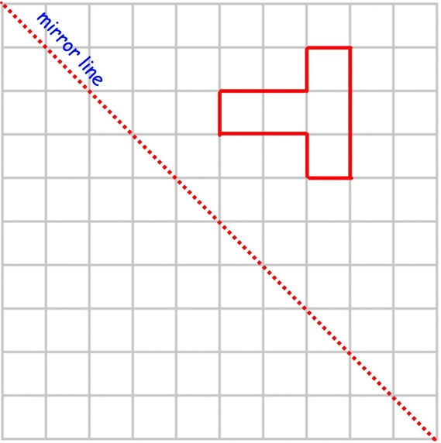
Question 2(f) Question 3(a)
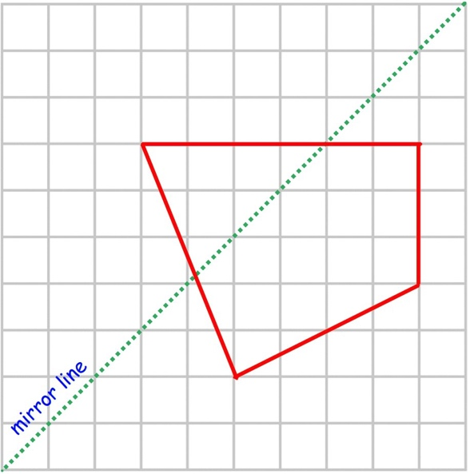
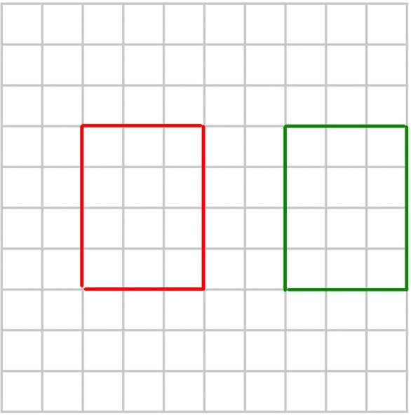

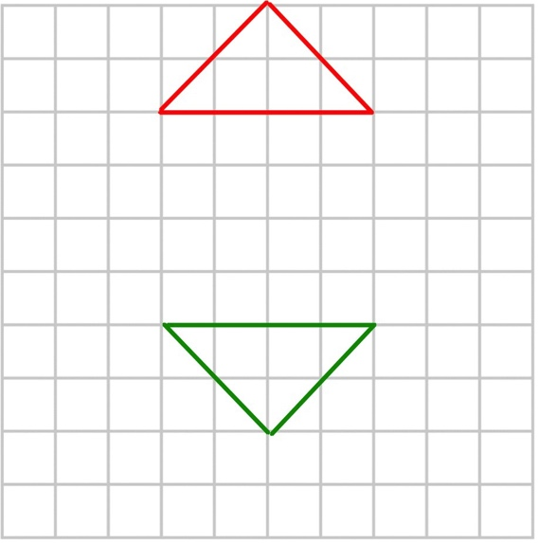
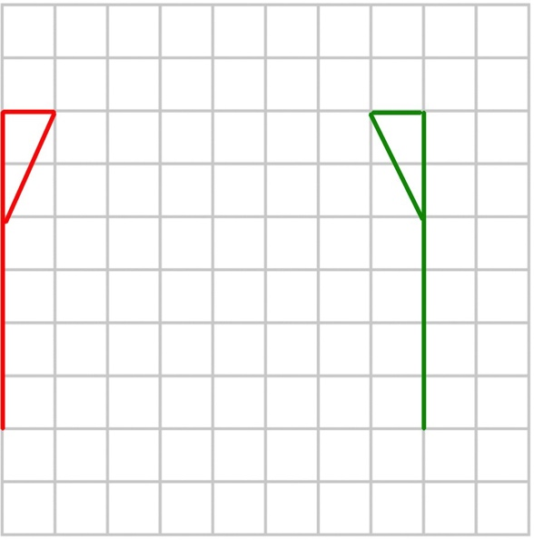
Question 3(b) Question 3(c)

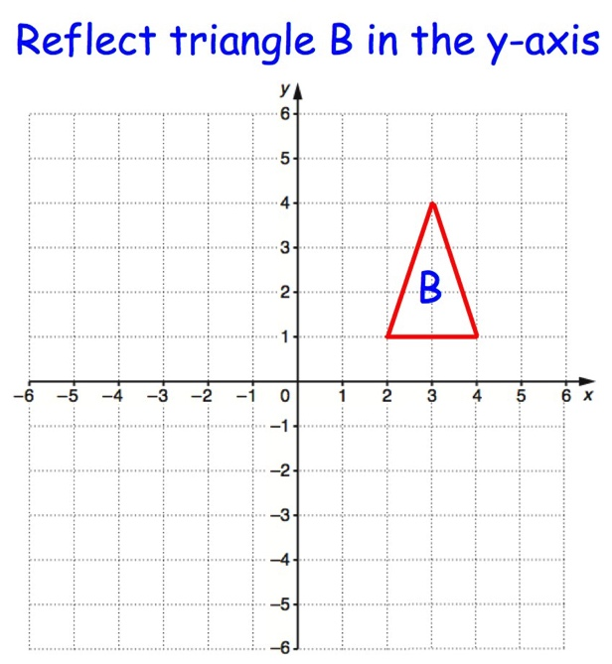
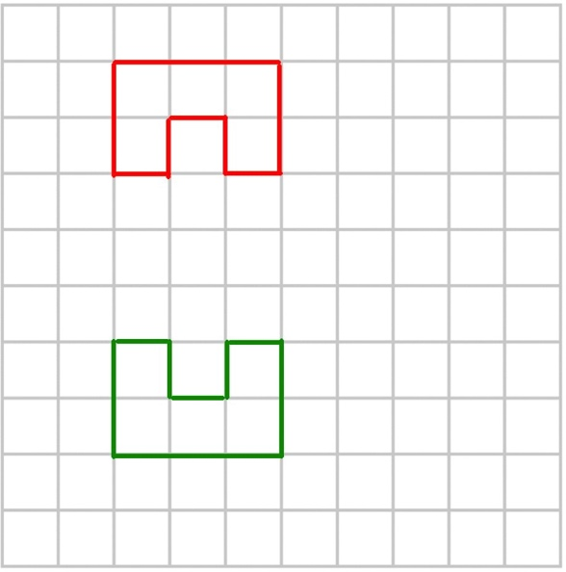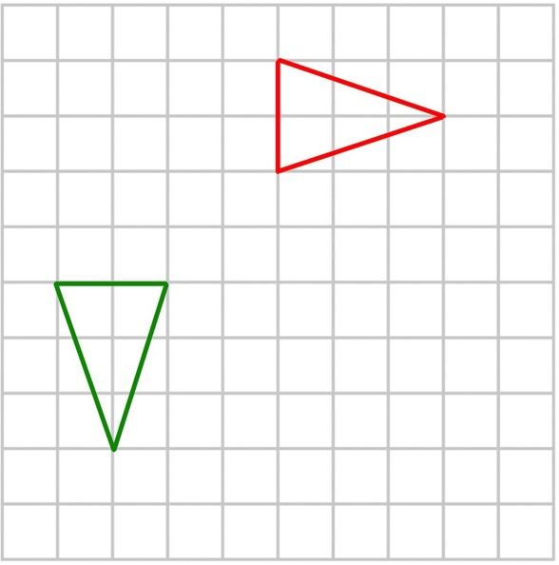
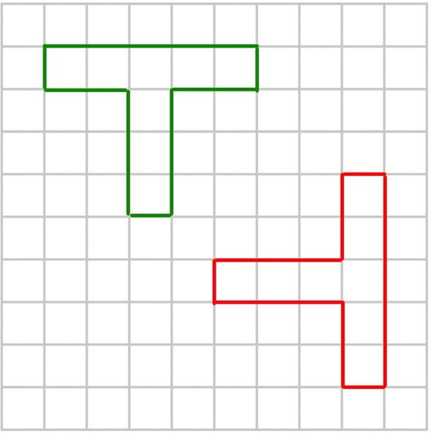
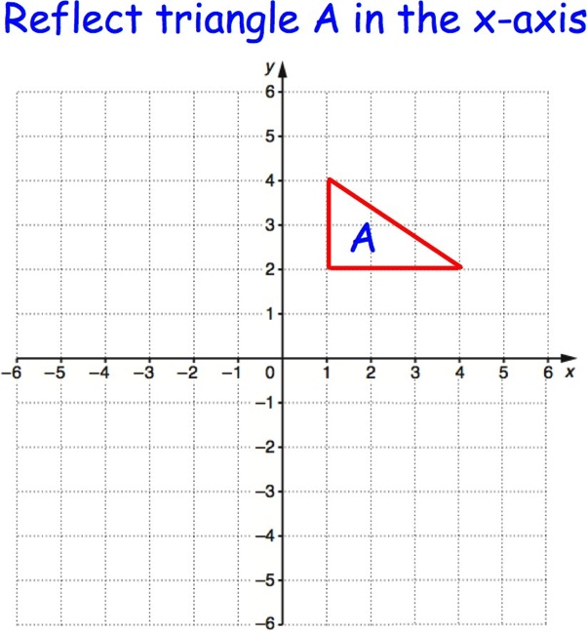
Question 3(f) Question 4(a)
Question 4(b) Question 4(c)
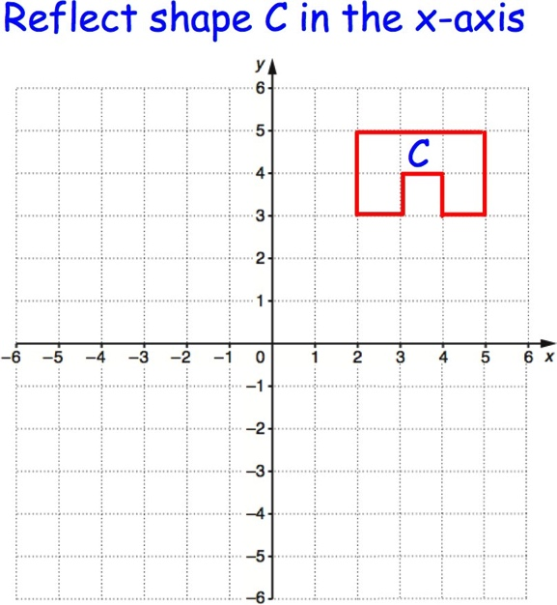

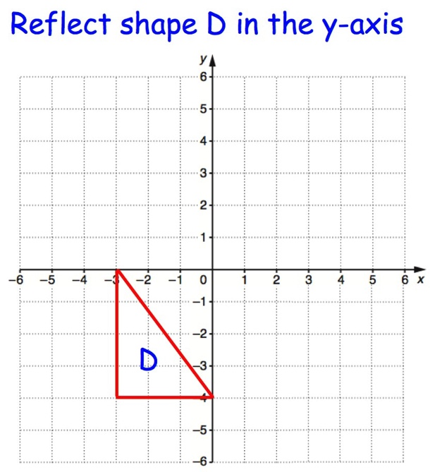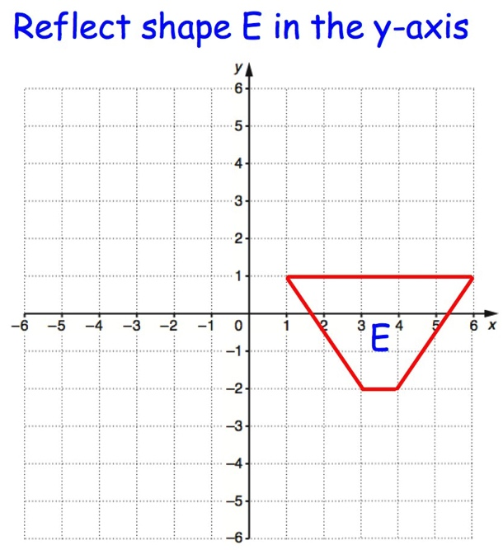
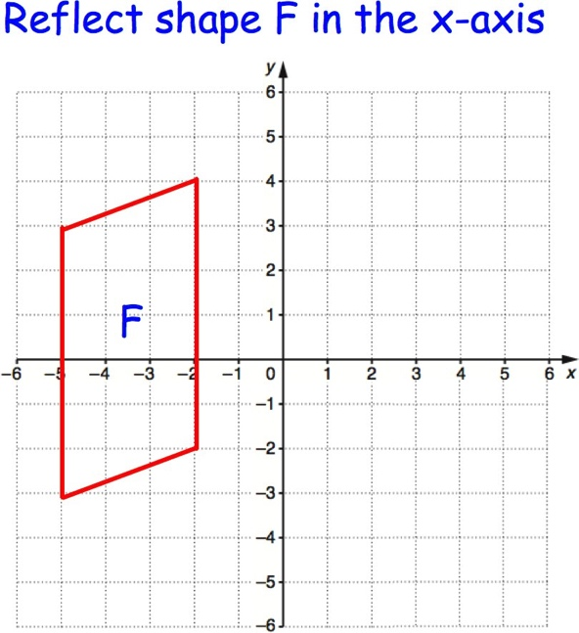
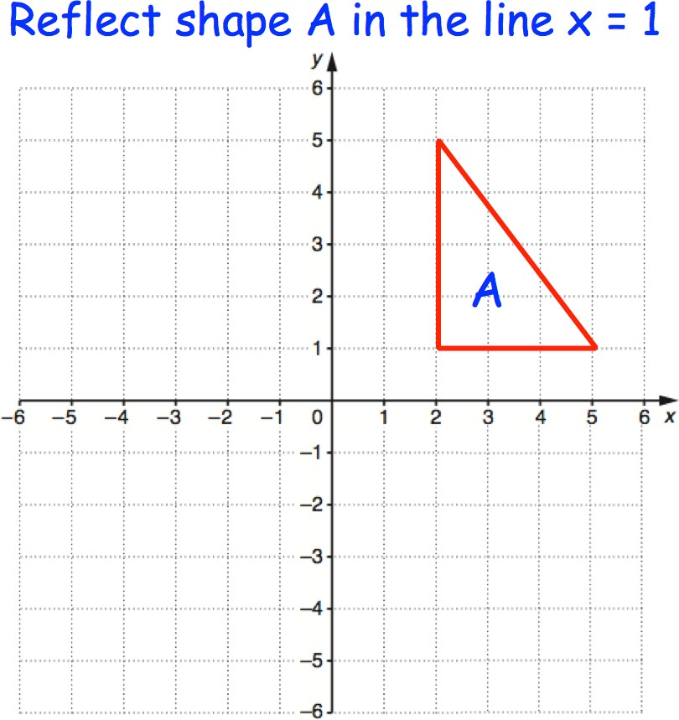
Question 4(f) Question 5(a)
Question 5(b) Question 5(c)
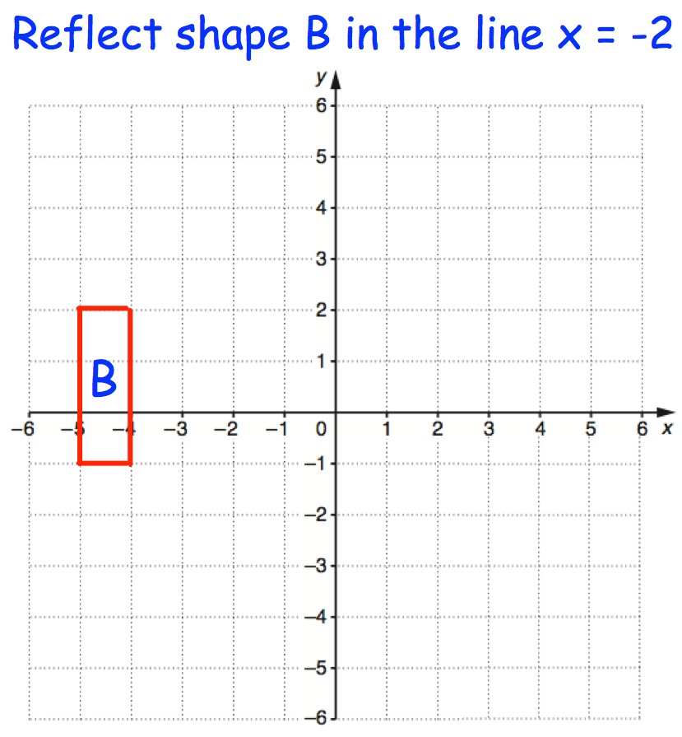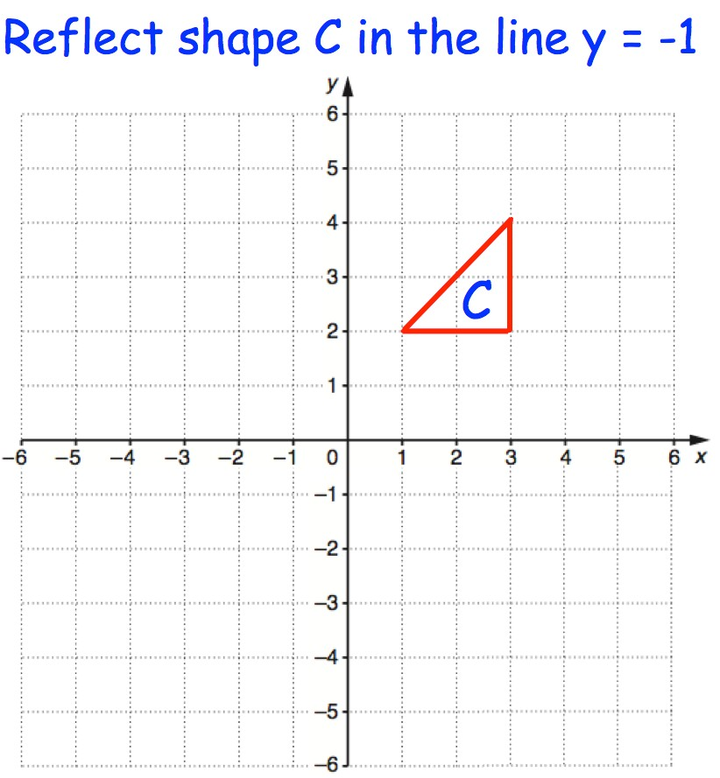
© CORBETTMATHS 2017

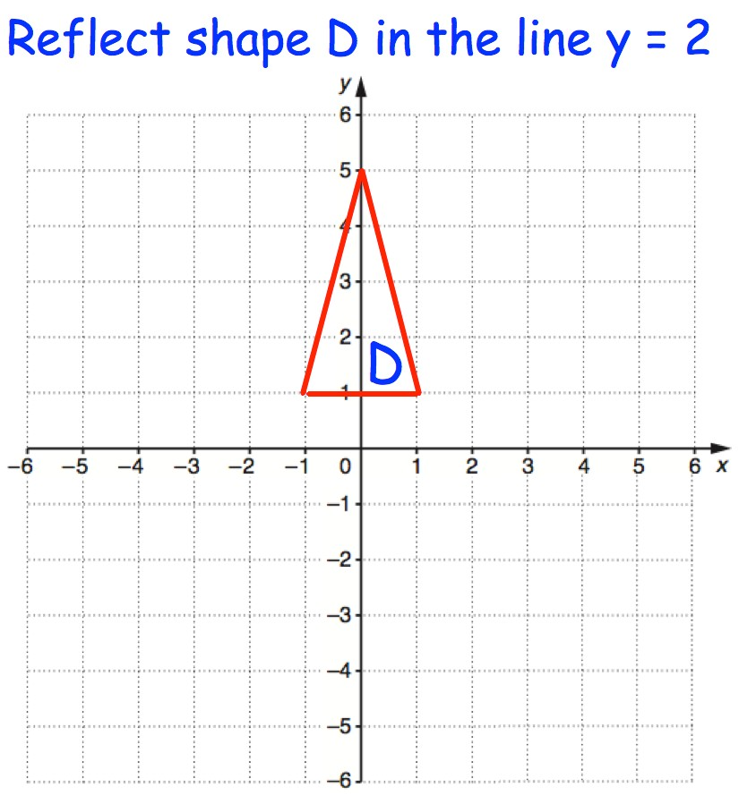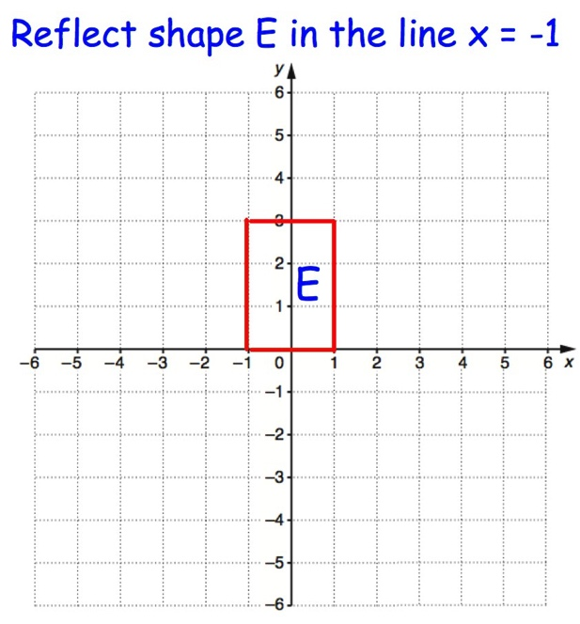
Question 5(f) Question 6(a)
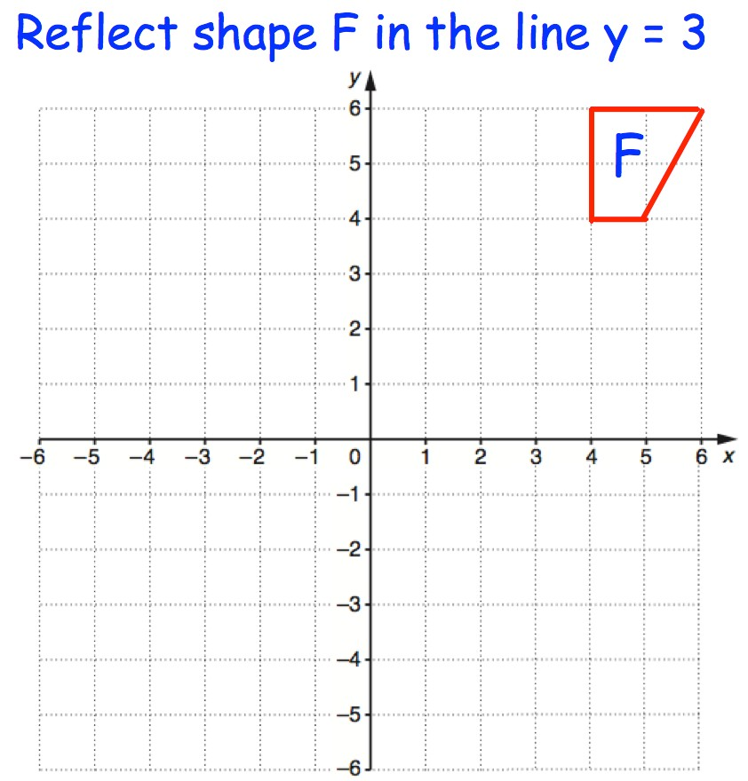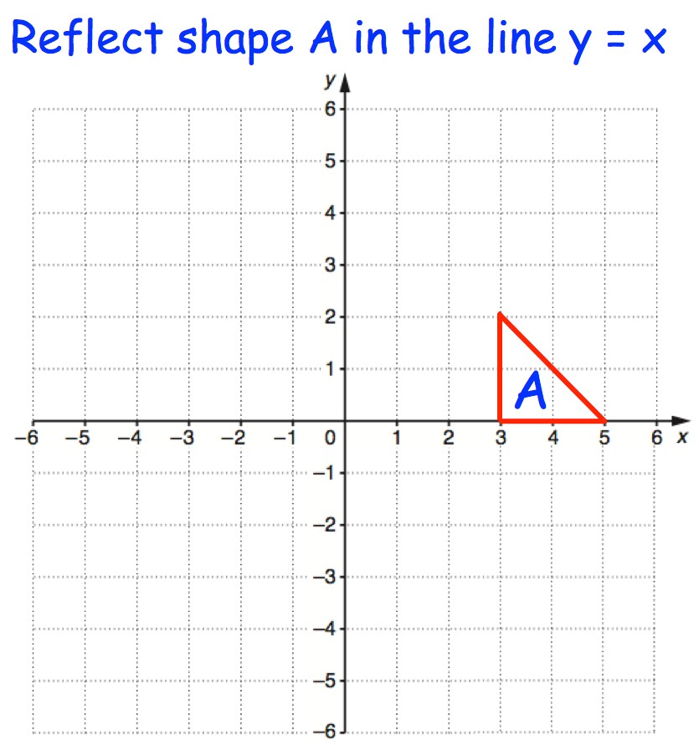
Question 6(b) Question 6(c)
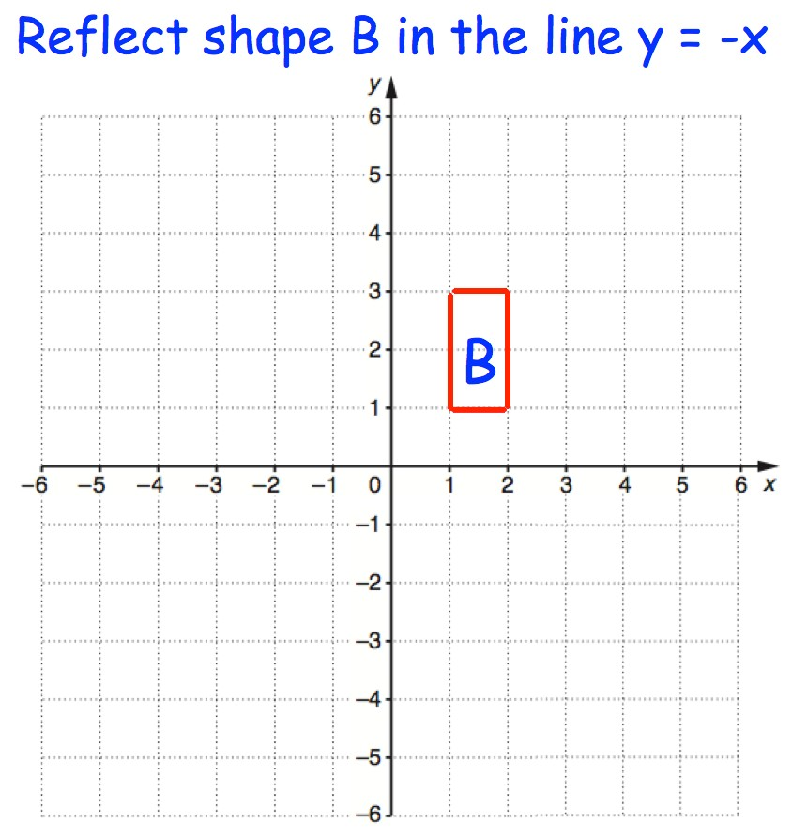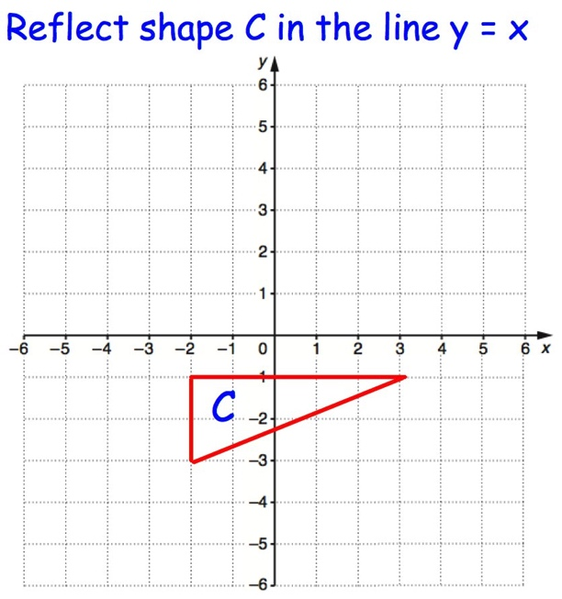
© CORBETTMATHS 2017

Rotations

*There are templates for questions 1, 2 and 3 at the end of this exercise

Question 1: Rotate each of the shapes below as instructed, using P as the centre of rotation.

(a) (b) (c)
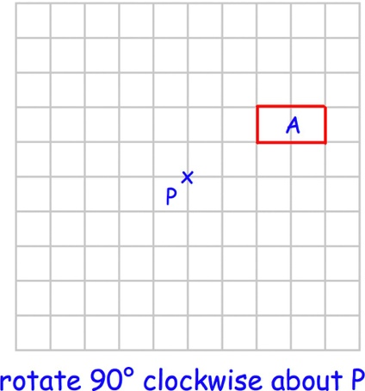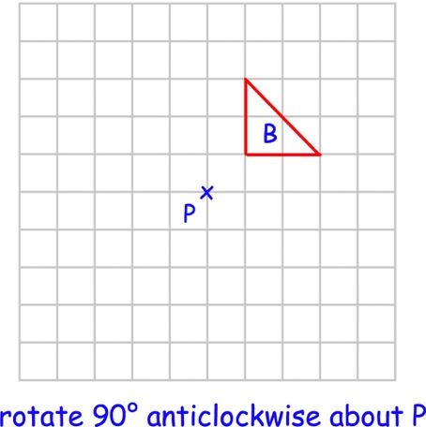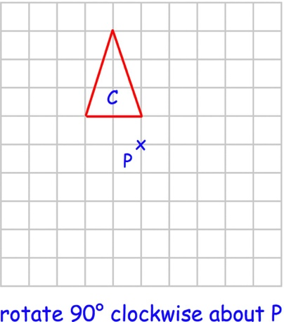
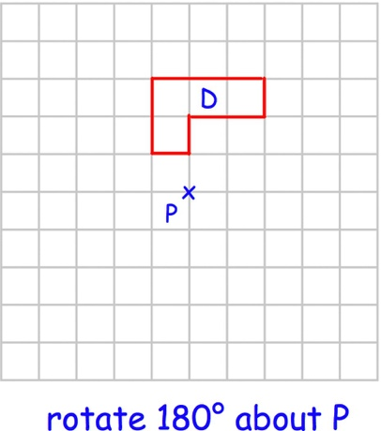
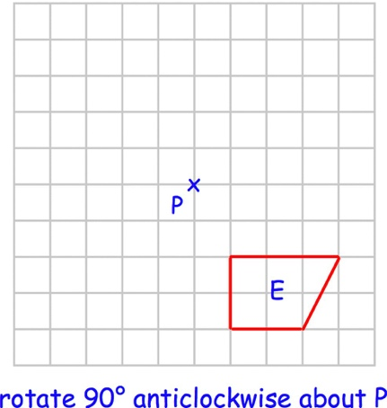
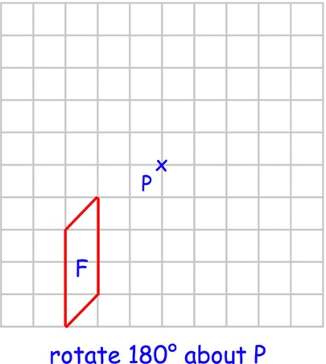
(d) (e) (f)
(g) (h) (i)
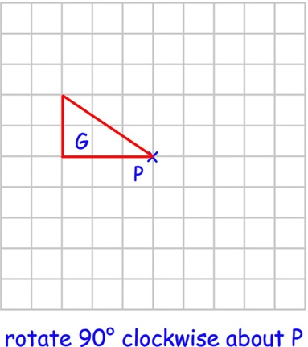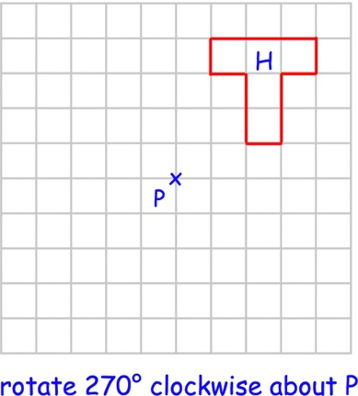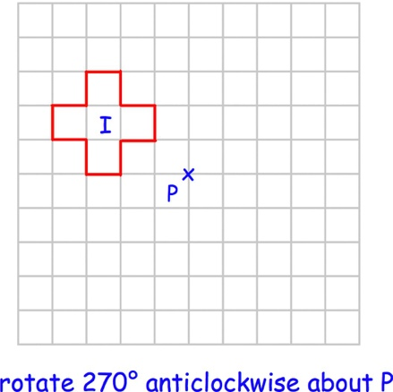

Question 2: Rotate each of the shapes below as instructed, using the origin, (0,0), as the centre of rotation.
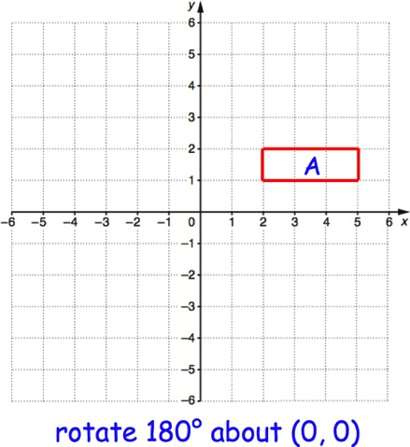
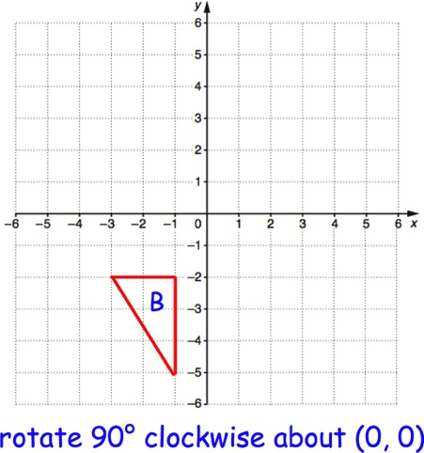
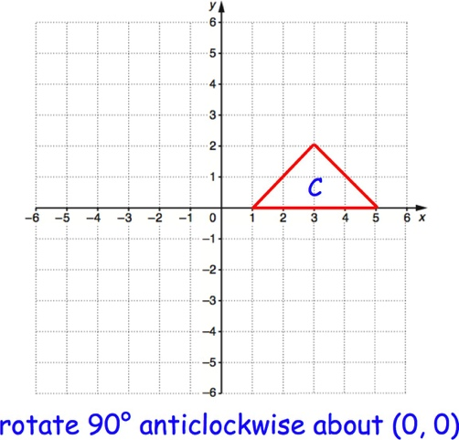
(a) (b) (c)

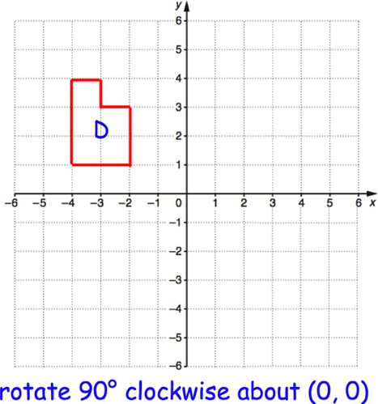
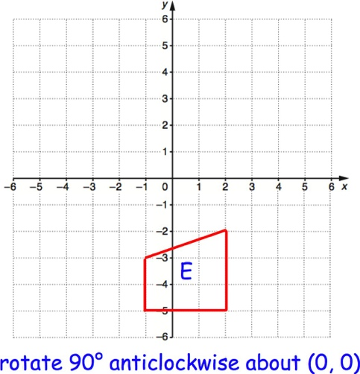
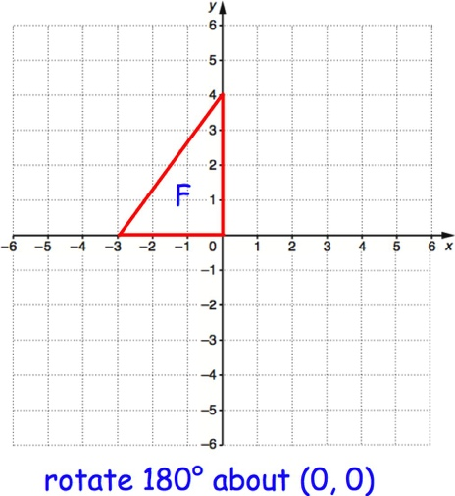
(d) (e) (f)

(g) (h) (i)
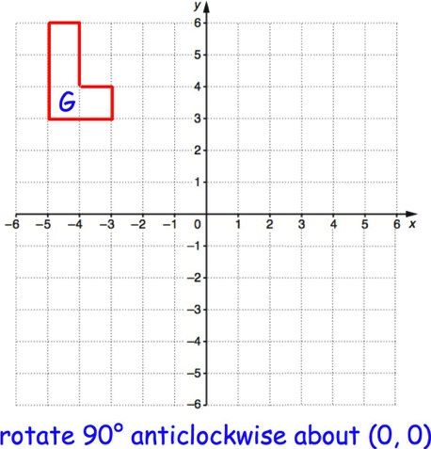
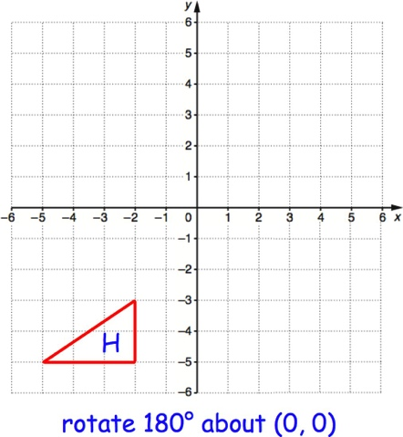
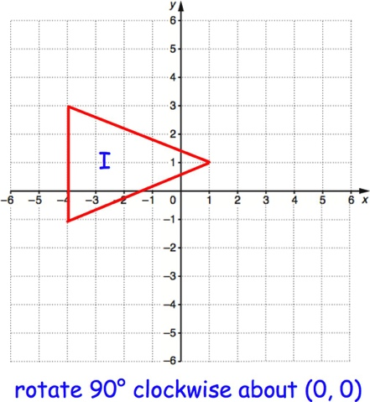

Question 3: Rotate each of the shapes below as instructed.

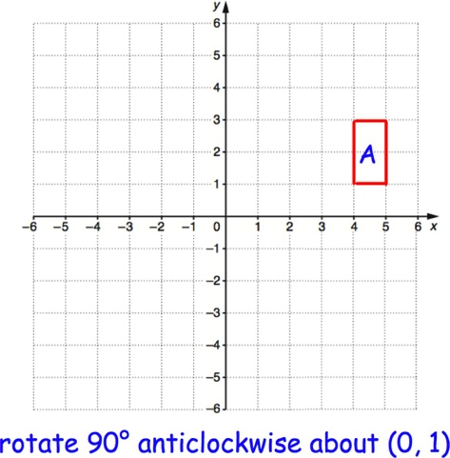
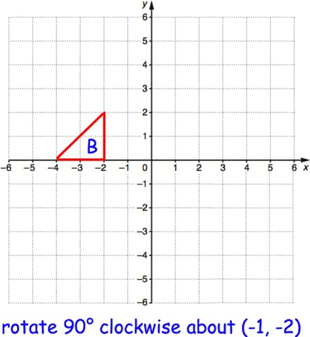
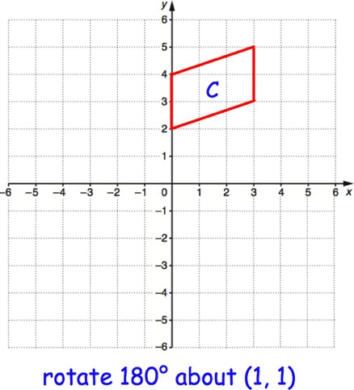
(a) (b) (c)

(d) (e) (f)
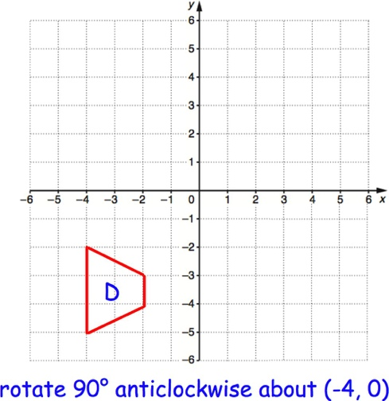
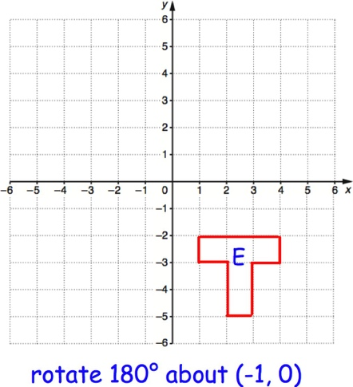
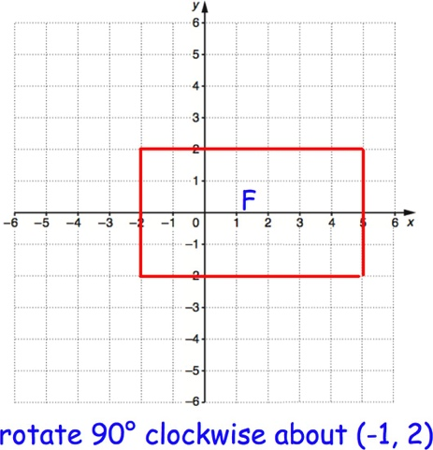
(g) (h) (i)
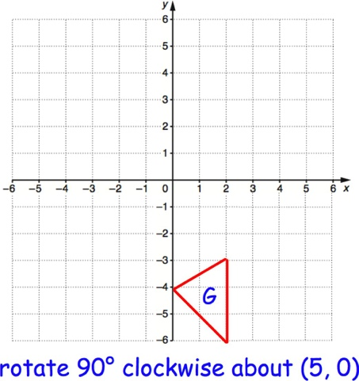
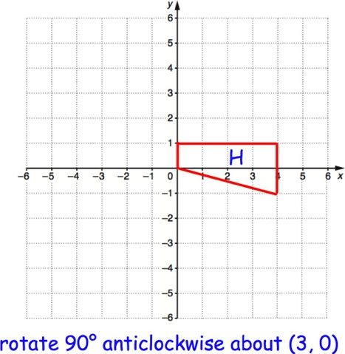
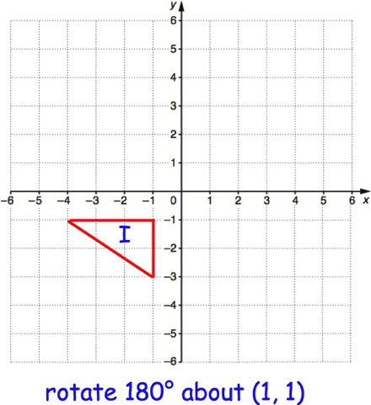

Question 4: Describe fully the single transformation that takes shape A to shape B.

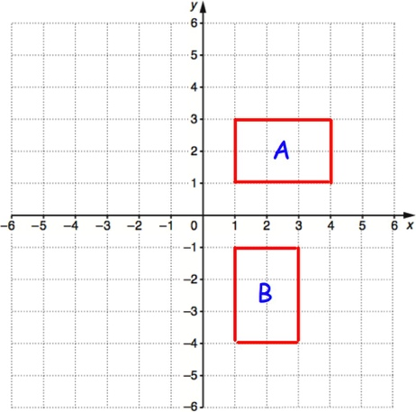
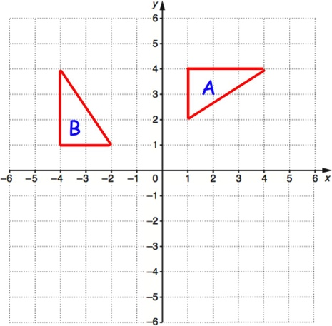
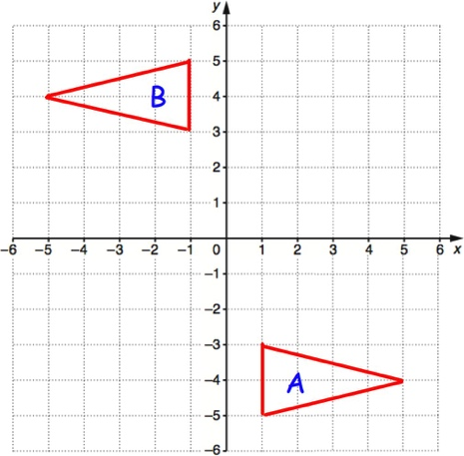
(a) (b) (c)

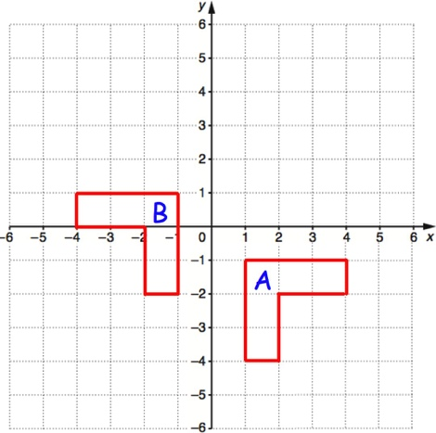
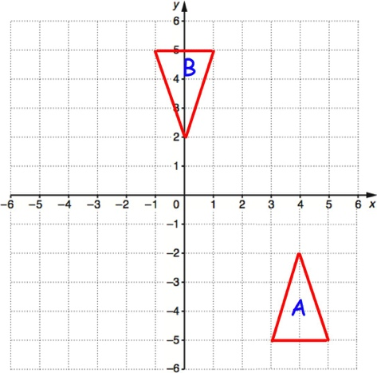
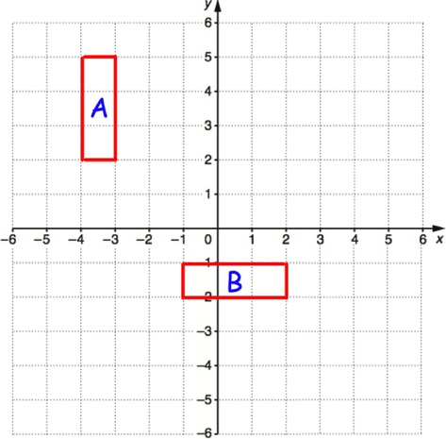
(d) (e) (f)

Templates
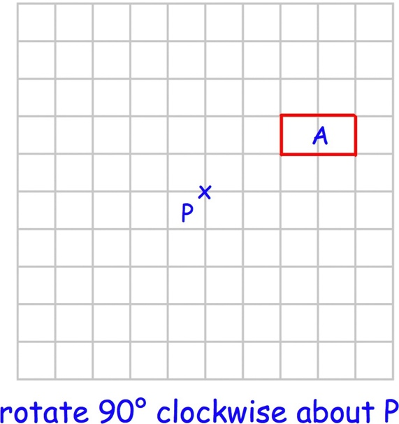
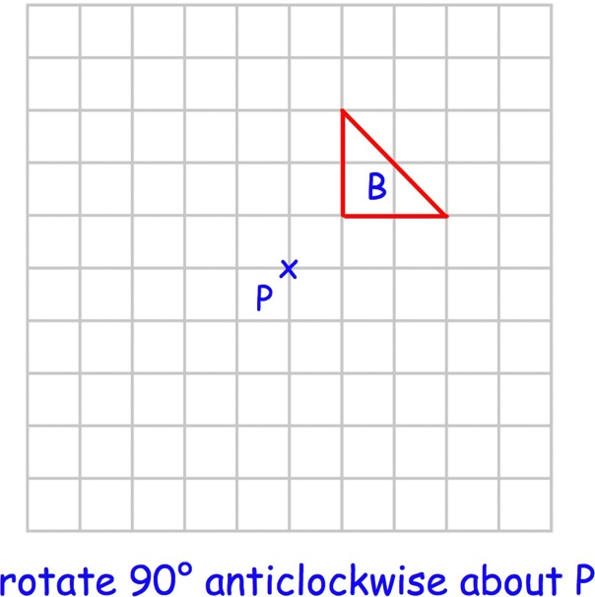
Q1(a) Q1 (b)

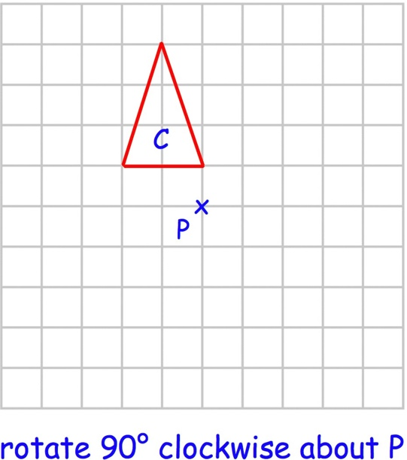
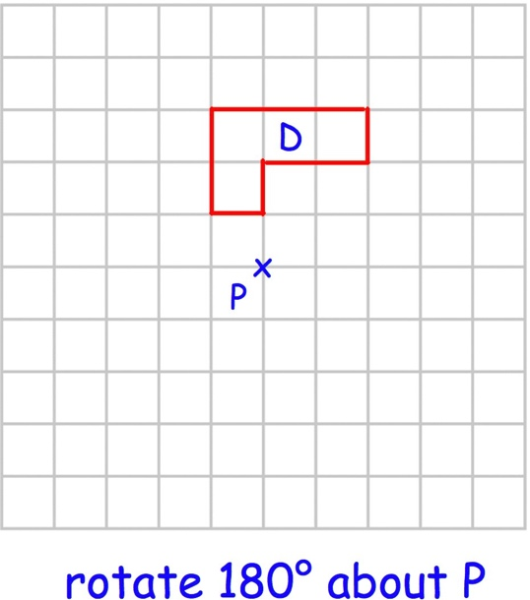
Q1(c) Q1(d)

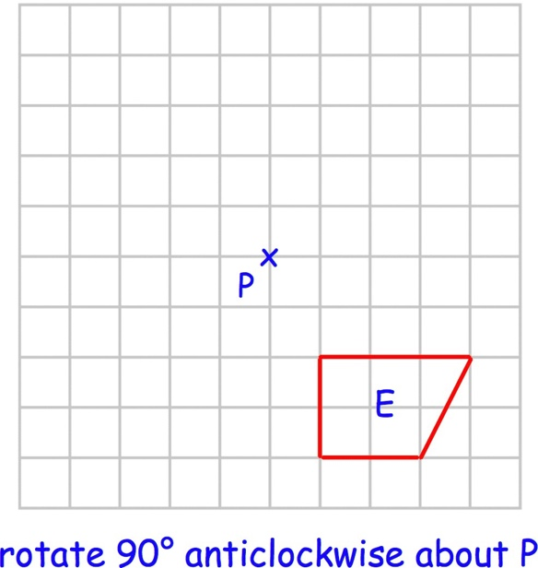
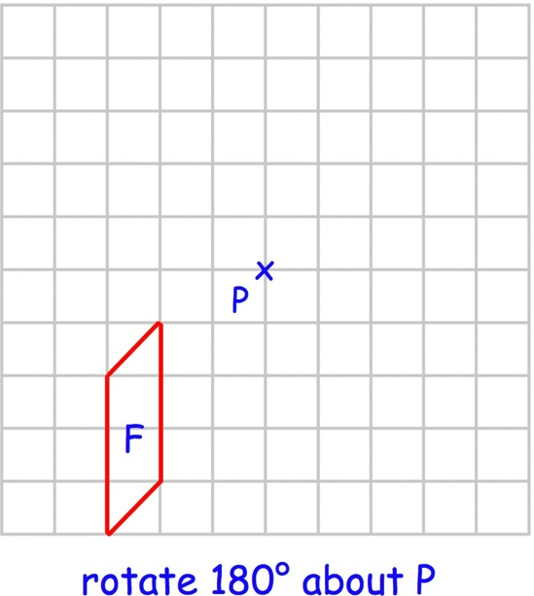
Q1(e) Q1 (f)

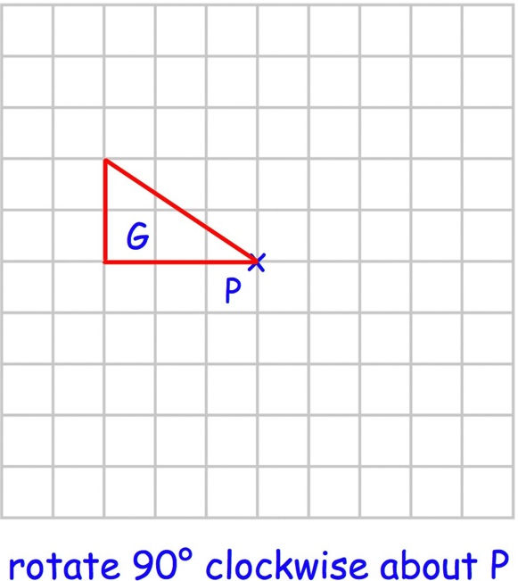
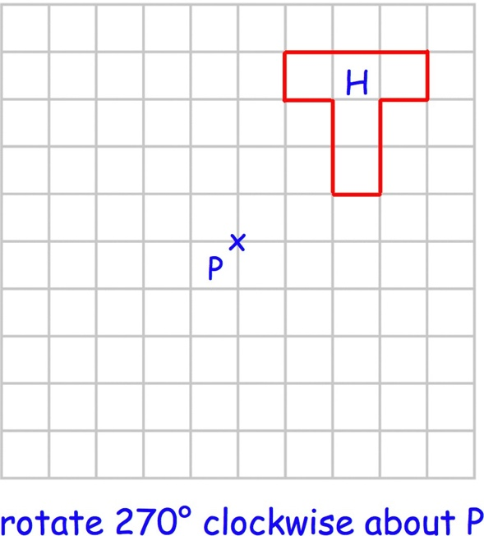
Q1(g) Q1(h)

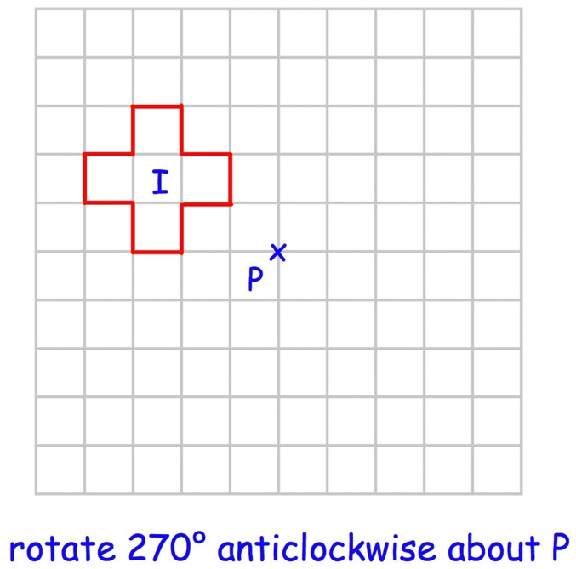
Q1(i) Q2(a)
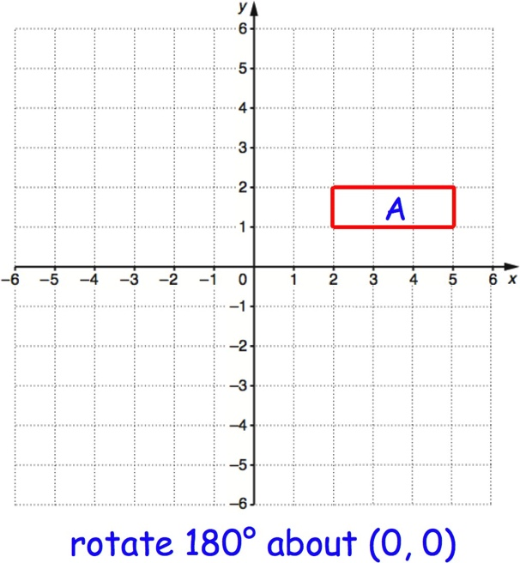
Q2(b) Q2(c)
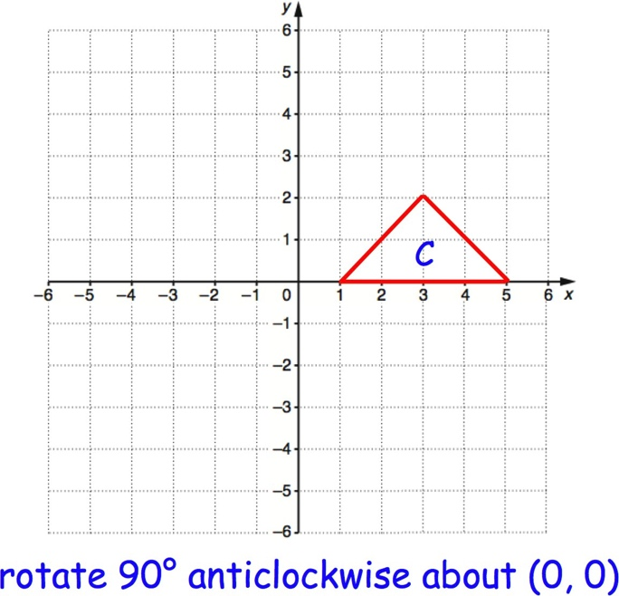
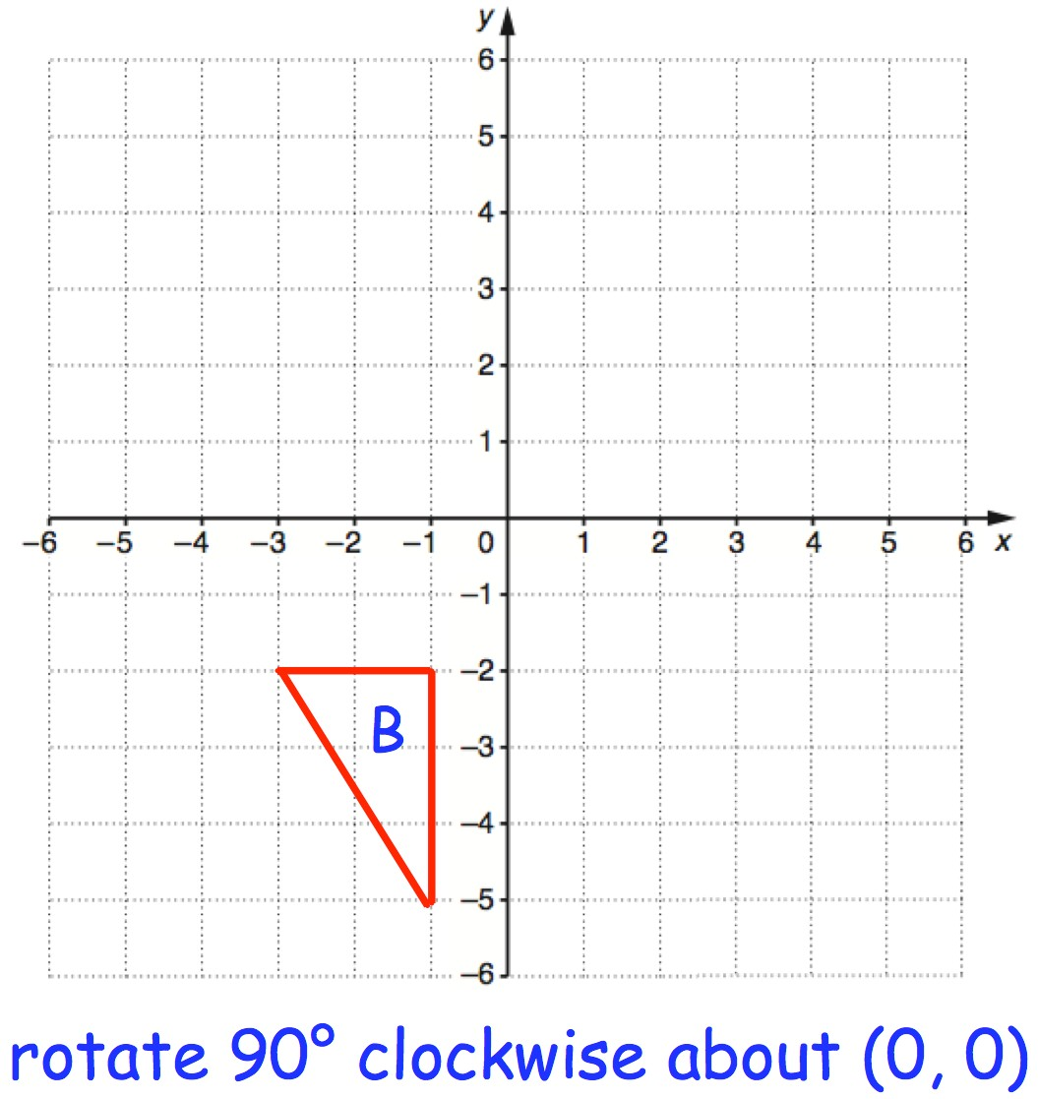
© CORBETTMATHS 2017

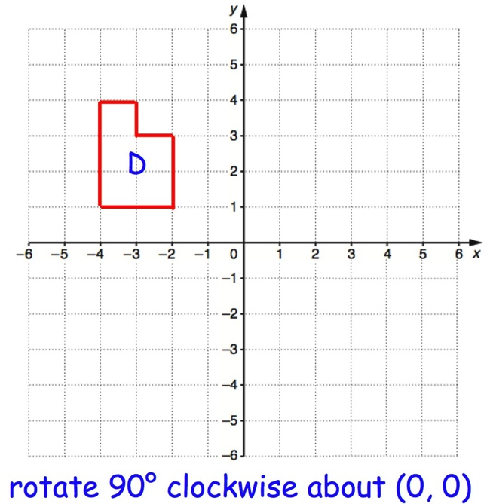
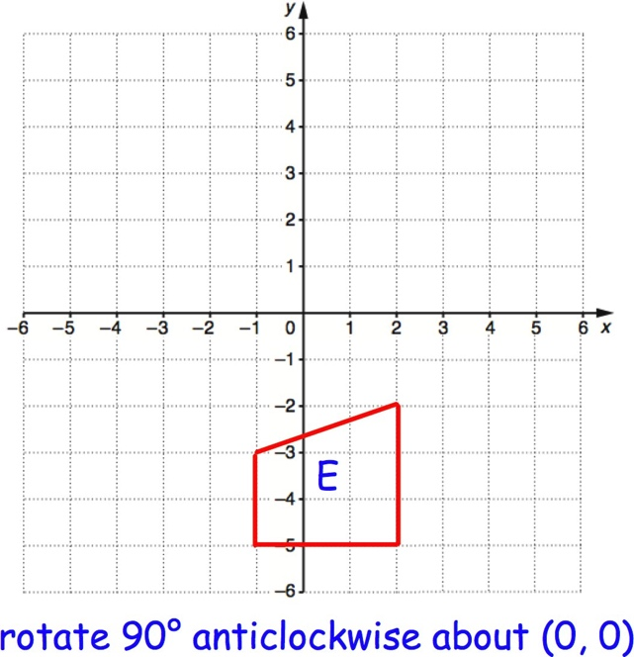
Q2(d) Q2(e)

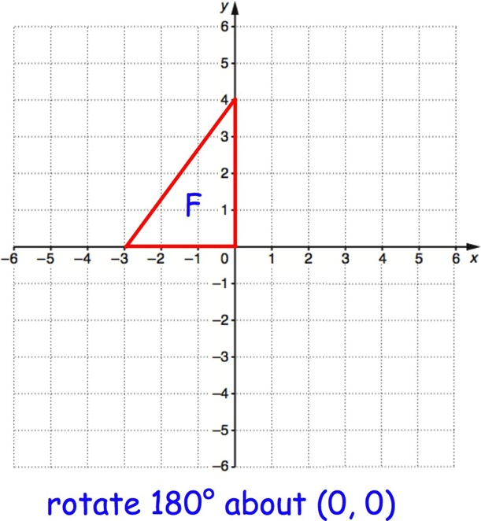
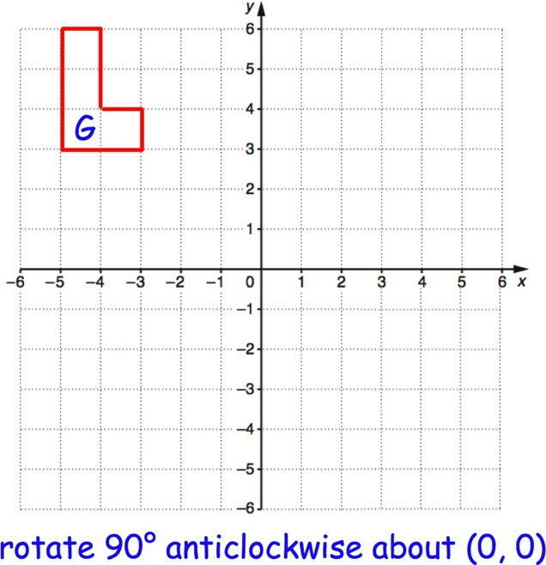
Q2(f) Q2(g)

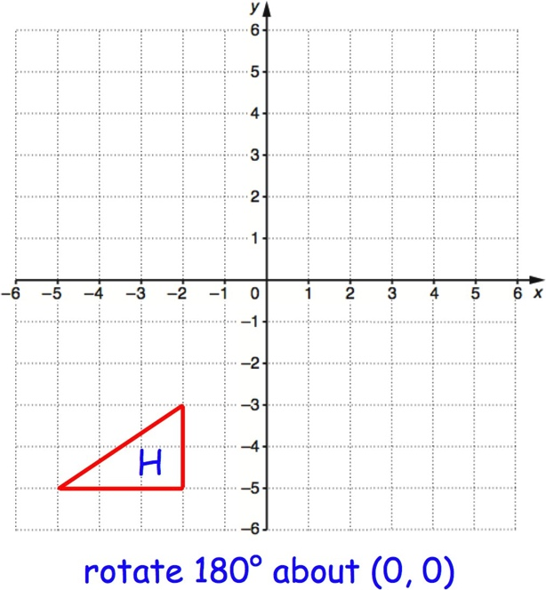
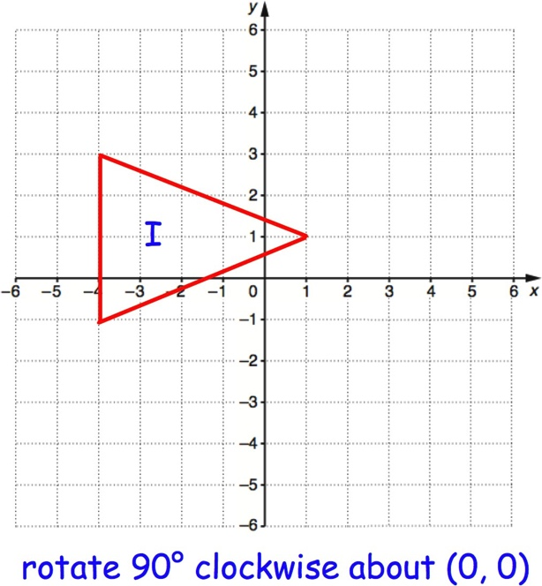
Q2(h) Q2(i)

© CORBETTMATHS 2017

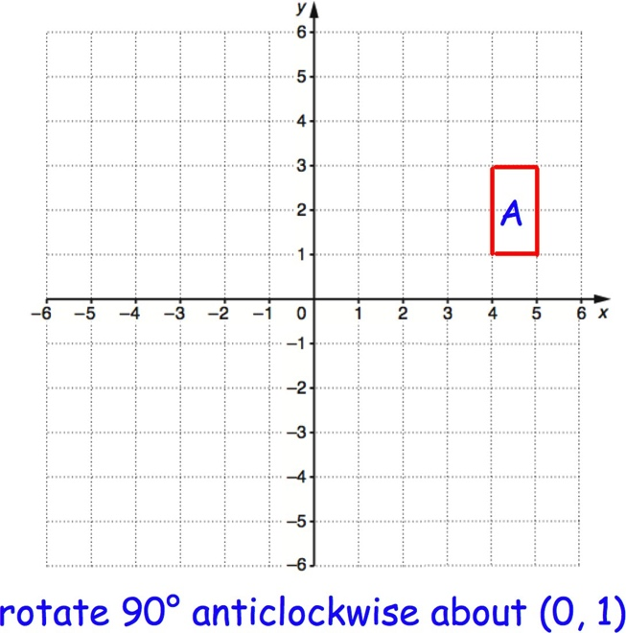
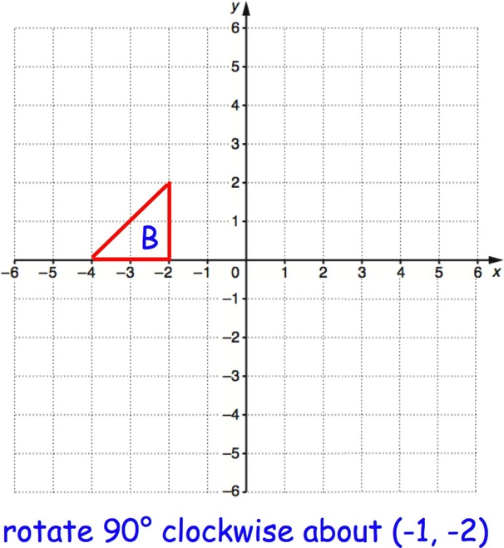
Q3(a 3(b)
) Q

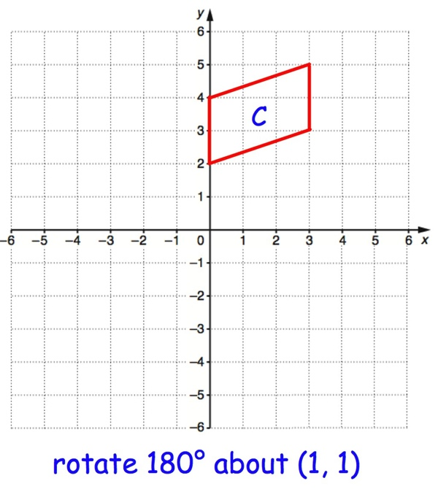
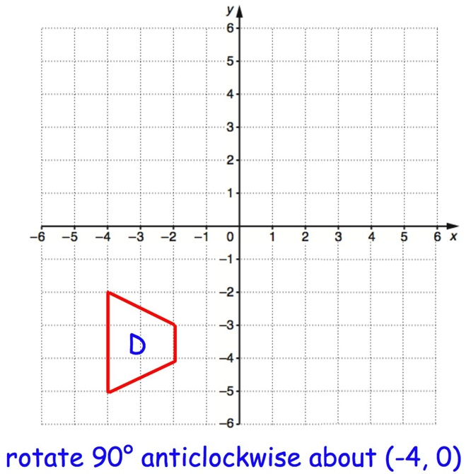
Q3(c) Q3(d)

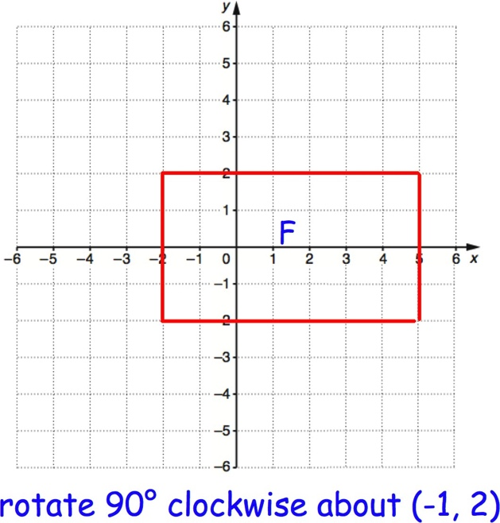
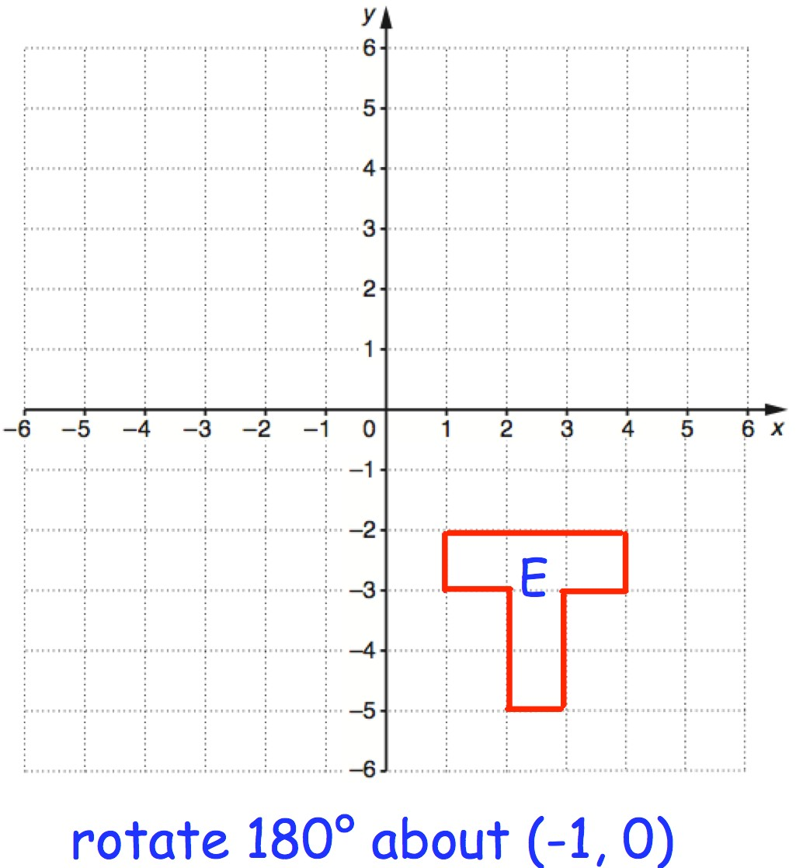Q3(e) Q3(f)
© CORBETTMATHS 2017

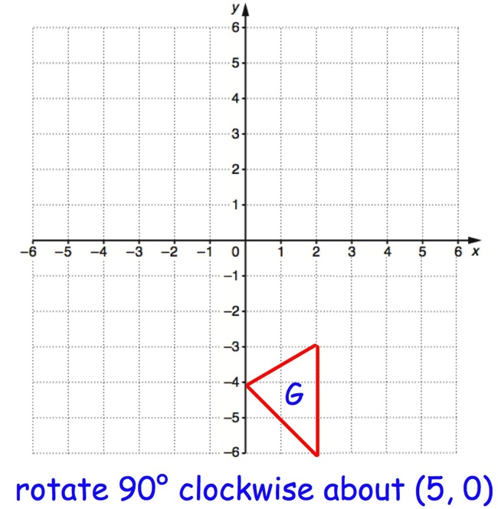
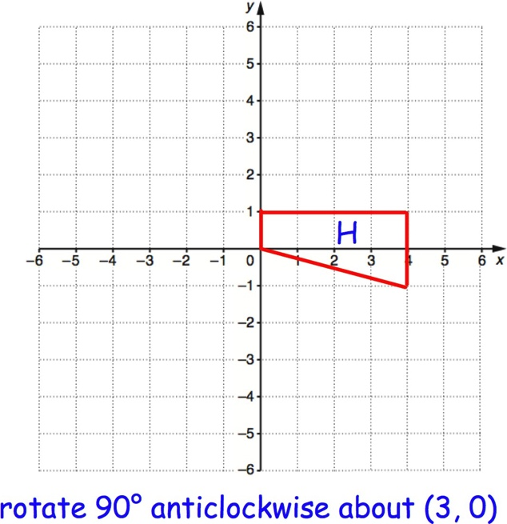
Q3(g) Q3(h)
Q3(i)
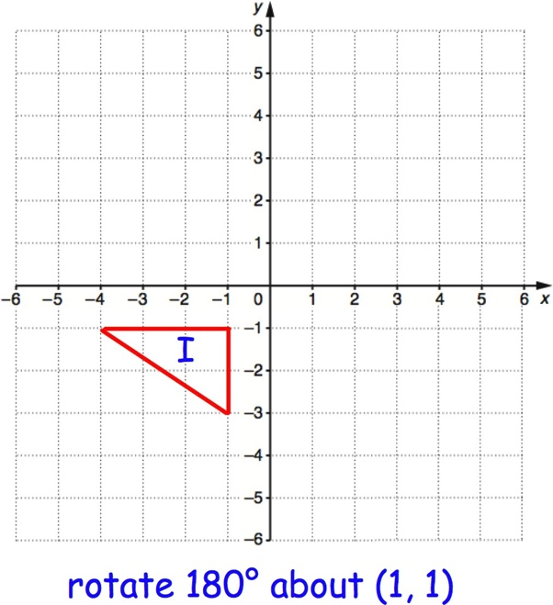

Decimals: Subtraction

Question 1: Work out the answers to the following subtractions

(a) | 0.9 − 0.1 | (b) 0.8 − 0.3 | (c) 0.7 − 0.6 | (d) 0.5 − 0.2
(e) | 1.2 − 0.3 | (f) 1.5 − 0.4 | (g) 1.8 − 0.6 | (h) 1.9 − 1.2
(i) | 2.4 − 0.5 | (j) 3.8 − 2.5 | (k) 4.1 − 1.8 | (l) 5.5 − 3.1
(m) | 8.7 − 1.3 | (n) 9.2 − 5.8 | (o) 7.3 − 3.9 | (p) 8.5 − 0.9
Question 2: Work out the answers to the following subtractions
(a) | 7.7 − 1.5 | (b) 8.5 − 4.1 | (c) 19.7 − 18.6 | (d) 26.2 − 5.2
(e) | 54.5 − 23.1 | (f) 80.4 − 10.3 | (g) 16.6 − 9.2 | (h) 85.7 − 50.4
(i) | 7.3 − 4 | (j) 8.6 − 2 | (k) 24.9 − 6 | (l) 15.1 − 9
(m) | 7 − 1.3 | (n) 9 − 3.6 | (o) 20 − 4.4 | (p) 32 − 8.7

Question 3: Work out these subtractions

(a) 0.39 − 0.23 (b) 0.47 − 0.15 (c) 0.75 − 0.41 (d) 0.99 − 0.65

(e) 0.46 − 0.18 (f) 0.81 − 0.55 (g) 1.24 − 0.72 (h) 2.13 − 1.66

(i) 8.63 − 0.4 (j) 5.55 − 3.1 (k) 8.13 − 0.5 (l) 3.84 − 1.9

(m) 10.4 − 0.15 (n) 5.8 − 1.92 (o) 14.5 − 0.77 (p) 12 − 4.55

Question 4: Complete these subtractions

(a) 40.5 − 19.3 (b) 88.3 − 52.58 (c) 155.73 − 48.89 (d) 203.5 − 51.64

(e) 498 − 70.94 (f) 500 − 384.11 (g) 8200 − 901.3 (h) 10000 − 4901.33

Question 5: Work out each of the following

(a) 1.284 − 0.151 (b) 2.028 − 1.115 (c) 39.45 − 6.061

© CORBETTMATHS 2018

(d) 40.5 − 7.258 (e) 204.1945 − 203.7885 (f) 716 − 409.4822

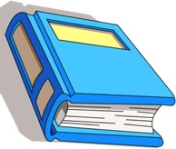
Question 1: Paul buys a book that costs £6.89 and pays with a £10 note.
How much change should Paul get?

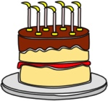
Question 2: Jennifer has 1.2kg of Ulour.
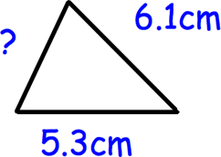
She uses 0.75kg of the Ulour to bake a cake. How much Ulour does she have left?

Question 3: The perimeter of the triangle is 16.1cm. Work out the length of the missing side.

Question 4: The Uirst four terms of a number sequence are 15.8, 15.1, 14.4, 13.7, ,
Work out the next two terms.

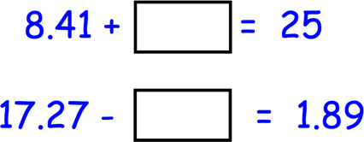
Question 5: Find the missing numbers
Question 6: Maxine buys 3 magazines that cost £1.99, £2.45 and £3.70.
She pays with a £50 note.
Work out how much change she should receive?

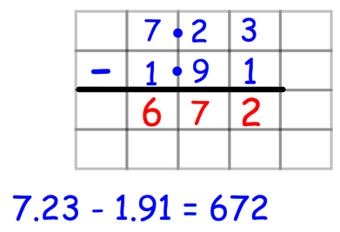
Question 7: Angus is working out 7.23 − 1.91 Can you spot any mistakes?

Area of Compound Shapes

Question 1: Work out the area of each of these shapes.

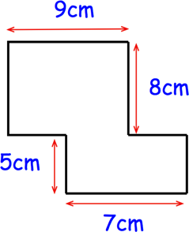
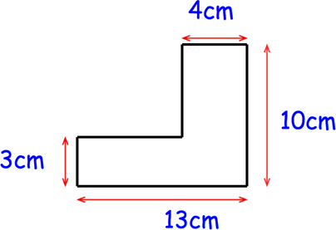
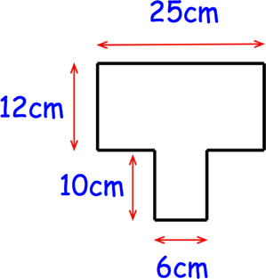
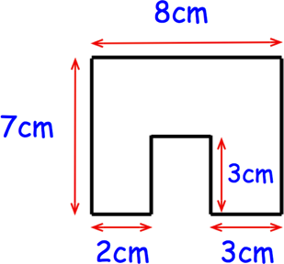
(a) (b) (c)
(d) (e) (f)
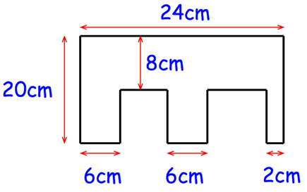

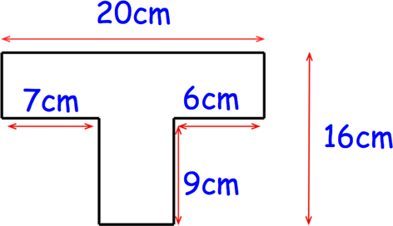
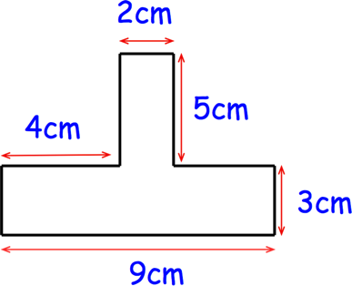
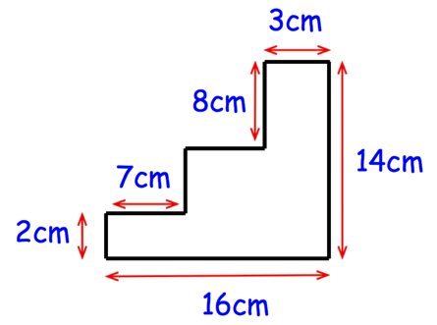
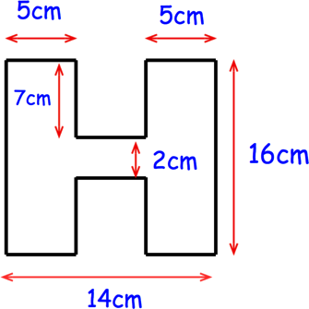
(g) (h) (i)

Question 2: Work out the shaded area.

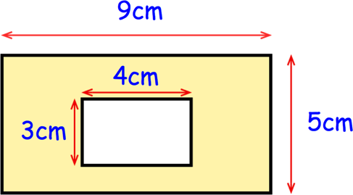
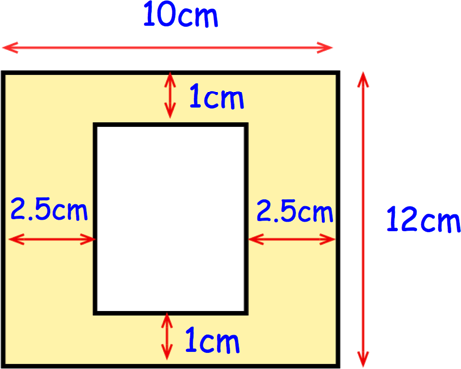
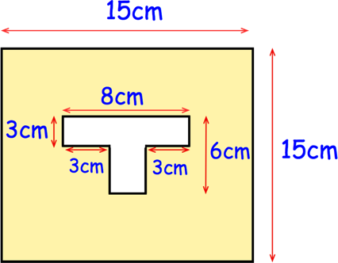
(a) (b) (c)

Question 3: Work out the area of each of these shapes.

(a) (b) (c)
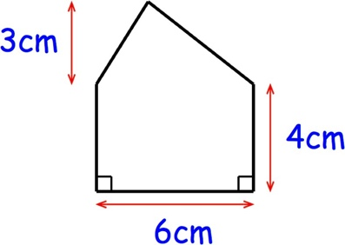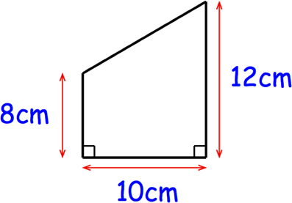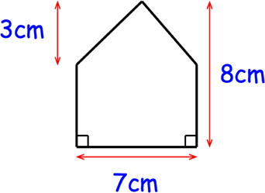

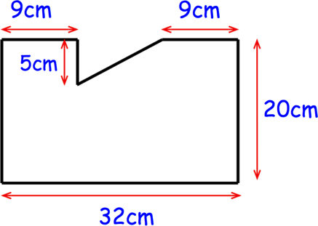
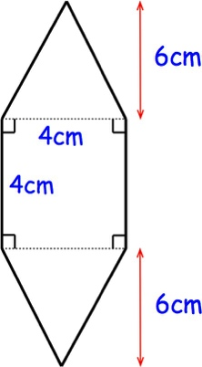
(d) (e) (f)
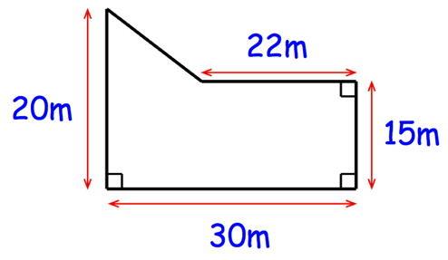

Question 4: Work out the shaded area.

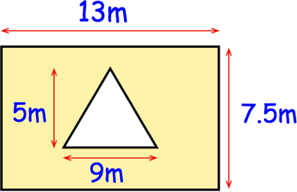
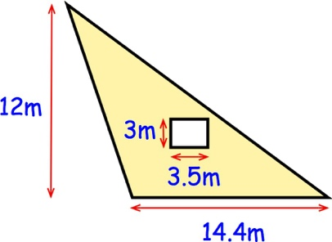
(a) (b) (c)
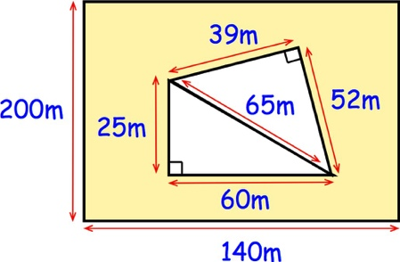
Question 5: Work out the area of each of these shapes.

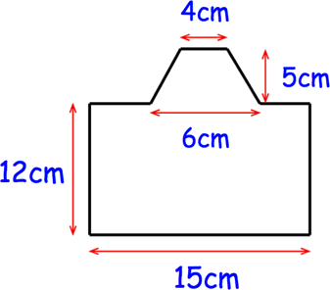
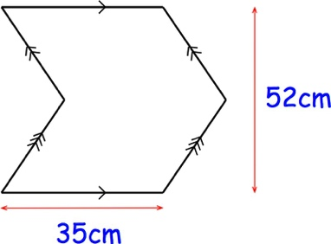
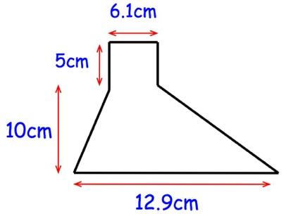
(a) (b) (c)

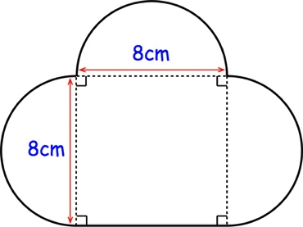
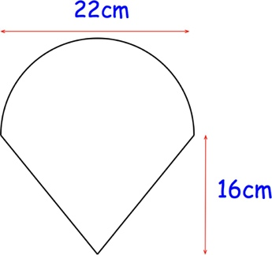
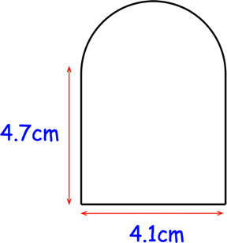
(d) (e) (f)

Question 1: William is painting the side of his house.
He has 8 litres of paint and each litre of paint covers 16m² Does William have enough paint?

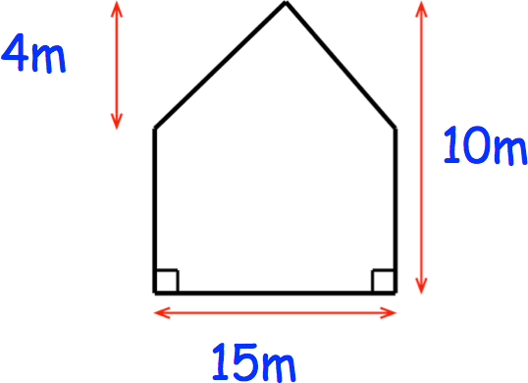
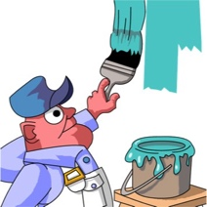

Question 2: Farmer Martin keeps chickens in the Qield below.
Each chicken needs 3m².
What is the maximum number of chickens that he can keep?

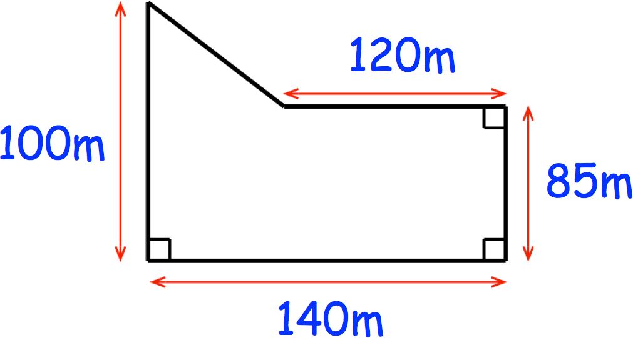

Adding Decimals
Question 1: Work out the answers to the following additions

(a) 4.5 + 2.3 | (b) 8.4 + 1.7 | (c) 0.7 + 0.5 | (d) 2.8 + 10.3
(e) 13.4 + 28.9 | (f) 206.2 + 72.8 | (g) 6.4 + 15.9 | (h) 0.5 + 0.8 + 0.1
(i) 9.7 + 1.4 + 1.3 | (j) 16.8 + 3.9 + 102.2 + 87.4

Question 2: Work out these additions

(a) 0.14 + 0.53 (b) 0.35 + 0.65 (c) 2.47 + 3.34 (d) 4.93 + 2.25

(e) 4.77 + 1.84 (f) 10.38 + 6.81 (g) 7.83 + 12.49 (h) 0.56 + 107.08

(i) 9.85 + 2.63 + 0.89 (j) 0.08 + 0.12 + 0.87 + 1.93 + 2.06

Question 3: Complete these additions

(a) 6.5 + 1.73 (b) 0.56 + 1.6 (c) 2.45 + 7.8 (d) 8.67 + 3.9

(e) 9.2 + 4.87 (f) 1.08 + 2.6 (g) 20.6 + 15.84 (h) 41.8 + 5.35

(i) 7.4 + 2.329 (j) 0.018 + 2.39 (k) 9.224 + 8.89 (l) 0.293 + 9.815

(i) 4.52 + 0.3 + 0.79 + 1.4 (j) 0.94 + 4.8 + 12.09 + 5.63
Apply

Question 1: Richard buys a notebook that costs £6.78 and a pen that costs £4.19.
Work out the total cost.

Question 2: Holly is saving money.
In January, she saves £15.15 In February, she saves £8.82 In March, Holly saves £13.37
Work out how much she has saved in total.

© CORBETTMATHS 2018

Question 3: David drives 4.8 miles to Bristol and a further 6.7 miles to Bath.
Work out how far he drives in total.

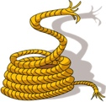
Question 4: Mr Jenkins has three pieces of rope.
The pieces of rope are 2.35m, 1.8m and 3.06m long. Work out the total length of the pieces of rope.

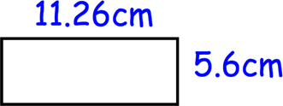
Question 5: Shown is a rectangle.
Calculate the perimeter.

Question 6: Work out the missing number.
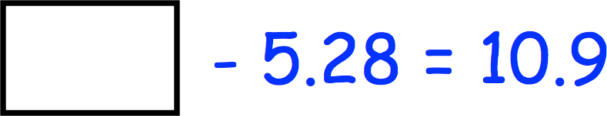
Question 7: Shown is a shape made from three identical squares and three identical rectangles.
Calculate the perimeter of the shape.
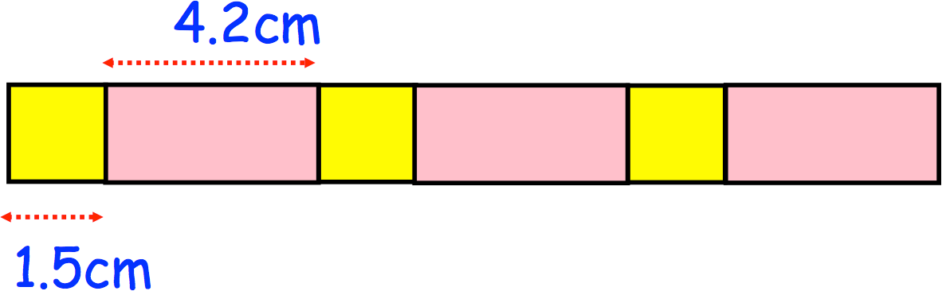
Question 8: The \irst four terms of a number sequence are 2.52, 2.71, 2.9, 3.09, …, …, …
Work out the next two terms.

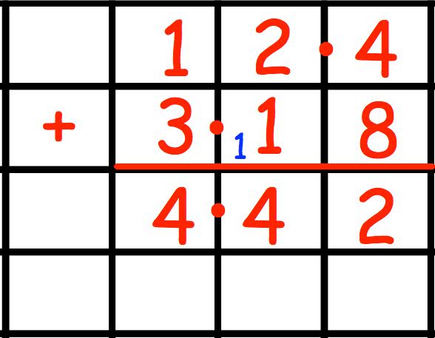
Question 9: Grace is working out 12.4 + 3.18
Can you spot any mistakes?

Question 10: Neil writes down four numbers with a sum of 50.
All the numbers have two decimal places and no two numbers are the same. Write down four possible numbers Neil could have written down.

