Creative Writing Book 2
Name:
Teacher:

Date:

Session 1 – Structural devices:
Most traditional stories and plays follow the same narrative arc.
It is like the template of a story.
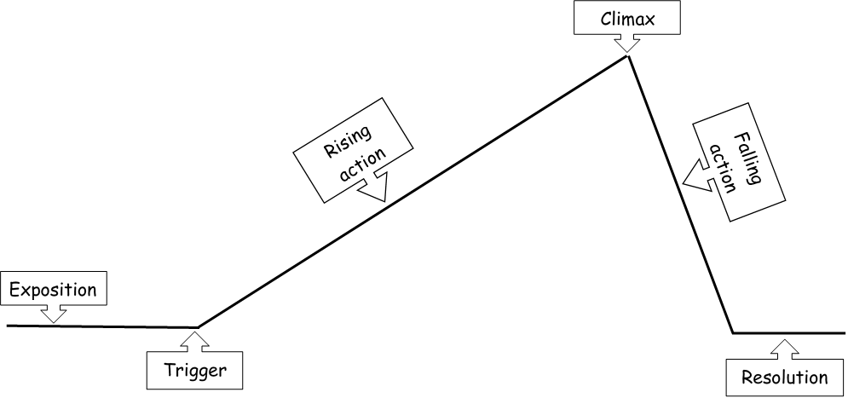
- Exposition – the normal everyday life
- Trigger – the moment when something exciting happens that disrupts the everyday life
- Rising action – a series of events, complications
- Climax – the most dramatic point
- Falling action – where all problems are resolved
- Resolution – the ending, the new everyday life

Choose a fairytale, such as Cinderella or The Three Little Pigs, and summarise the details for each part of the narrative arc:
Exposition
Trigger
Rising action
Climax
Falling action
Resolution
In an assessment, you could be asked to write a description or a story opening based on an image, or you could be given an opening line or a story title.
You might be tempted to attempt to write a story that covers the whole narrative arc but that is really difficult to do well in the limited time that you will be given, especially when you take in to account planning and editing as well as the actual writing.
You would do better to focus on a single moment from the narrative arc and describe it in detail.
Exposition
Below is the first page from a very famous story – its exposition:
Mr and Mrs Dursley, of number four, Privet Drive, were proud to say that they were perfectly normal, thank you very much. They were the last people you’d expect to be involved in anything strange or mysterious, because they just didn’t hold with such nonsense.

Mr Dursley was the director of a firm called Grunnings, which made drills. He was a big, beefy man with hardly any neck, although he did have a very large moustache. Mrs Dursley was thin and blonde and had nearly twice the usual amount of neck, which came in very useful as she spent so much of her time craning over garden fences, spying on the neighbours. The Dursleys had a small son called Dudley and in their opinion there was no finer boy anywhere.

The Dursleys had everything they wanted, but they also had a secret, and their greatest fear was that somebody would discover it. They didn’t think they could bear it if anyone found out about the Potters. Mrs Potter was Mrs Dursley’s sister, but they hadn’t met for several years; in fact, Mrs Dursley pretended she didn’t have a sister, because her sister and her good-for-nothing husband were as unDursleyish as it was possible to be. The Dursleys shuddered to think what the neighbours would say if the Potters arrived in the street. The Dursleys knew that the Potters had a small son, too, but they had never even seen him. This boy was another good reason for keeping the Potters away; they didn’t want Dudley mixing with a child like that.

What are your first impressions of the Dursley family based on this extract?
How has the writer created these impressions?
Which words or phrases are the most descriptive and what do they make you think or imagine?
Why does the writer want you to feel this way about the Dursleys at the beginning of the story?
How does this link to other characters or details from later in the story?

Date:
Session 2 – Describing a setting:
Setting includes the place (where) and the time (when).
You have 3 different settings below – bullet point plan a ‘Show me, don’t tell me’ description for each:
- What time of day is it?
- What is the climate or temperature like?
- What can you see? What can you hear?
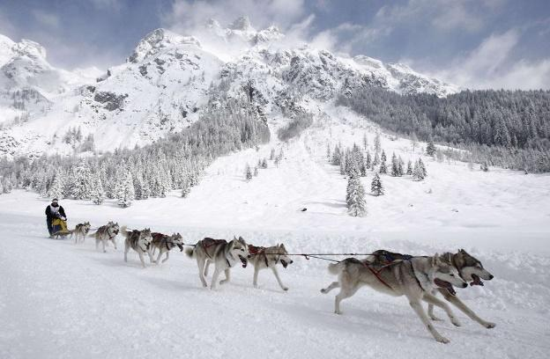
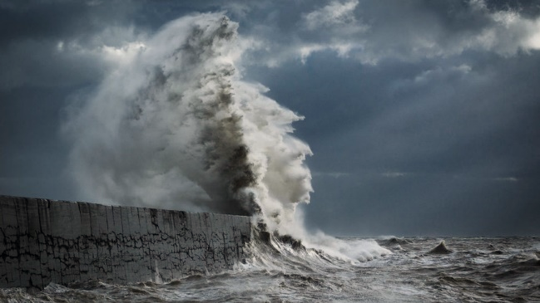
Choose one of the images to describe in more detail:
Use this page to plan your vocabulary and devices before you start writing:
Bigger picture:
(For example, the sky, the snow / sand / water)
Zoom in:
(Focus on a particular detail and describe it as though you are looking at it very closely)
Choose a few ideas to write about in detail rather than trying to write about lots of different ideas, as this can be overwhelming for your reader. Remember that we are trying to give them a clear and detailed ‘written picture’ of where they are.

Content & organisation

Linguistic devices:
- Simile
- Triple / rule of three
- Alliteration
- Metaphor
- Personification
- Onomatopoeia
- Multi-sensory

Structural features:
- Zoom in on the small details
- Zoom out to see the bigger picture

- Change paragraph whenever you change the time / place / topic / person (TiP ToP) that you are writing about.
- Link your paragraphs using prepositions such as Across from… or Below....

Technical accuracy

Range of punctuation used accurately:
- Capital letters at the beginning of each sentence and for proper nouns like names
- Full stops and commas
- Brackets or dashes to add detail

Range of sentence forms for effect:
- Variety of SPACE sentence starters
- Simple sentences
- Compound sentences
- Complex sentences

Last checks:
- Read it slowly and carefully twice
- Tick the list where you have met the criteria
- Change any boring words to make your vocabulary ambitious.

Extra space:
Peer assessment
Peer assessed by:
Carefully read the writing through once.
Use the strip in the margin to assess against the marking criteria:
- Highlight or tick in green all the things that they have done.
- Highlight or underline in pink one target for content and organisation and one target for technical accuracy.
On their writing, highlight your favourite part in green and explain below what you like about it:
Improvements
In a different colour, either add to or change what you have already written based on your peer assessment. Use the extra space box above if you need to.
Date:
Session 3 – Focusing on fine detail:
One cinematic technique that is easy to include in your writing is zooming in. We often recognise this in television or film more than we do in writing because it is more obvious on screen – think about how a camera might zoom in on a character’s face or on a clue in a mystery.
You are going to write in fine detail about raindrops on a pane of glass.
Discuss:
- How can you write about the different senses to extend your writing?
- How can you use language devices such as metaphors and personification make your writing more descriptive?
- How can you use onomatopoeia and descriptive language to describe the sounds?

Remember to show, not tell!

Planning page
You should write in third person perspective and past tense.
Use this page to plan your ideas, vocabulary and devices before you start writing:
What does it look like? |  |  | How does it move?
What does it sound like? |  |  | What does it feel like?
Choose a few ideas to write about in detail rather than trying to write about lots of different ideas, as this can be overwhelming for your reader.
Content & organisation

Linguistic devices:
- Simile
- Triple / rule of three
- Alliteration
- Metaphor
- Onomatopoeia
- Multi-sensory

Structural features:
- Consistent third person perspective and past tense
- Zoom in on the small details

- Change paragraph whenever you change the time / place / topic / person (TiP ToP) that you are writing about.
- Link your paragraphs using prepositions to demonstrate the shift.

Technical accuracy

Range of punctuation used accurately:
- Capital letters at the beginning of each sentence and for proper nouns like names
- Full stops and commas
- Brackets or dashes to add detail

Range of sentence forms for effect:
- Variety of SPACE sentence starters
- Simple sentences
- Compound sentences
- Complex sentences

Last checks:
- Read it slowly and carefully twice
- Tick the list where you have met the criteria
- Change any boring words to make your vocabulary ambitious.
Extra space:
Peer assessment
Peer assessed by:
Carefully read the writing through once.
Use the strip in the margin to assess against the marking criteria:
- Highlight or tick in green all the things that they have done.
- Highlight or underline in pink one target for content and organisation and one target for technical accuracy.
On their writing, highlight your favourite part in green and explain below what you like about it:
Improvements
In a different colour, either add to or change what you have already written based on your peer assessment. Use the extra space box above if you need to.
Date:
Session 4 – Creating shifts in time:
A setting can appear very different depending on the time of day or year that you base your writing.
Imagine a park at different times of day or in different seasons.
How might this change affect the atmosphere of your writing?
 | 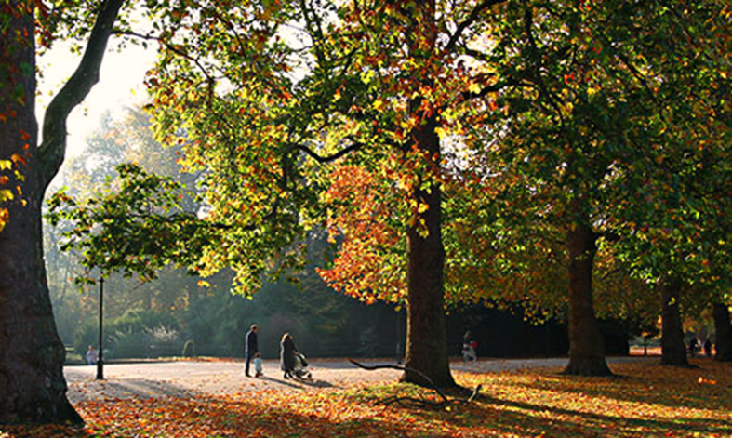
Discuss:
- How might a park seem different first thing in the morning, the middle of the day, and at night?
  - Consider the number of passersby, the type of people and their activities; the amount of light; the temperature.
  - For example, a play area might be light, bright and full of laughter in the morning, but eerie and shadowy at night.
- How might a park seem different at different points in the year?
  - Late Spring when trees and plants come back to life; Summer when the days are long and hot; late Autumn when it turns colder.
  - How might this affect the five senses?
- How can you use prepositions and adverbs to show how time has moved on without saying: “Three hours / months later…” ?

Planning page
You should write in third person perspective and past tense.
Use this page to plan your ideas, vocabulary and devices before you start writing:
Original setting:
(Remember to use your SPACE sentence starters: Simile, Preposition, Adjectives and Adverbs, Conjunctions, -Ed verbs – there will be a temptation to start every sentence with The!)
Shift time of day or year:
(How can you use effective prepositions and adverbs to show the shift?)
Choose a few ideas to write about in detail rather than trying to write about lots of different ideas, as this can be overwhelming for your reader.
Content & organisation

Linguistic devices:
- Simile
- Triple / rule of three
- Alliteration
- Metaphor
- Onomatopoeia
- Multi-sensory

Structural features:
- Consistent third person perspective and past tense
- Zoom in on the small details
- Zoom out to see the bigger picture

- Change paragraph whenever you change the time / place / topic / person (TiP ToP) that you are writing about.
- Link your paragraphs using prepositions to demonstrate the shift.

Technical accuracy

Range of punctuation used accurately:
- Capital letters at the beginning of each sentence and for proper nouns like names
- Full stops and commas
- Brackets or dashes to add detail

Range of sentence forms for effect:
- Variety of SPACE sentence starters
- Simple sentences
- Compound sentences
- Complex sentences

Last checks:
- Read it slowly and carefully twice
- Tick the list where you have met the criteria
- Change any boring words to make your vocabulary ambitious.
Extra space:
Peer assessment
Peer assessed by:
Carefully read the writing through once.
Use the strip in the margin to assess against the marking criteria:
- Highlight or tick in green all the things that they have done.
- Highlight or underline in pink one target for content and organisation and one target for technical accuracy.
On their writing, highlight your favourite part in green and explain below what you like about it:
Improvements
In a different colour, either add to or change what you have already written based on your peer assessment. Use the extra space box above if you need to.
Date:
Session 5 – Creating shifts in perspective:
You can develop your main character by sharing their thoughts, feelings, dreams and fears. This helps the reader to understand your character and care more about them by making them seem real.
How do I feel?
What do I remember from my past? | What do I hope for? | What am I afraid of?  Which of my hidden thoughts are revealed in my dreams?  What do I think but wouldn’t say out loud?
You are going to write the opening to a story about a character called Storm, who is troubled by events in their past.
You should establish your setting first to help your reader imagine where they are and give details that help them understand the character – think about how the exposition about the Dursleys in Session 1 sets up the story of Harry Potter.

Then you can introduce your main character by sharing both an external perspective (what they are like on the outside) and their internal perspective (how they feel on inside).

Planning page
You should write in first person perspective and past tense.
Use this page to plan your ideas, vocabulary and devices before you start writing:
1) Setting:
(Remember you need to establish where and when your story is set. Look back at the Session 2 planning and writing to help you.)
2) Character:
(Your character should be more substantial than just their appearance. Remember to include details about the way that they move, interact with the setting, etc.)
3) Shift:
Could you combine a shift in perspective with a shift in time to share insight into your character’s troubled past?
Content & organisation

Linguistic devices:
- Simile
- Triple / rule of three
- Alliteration
- Metaphor
- Onomatopoeia
- Multi-sensory

Structural features:
- Consistent first person perspective and past tense
- Zoom in on the small details
- Zoom out to see the bigger picture
- Internal perspective

- Change paragraph whenever you change the time / place / topic / person (TiP ToP) that you are writing about.
- Link your paragraphs using prepositions such as Across from… or Below....

Technical accuracy

Range of punctuation used accurately:
- Capital letters at the beginning of each sentence and for proper nouns like names
- Full stops and commas
- Brackets or dashes for parenthesis (adding detail)

Range of sentence forms for effect:
- Variety of SPACE sentence starters
- Simple sentences
- Compound sentences
- Complex sentences

Last checks:
- Read it slowly and carefully twice
- Tick the list where you have met the criteria
- Change any boring words to make your vocabulary ambitious.
Content & organisation

Linguistic devices:
- Simile
- Triple / rule of three
- Alliteration
- Metaphor
- Onomatopoeia
- Multi-sensory

Structural features:
- Consistent first person perspective and past tense
- Zoom in on the small details
- Zoom out to see the bigger picture
- Internal perspective

- Change paragraph whenever you change the time / place / topic / person (TiP ToP) that you are writing about.
- Link your paragraphs using prepositions such as Across from… or Below....

Technical accuracy

Range of punctuation used accurately:
- Capital letters at the beginning of each sentence and for proper nouns like names
- Full stops and commas
- Brackets or dashes for parenthesis (adding detail)

Range of sentence forms for effect:
- Variety of SPACE sentence starters
- Simple sentences
- Compound sentences
- Complex sentences

Last checks:
- Read it slowly and carefully twice
- Tick the list where you have met the criteria
- Change any boring words to make your vocabulary ambitious.
Extra space:
Peer assessment
Peer assessed by:
Carefully read the writing through once.
What are your first impressions of this character?
Are there any details you would add or changes you would make to help you understand this character?
200-word challenges:
Complete on lined paper.
Describe the sunrise at Angkor Wat.

Things to include:
- A metaphor
- A one word paragraph
- 3 different types of punctuation
- The word ‘mesmerising’
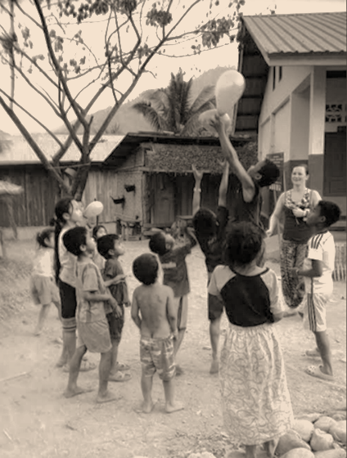 | Describe the children playing with the balloon.  Things to include:  - Exaggeration  - A superlative  - A simple sentence  - The word ‘elated’
Describe Mount Bromo.  Things to include:  - Pathetic fallacy (personification of nature to create mood)  - Colours  - A complex sentence  - The word ‘spectacular’ |  | 