English Functional Skills Level 1 – TASKS

Task 1 – Week commencing 23/03/2020.

Have a look at the 'Revision Pack: Techniques' and the 'Types of Writing: What to Do'. Familiarise yourself with the ideas in them and how you would use, for example, different types of punctuation/ word types/ structural techniques - thinking about how these could be used in different forms of writing.
Then, complete the following task (worth 10 marks). Remember that spelling, punctuation and grammar is assessed - so make a tick list of techniques that you want to use in your answer and check them off as you use them. Your answer should be about 250 words.
Task
Information
You have arranged to hold a sponsored music event in your college car park. The caretaker, Alan Booth, has asked you to email him with details of what you require.
Writing task
Write an email to Alan Booth with your requests for the car wash.
In your email, you may wish to:
- state the date of the event and the times you need the car park to be opened and closed;
- check details of how to access the water supply;
- state whether you are bringing your own equipment (DJ decks, mics, speakers, etc.) or asking to borrow them from the college;
- include any other details you feel are important.
Tip: the task has already told you the FORM, PURPOSE and AUDIENCE, so adapt your techniques to suit what's relevant to each in this task.
FORM: email
PURPOSE: inform
AUDIENCE: college care taker

Task 2 – Week commencing 30/03/2020.

You’ve already had a go at a full writing task. Now, let’s break down how we could make that writing even better, by mastering all the techniques we might use to create a great piece of work.

Have a look at the ‘sentence types’ in your ‘Revision Pack: Techniques’. Have a go at writing two examples of each type of sentence.

The sentence types are:
- Simple
- Compound
- Complex
- Compound-complex

Write sentences that you might include in a letter to residents of your street, complaining about the fact that they all keep hoarding toilet roll.

Task 3 – Week commencing 20/04/2020.

We had a look at sentence types before half term and had a go at writing a few examples of each. Now, lets build on our knowledge of that, and see if we can incorporate different types of punctuation in our work.

Have a look at the table of punctuation in your Functional Skills revision pack.

Select 8 different types of punctuation and write a different sentence for each type. Each sentence must have at least one different type of punctuation.

Task 4 – Week commencing 27/04/2020.

Now, let’s have a look at word types – all of the skills you are learning now will not only be good for functional skills, but if you can use them well, will also stand you in great stead for your GCSE English work!

Have a look at the ‘Types of Words’ sheet in your revision pack. Write a sentence which includes one different type of word per sentence. You should have 7 different sentences in total. Underline the word you are practising and write the word type next to the sentence.

For example,

Verb: The cat, who had very sneakily pushed her face into the hamster’s cage, was licking her lips rather suspiciously.

Task 5 – Week commencing 04/05/2020.

At this point, we’ve mastered sentence types, words types, and different types of punctuation; we’re now ready to move on to paragraphs!

Theschoolrun.com states that, ‘A paragraph is a section of writing which consists of one or more sentences grouped together and discussing one main subject. New paragraphs are either signalled by an indent (where the text starts some way into the line) or by leaving a line blank’.

When writing paragraphs – especially when you are arguing, analysing or informing someone of something – a good way of structuring them is the ‘P.E.E.L.’ technique:

- Point – the first sentence in the in the paragraph tells readers its main point.
- Evidence – next, give readers facts and/ or anecdotes to prove that the point is sensible.
- Explain – after giving evidence, explore its significance. Explain the main point in more depth or add other smaller points related to it.
- Link – end the paragraph by showing how it links to the main topic of the point in the next paragraph.

Have a go at writing a paragraph from a leaflet to students, explaining how they should present themselves well during work experience.

Task 6 – Week commencing 11/05/2020.

Given all the work that we’ve done so far, we now can now use all of these building blocks to write in a particular style – either formal or informal. Have a look at your ‘Understanding Style’ sheet in your revision pack, to see what is needed for both formal and informal writing.

The style you need to write in will be dictated by the audience, purpose (argue/ advise/ inform, etc.), and form (letter/ e-mail/ article, etc.) of the task. Look at the ‘Types of Writing’ table in your revision pack, if you need guidance.

Now, write a paragraph in response to the task, ‘Who is your hero? Write an article for your school website about a hero you admire, explaining why you think they are a hero’.
Decide whether this writing should be formal or informal before starting, and state which you have chosen. Give a sentence which states why you have chosen to write in that style.

Task 7 – Week commencing 18/05/2020.

Building on our use of P.E.E.L. paragraphs, different sentence types, and use of punctuation, we are now going to look at how we can use facts and opinions to support our non-fiction work. Facts and opinions are often great to use in the ‘Evidence’ part of our paragraphs.

Remember: a fact is a piece of information that can be proven or not. For example, there are 7,000 ice cream shops in Skegness.

An opinion is someone’s point of view. For example, there should be more ice cream shops in Skegness.

You need to know the purpose of your text in order to be able to decide whether to include facts or opinions. For example, an information text should include facts. Persuasive texts may include opinions supported by facts.

Write a plan for an article for a school magazine, arguing that the legal driving age should be raised to 21.

To plan, you should:
- Decide on your main point and argument.
- Decide on three points you want to make in three paragraphs. Consider opposing points of view and argue against them.
- Decide on your concluding paragraph – how will you sum up everything that you’ve argued throughout the piece and answer the question?

Task 8 – Week commencing 01/06/2020.

Using all the skills that you have mastered over the last 8 weeks, write your response the task you planned last time:

Write an article for a school magazine, arguing that the legal driving age should be raised to 21.

Don’t forget to show off all of your skills – and let’s see how much you’ve improved in these 8 weeks!

Revision Pack Resource: Writing Styles – Formal Vs. Informal

Formal | Informal
You should use a formal style if:  - Your audience is an organisation, for example a business, local council, school or charity.  - Your purpose is official or legal, for example to apply for a job or make a complaint.  - You are asked to write in a formal form, for example a formal letter or a briefing note. | You should use a more informal style if:  - You know your audience personally, for example a family member, teacher, or fellow students.  - Your purpose is to seem friendly and approachable, for example to persuade a friend to help you with a charity event.  - You are asked to write an informal form, for example an email.
- Use correct grammar.  - Do not use dialect or slang.  - Use sophisticated or technical words.  - Keep your writing impersonal. | - Use correct grammar.  - Do not use dialect or slang.  - Include some informal words such as don’t or can’t.  - Your writing can be more personal and direct.
For example:  Dear Sir,  I understand that Printworks offers students work experience in printing. I would very much like to work in this area when I leave school. For this reason I am already studying relevant GCSEs. | For example:  Hi  I’ve written to the manager at Printworks to ask if I can do my work experience with them. Hopefully I’ll find out what it’s really like – and they might have a job going for me later on. What do you think?

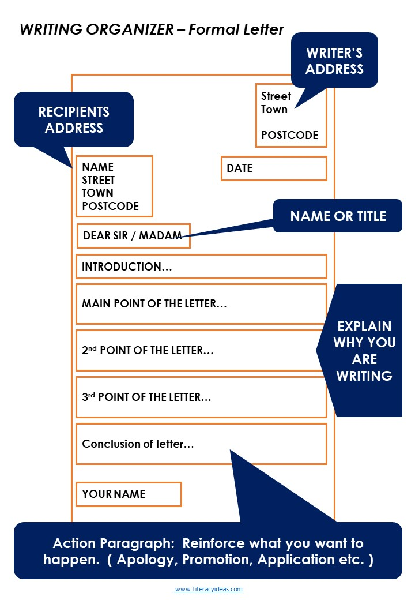

Mark Scheme for English Functional Skills Level 1: Writing

Level 1 Skill standard for writing:
Write a range of texts to communicate information, ideas and opinions, using formats and styles suitable for their purpose and audience.
Write clearly and coherently, including an appropriate level of detail
Present information in a logical sequence
Use language, format and structure suitable for purpose and audience
Use correct grammar, including correct and consistent use of tense
Ensure written work includes generally accurate punctuation and spelling and that meaning is clear

